First Presbyterian Church, Waynesboro, VA
First Presbyterian Church of Waynesboro is a community-minded
congregation living out the love of Christ as we serve one another with
humility, gentleness, and patience through God’s grace.

February 2024, Volume 62, Issue 2

THE COLUMNS

Pro·cess (ˈprä-ˌses), noun. 1. a natural phenomenon marked by gradual changes that lead toward a particular result; the process of growth. 2. a continuing natural or biological activity or function, such as breathing. 3. a series of actions or operations conducing to an end. 4. a continuous operation or treatment, especially in manufacture. 5. the whole course of proceedings in a legal action; the summons, mandate, or writ used by a court to compel the appearance of the defendant in a legal action or compliance with its order. 6. a prominent or projecting part of an organism or organic structure, i.e. the Xiphoid process.

Just as natural processes govern our basic functions, like breathing, and dictate how our bodies fight infection, our lives as social beings are governed by processes - cultural, legal, managerial and religious. From recipes to licensing, criminal investigation and prosecution to academic achievement; from the election of Ruling and Teaching Elders to the celebration of the Sacraments, our lives, both sacred and profane, are governed by processes.
Of course, there are many times when these processes seem outdated or pointless - especially when they seem to preclude the kind of swift, decisive action we often feel is necessary.

Why bother with the recipe, when I've made my famous Cabbage and Grape Stew a hundred times?

Why ask my wife? It's obvious the rooms needed painting, and Pepto Bismol Pink was on sale!

License? I don't need a license! How hard can it be to drive an 18-wheeler?

Why go through the rigamarole of a Pastor Nominating Committee? I know a guy...
Continued

In my life, I have often looked to avoid the time and hassle of process when time and circumstance seemed to be on the side of action. I have ignored instructions on how to construct furniture; I have ignored crucial details in a recipe because it was quicker or easier to do so; I have merely skimmed important documents and missed key pieces of information. And it doesn't stop there. In my many years of ministry, I have both witnessed, and participated in, actions and decisions which failed to take into account the ecclesiastical processes designed to guide those actions and decisions. Sometimes it worked; often it didn’t, leading to lousy meals, wasted money, wobbly tables and hurt feelings. My second rule is thus born out of hard experience:
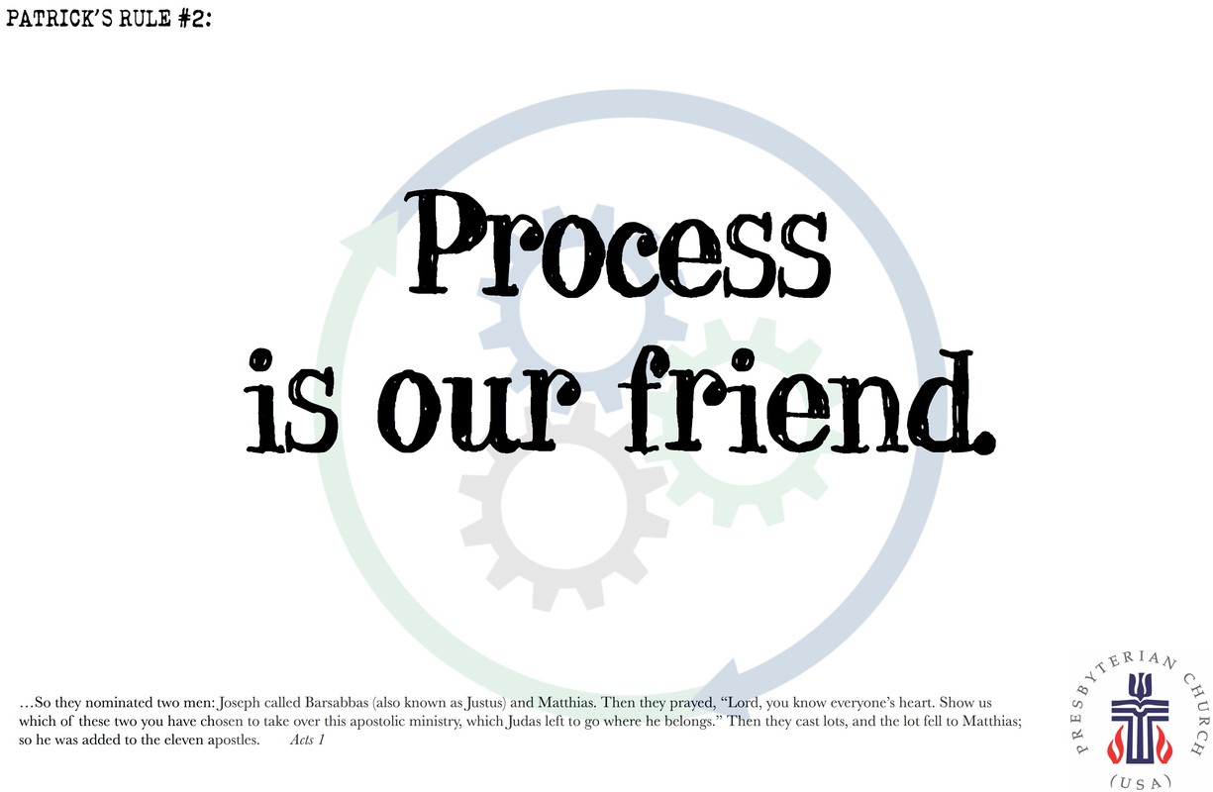
Process takes time, but time helps us avoid rash decisions. Process can slow us down, but it eases the burden of decision making and makes sure everyone has their say. Process can be complicated, but it encourages consistent results. Process can seem like a waste of time, but it provides room for the Holy Spirit to act - in us, through us and around us.

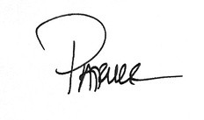
We have already completed many steps in the process of transition, and now a Pastor Nominating Committee is beginning their process of discernment with the creation of a Ministry Discernment Profile for the congregation. Please support them with

Music Notes for February

February may be the shortest of all the months, but this year, it encompasses two seasons. We conclude Epiphany and make our way into Lent, which begins on Valentine’s Day.

As FPC continues various maintenance projects, we will worship in the Barksdale Room until the Sanctuary is ready. The intimate services in the Barksdale Room feature hymns that are near and dear to our hearts.

We celebrate communion on 4 February and will open the service with the joyous hymn All Who Hunger, Gather Gladly. The hymn is part of the shape-note tradition, a style of hymn singing developed in New England in the 18th century which flourished in rural communities in the South. The melody is one of the oldest American folk tunes to be published, part of William Moore’s (1790-1850) Columbian Harmony of 1825. The tune was also included in other American hymnals, including Southern Harmony of 1835.

The closing hymn will be Immortal, Invisible, God Only Wise. It is based on a traditional Welsh Ballad, Can mlynedd I nawr (A Hundred Years From Now) and first published as a hymn tune in 1839 as part of the collection Hymns of the Sanctuary. The tune name refers to the patron saint of France, St. Denis.

We will celebrate the Transfiguration on 11 February. The opening hymn, Jesus, Take Us to the Mountain, tells the story of Jesus’ transfiguration and how we, as Christians, respond. The closing hymn, Christ, Whose Glory Fills the Skies, depicts Christ as the True Light. It is filled with images of how light transforms the gloom of darkness into the joy of His radiant light.

The first Sunday of Lent will be 18 February. We open the season of penitence with Forty Days and Forty Nights and The Glory of These Forty Days. These hymns depict Jesus’s temptation in the wilderness and how remembering Christ’s struggle helps prepare us for the season and the eventual joy of Easter.

For the final Sunday of February, we will open the service with The God of Abraham Praise. This hymn delineates the many ways that God blesses His people, with a melody that dates back to 17th century Judaism. The closing hymn, To Abraham and Sarah, recalls the second lesson of the day. In Genesis 17, God tells Abram that He will make His covenant between Him and Abram and “greatly increase your numbers.” God also tells Sarai that she will be the mother of nations. God gives them both new names: Abraham and Sarah.

With gratitude to FPC for the continued support of the music program –

Roger and Kimberlea Daggy

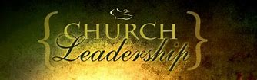

SESSION HIGHLIGHTS

Session held a Stated Meeting on January 9, 2024.
- Session approved, with the regret, the transfer of membership of Terry Crickenberger and Joe Earhart to Second Presbyterian Church in Richmond, per their request.
- Rev. Pettit explained the procedure for Incorporation which is required for Presbyterian Churches in the state of Virginia. He is in contact with our lawyer.
- Plans are under way to expand our Preschool Summer Session for 5 to 9 year-olds with our current staff.
- Preschool is planning a Night Out for parents on February 10 with children’s activities in the Fellowship Hall.
- The Mission/Outreach Report was received (reported elsewhere in The Columns.)
- P&M: Tree at corner of Wayne & 11st Street has been cut down. Sanctuary is being painted.
- Worship Service on January 6 was cancelled because of inclement weather.
- FPC will not hold an Ash Wednesday service. Members will be notified what services are available at neighboring Presbyterian churches.
- Our Search Committee is awaiting confirmation from the Presbytery.
- The Presbyterians Better Together Bible Study will meet at FPC on January 29.
- Boundary Training for Elders will be held at Smyrna PC on January 14 led by Associate Presbyter Rev. Dr. Nancy Meehan Yao.
- Session meetings are opened and closed with prayer. The next meeting will be February 13, 2024. --Betsy Ruehl, Clerk of Session

MISSION/OUTREACH DECEMBER 2023

- Ordered and received food from Blue Ridge Area Food Bank December 12 and 19. Volunteers assembled 20 pantry boxes for each order.
- Maintained temperature logs for refrigerators and freezers.
- Food Bank held November 7, 14, 21 and 28.
- Purchased eggs, bread, and margarine for Food Bank weekly. Now using bilingual list.
- Updated weekly shopping list for extra options.
- Completed pantry inventory and report: Served 210 individuals and 57 households. During 2023 served 1,900 individuals and 658 households.
- Collected chicken noddle soup and spaghetti (dry pasta) for Food Bank.
- Received donations from Boy Scouts, LD&B Insurance, and local neighborhood.
- Donated 6 hats, 6 pairs of gloves and 17 pairs of socks for Disciples’ Kitchen.
- Presented Advent Calendars to Preschoolers
- Served 53 meals at Disciples’ Kitchen December 7. Next Disciples’ Kitchen is February 1.
- Collecting shampoo for Food Bank in January and February.
--Cynthia Hoover, Mission Chair

SUGGESTION FOR FOOD BANK IN FEBRUARY:
SHAMPOO

A LITTLE FOOD FOR THOUGHT…..

Tip your server. Return your shopping cart. Pick up a piece of trash.
Hold the door for the person behind you. Let someone into your lane.
Small acts can have a ripple effect. That’s how we change the world.

PRESCHOOL NEWS

Our preschool children are glad to be back at school and learning with their friends and making new memories. We were so excited that we got to experience a couple snow days at home with our families although we got to have a few of those days here at school with our friends as well.
Ms. Carol’s twos room have been focusing on blue for the month, as well as learning about snow and Arctic animals. Ms. Lynda’s threes have been talking about snowflakes and experimenting with ice, as well as making paintings with ice cubes. Our four-year-olds in Ms. Aimee’s class have also been learning about Arctic animals, as well as recognizing the letters that are in their names.

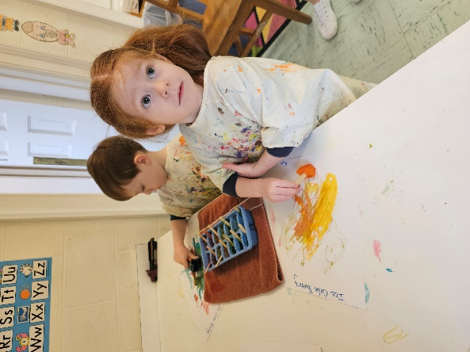

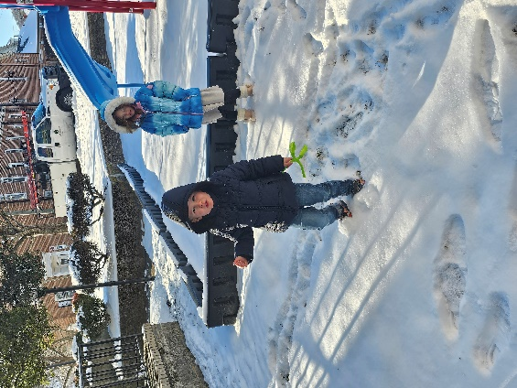

FIRST FRIDAY ORGAN CONCERT
March 1 – 12:15 pm
LIGHT REPAST FOLLOWING IN BARKSDALE ROOM

ASH WEDNESDAY

First Presbyterian Church will not be holding an Ash Wednesday Service.

Look for announcements from other churches, particularly Better Together Presbyterian Churches,
which will be posted when available.

HAPPY VALENTINE’S DAY

“The best and most beautiful things in the world cannot be seen
or even touched. They must be felt with the heart.”

--Helen Keller, The Story of My Life

WHAT MAKES US UNIQUE
PART 7

The Presbyterian Church (U.S.A.) is distinctly a confessional and connectional church, distinguished by the representation of elders in the government.
Sacraments
“….The Reformed tradition recognizes the sacraments of Baptism and the Lord’s Supper….as having been instituted by the Lord Jesus Christ through the witness of the Scriptures and sustained through the history of the universal church.” (W-3.0401)
Infant Baptism
The Bible declares that God claimed humanity as God’s own “before the foundation of the world”. (Ephesians 14).
“Both believers and their children are included in God’s covenant love. The baptism of believers witnesses to the truth that God’s gift of grace calls for our grateful response. The baptism of our young children witnesses to the truth that God claims people in love even before they are able to respond in faith. These two forms of witness are one and the same Sacrament.” (W-3.0402).
Though a person may be baptized at any age, infant baptism is a common practice in the Presbyterian Church. Parents bring their child to church, where they publicly declare their desire for that child to be baptized. When an infant or child is baptized the church commits itself to nurture the child in faith. When adults are baptized they make a public profession of faith.
“The Sacrament of Baptism holds a deep reservoir of theological meaning, including dying and rising with Jesus Christ, pardon, cleansing, and renewal; the gift of the Holy Spirit; incorporation into the body of Christ; and a sign of the realm of God. The Reformed tradition understands Baptism to be a sign of God’s covenant. The water of Baptism is linked with the water of creation, the flood, and the exodus. Baptism thus connects us with God’s creative purpose, cleansing power, and redemptive promise from generation to generation. Like circumcision, a sign of God’s gracious covenant with Israel, Baptism is a sign of God’s gracious covenant with the Church. In this new covenant of grace God washes us clean and makes us holy and whole. Baptism also represents God’s call to justice and righteousness, rolling down like a mighty stream, and the river of the water of life that flows from God’s throne.” (W-3.0402).
Presbyterians do not require a person to be entirely immersed in water during baptism; the water may be administered by lifting with the hand or pouring from a vessel. Baptism is received only once. Its effect is not tied to the moment when it is administered, for it signifies the beginning of life in Christ, not its completion. The Presbyterian Church (U.S.A.) believes that persons of other denominations are part of one body of Christian believers; therefore, it recognizes and accepts baptisms by other Christian churches.
“Baptism is ordinarily celebrated on the Lord’s Day in the gathering of the people of God. The presence of the covenant community bears witness to the one body of Christ into whom we are baptized. When circumstances call for the administration apart from public worship, the congregation should be represented by or more members.” (W-3.0402).
(What Makes Us Unique to be continued.)

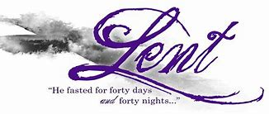

Liturgists

February 4 Betsy Ruehl

February 11 Bill Pannill

February 18 Jo Pannill

February 25 Jean Hashagen

REV PETTIT’S WORK SCHEDULE

Monday – work at home
Tuesday and Thursday– onsite First Pres
Wednesday – visitation
Friday – off

February Birthdays

5 – Anne Johnson

7 – Cathy Cunningham, Nancy Snyder

16 – Sandi Henderson

18 - Phyllis Poluito, Valerie Purcell

February Calendar

Thursday, February 1
6-7:30 pm Food Bank
Sunday, February 4
11 am Worship Service
Monday, February 5
1 pm Bible Study Smyrna Presbyterian
Tuesday, February 6
6-10 pm Waynesboro Symphony Practice, Fellowship Hall
Thursday, February 8
2-4pm Food Bank
Sunday, February 11
11 am Worship Service
Monday, February 12
1 pm Bible Study Second Presbyterian
Tuesday, February 13
2:30 pm Session Room 212
6-10 pm Waynesboro Symphony Practice, Fellowship Hall
Wednesday, February 14
Ash Wednesday - no service
Thursday, February 15
6-7:30 pm Food Bank
Sunday, February 18
11am Worship Service
Monday, February 19
1 pm Bible Study Hermitage Presbyterian
Thursday, February 22
2-4 pm Food Bank
Sunday, February 25
11 am Worship Service
Monday, February 26
1pm Bible Study Finley Memorial Presbyterian
Tuesday, February 27
6-10 pm Waynesboro Symphony, Fellowship Hall
Thursday, February 29
6-10 pm Waynesboro Symphony, Fellowship Hall

Mailing Address
P. O. Box 877
Waynesboro, VA 22980
Phone 540.949.8366
Fax 540.949.5750
E-mail: church@firstpresway.com
Website: www.firstpresway.org

Interim Pastor Music Director
Rev. Patrick S. Pettit Mr. Roger Daggy
pspettit@gmail.com firstpreswaymusic@gmail.com

Administrative Assistant Music Assistant
Mrs. Colleen Cash Mrs. Kimberlea Daggy
ccash@firstpresway.com firstpreswaymusic@gmail.com

Preschool Director Audio/Video Technician
Ms. Tami Hemp Mr. Craig Cavenaugh
preschool@firstpresway.com
Maintenance Technician
Mr. Michael Griffith

