SECOND SUNDAY IN LENT February 25, 2024

PRELUDE Prelude in g, BWV 535 Bach (1685-1750)

WELCOME & ANNOUNCEMENTS

INTROIT What Does the Lord Require Routley (1917-1982)

CALL TO WORSHIP
Leader: God’s amazing love surrounds us;
People: We give thanks for the love and grace of God.
Leader: Christ’s life, death and resurrection transform us;
People: We give thanks for the love and grace of God.
Leader: The Spirit’s stirring brings God’s love and grace alive for us;
All: Let us worship in the love and grace of God.

MORNING PRAYER

OPENING HYMN 49 The God of Abraham Praise Leone

CALL TO CONFESSION
God of Mercy, what You offer is beyond our imaginations. We crave love, yet we cannot love the way You do. We can offer only momentary grace, while Yours is constant. We say we want fairness, but demand preference; You offer boundless love to all. Forgive us, Lord, this and all our sin. Empower us to reflect, however dimly, the love and mercy and grace You so generously shower upon us.

SILENT PRAYER

ASSURANCE OF PARDON

*GLORIA PATRI 581 Greatorex

FIRST SCRIPTURE READING Psalm 22:23-31 p. 435

ANTHEM To Abraham and Sarah Welsh folk tune

SECOND SCRIPTURE READING Genesis 17:1-10, 15-16 p. 11

SERMON A God with a plan. Patrick S Pettit, Interim Pastor

*AFFIRMATION OF FAITH Apostles’ Creed p.35

PRAYERS OF THE PEOPLE & THE LORD’S PRAYER

* HYMN 65 Guide Me, O Thou Great Jehovah Cwm Rhondda

*CHARGE and BENEDICTION

POSTLUDE Fugue in g, BWV 535 Bach

*Please stand if able

Hearing devices are available for your convenience.
Please be aware that they do not function until after the service begins.

Today’s link is: https://www.youtube.com/watch?v=Qd0lhLhh6dc

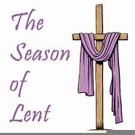

Shenandoah Nursing Home: Nancy Garber

Home: Mary Ultee, Mary Ann Maupin, Linda Sandquist, Mike &
Cathy Cunningham, Warner Sandquist

Friends and Family: Bill Bromley, Jean Custen, Jerry Hughes, Sally McNeel,
Bill Metzel (Joyce Tipton), Col. Stuart Roberts (Mark Henderson),
Paul Watts, Kathleen Clements, (Colleen Cash), Betsy Boswell (Curry)

Military: Carson Craig

Monday, February 25, Better Together Bible study continues at Finley Memorial in Stuarts Draft at 1pm.

Offering envelopes are available; contact Colleen.

Wednesdays at noon
Barksdale Room

Book of James

FIRST PRESBYTERIAN CHURCH
WAYNESBORO, VIRGINIA

A community-minded congregation living out the love of Christ as we serve one another with humility, gentleness, and patience through God’s grace.

February 18, 2024 11:00 AM

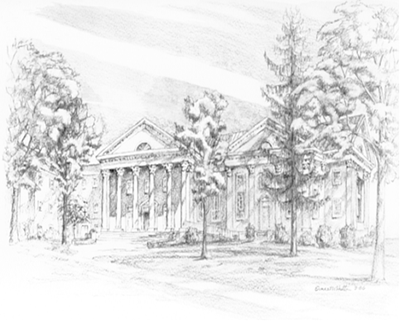

P.O. Box 877
249 South Wayne Avenue
Waynesboro, Virginia
(540) 949-8366
Church Website: www.firstpresway.org
Preschool Website: www.firstprespre.org
Email: church@firstpresway.com

