Fourth Sunday after Epiphany January 28, 2024

PRELUDE Selected Hymns

WELCOME & ANNOUNCEMENTS

CALL TO WORSHIP
Leader: I will give thanks to the Lord with my whole heart.
People: Your righteousness endures forever.
Leader: The fear of the Lord is the beginning of wisdom;
People: May we practice it and gain understanding.
Leader: Let us worship God.

MORNING PRAYER

OPENING HYMN 39 Great is Thy Faithfulness Faithfulness
stanzas 1 and 2

CALL TO CONFESSION
Eternal God, we rejoice that your love never ends, and yet we fail to recognize that love. We are selfish and thoughtless - more childish than childlike. We are rude and irritable - more fearful than confident. We have sinned against love itself and against those whom you love. Forgive us, Lord, this and all our sin. Give us words to speak and hearts to act out of your great love.

SILENT PRAYER

ASSURANCE OF PARDON

*GLORIA PATRI 581 Greatorex

FIRST SCRIPTURE READING Psalm 111 p. 490

SPECIAL MUSIC Forlane Ravel (1875-1937)

SECOND SCRIPTURE READING 1 Corinthians 8:1–13 p.930

SERMON The price of Christian Freedom. Patrick S Pettit, Interim Pastor

*AFFIRMATION OF FAITH Apostles’ Creed p.35

PRAYERS OF THE PEOPLE & THE LORD’S PRAYER

* HYMN 546 Lord, Dismiss Us With Thy Blessing Sicilian Mariners

*CHARGE and BENEDICTION

POSTLUDE Reprise: Sicilian Mariners

*Please stand if able

Hearing devices are available for your convenience.
Please be aware that they do not function until after the service begins.

Today’s link is: https://www.youtube.com/watch?v=R4bWCqyYdoY

Shenandoah Nursing Home: Nancy Garber

Home: Mary Ultee, Mary Ann Maupin, Linda Sandquist, Mike &
Cathy Cunningham, Warner Sandquist, Charles Simpkins

Friends and Family: Bill Bromley, Jean Custen, Jerry Hughes, Sally McNeel,
Bill Metzel (Joyce Tipton), Col. Stuart Roberts (Mark Henderson),
Paul Watts, Kathleen Clements, (Colleen Cash), Josh Slonaker, Barb Ostrander
(Holly Bennett), Betsy Boswell (Curry)

Military: Carson Craig

Better Together Bible study continues January 29. First Presbyterian will be hosting
at 1pm.

Offering envelopes are available; contact Colleen.

FIRST FRIDAY CONCERT CANCELLED
FOR FEBRUARY 2

Concerts will resume in March

FIRST PRESBYTERIAN CHURCH
WAYNESBORO, VIRGINIA

A community-minded congregation living out the love of Christ as we serve one another with humility, gentleness, and patience through God’s grace.

January 28, 2024 11:00 AM

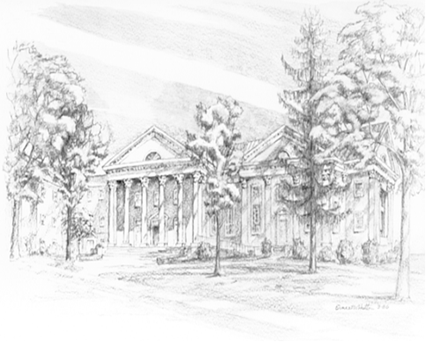

P.O. Box 877
249 South Wayne Avenue
Waynesboro, Virginia
(540) 949-8366
Church Website: www.firstpresway.org
Preschool Website: www.firstprespre.org
Email: church@firstpresway.com

