FOURTH SUNDAY IN LENT March 10, 2024

PRELUDE Prelude in d, BWV 554 attr. Bach (1685-1750)

WELCOME & ANNOUNCEMENTS

INTROIT Lord, Have Mercy Lim (b. 1963)

CALL TO WORSHIP
Leader: O give thanks to the LORD, for he is good; for his steadfast love endures forever.
People: Let the redeemed of the LORD say so, those he redeemed from trouble and gathered in from the lands, from the east and from the west, from the north and from the south.
Leader: Let us worship God.

MORNING PRAYER

OPENING HYMN 415 Come Ye Sinners, Poor and Needy Restoration
(Refrain after stanzas 1 and 4)

CALL TO CONFESSION
Merciful God, your grace saves us; yet we believe we can earn your love. Your provision is sure, even unto eternal life; yet we live as if we are in control. Forgive us, Lord, this and all our sin. Have mercy when we fail to share your grace, for the sake of our Lord Jesus.

SILENT PRAYER

ASSURANCE OF PARDON

*GLORIA PATRI 581 Greatorex
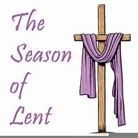

FIRST SCRIPTURE READING Numbers 21:4-9 p. 122

SPECIAL MUSIC What Wondrous Love Is This Southern Harmony

SECOND SCRIPTURE READING John 3:14-21 p. 864

SERMON A God who saves Patrick S Pettit, Interim Pastor

*AFFIRMATION OF FAITH Apostles’ Creed p.35

PRAYERS OF THE PEOPLE & THE LORD’S PRAYER

* HYMN 377 I Want to Walk as a Child of the Light Houston

*CHARGE and BENEDICTION

POSTLUDE Fugue in d, BWV 554 attr. Bach

*Please stand if able

Hearing devices are available for your convenience.
Please be aware that they do not function until after the service begins.

Today’s link is: https://www.youtube.com/watch?v=SAyf2X1T62g

Shenandoah Nursing Home: Nancy Garber

Home: Mary Ultee, Mary Ann Maupin, Linda Sandquist, Mike &
Cathy Cunningham, Warner Sandquist

Friends and Family: Bill Bromley, Jean Custen, Jerry Hughes, Sally McNeel,
Bill Metzel (Joyce Tipton), Col. Stuart Roberts (Mark Henderson),
Paul Watts, Kathleen Clements, (Colleen Cash), Betsy Boswell (Curry)

Military: Carson Craig

Monday, March 11, Better Together Bible study continues at Second Presbyterian in Waynesboro.

Offering envelopes are available; contact Colleen.

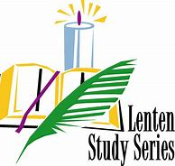

Wednesdays at noon
Barksdale Room

Book of James

FIRST PRESBYTERIAN CHURCH
WAYNESBORO, VIRGINIA

A community-minded congregation living out the love of Christ as we serve one another with humility, gentleness, and patience through God’s grace.

March 10, 2024 11:00 AM

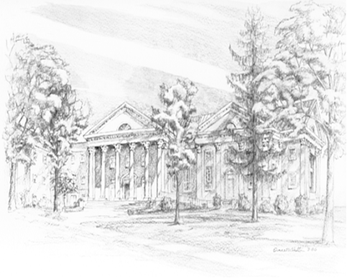

P.O. Box 877
249 South Wayne Avenue
Waynesboro, Virginia
(540) 949-8366
Church Website: www.firstpresway.org
Preschool Website: www.firstprespre.org
Email: church@firstpresway.com

