FIFTH SUNDAY IN LENT March 17, 2024

PRELUDE Prelude in g, BWV 535 Bach (1685-1750)

WELCOME & ANNOUNCEMENTS

INTROIT Lord, Have Mercy Lim (b. 1963)

CALL TO WORSHIP
Leader: Have mercy on me, O God, according to your steadfast love; according to your abundant mercy blot out my transgressions.
People: Create in me a clean heart, O God, and put a new and right spirit within me.
Leader: Let us worship God.

MORNING PRAYER

OPENING HYMN 722 Lord, Speak to Me That I May Speak Canonbury

CALL TO CONFESSION
O God, we pray for clean hearts and right spirits. But too often, our prayers are words alone, and we fail to pray with our actions. Too often we contribute to the suffering of others and add to the burdens of our neighbors. Forgive us, Lord, this and all our sin. Renew your Spirit within us and send us forth to spread your Good News.

SILENT PRAYER

ASSURANCE OF PARDON

*GLORIA PATRI 581 Greatorex

FIRST SCRIPTURE READING Psalm 119:9-16 p.493

ANTHEM Teach Me, O Lord Hurd (b. 1950)

SECOND SCRIPTURE READING Jeremiah 31:31-34 p. 642

SERMON A God who forgives. Patrick S Pettit, Interim Pastor

*AFFIRMATION OF FAITH Apostles’ Creed p.35

PRAYERS OF THE PEOPLE & THE LORD’S PRAYER

* HYMN 541 God Be with You Till We Meet Again Randolph

*CHARGE and BENEDICTION

POSTLUDE Fugue in g, BWV 535 Bach (1685-1750)

*Please stand if able

Hearing devices are available for your convenience.
Please be aware that they do not function until after the service begins.

Today’s link is: https://www.youtube.com/watch?v=n5shiKznXrA

Shenandoah Nursing Home: Nancy Garber

Home: Mary Ultee, Mary Ann Maupin, Linda Sandquist, Mike &
Cathy Cunningham, Warner Sandquist

Friends and Family: Bill Bromley, Jean Custen, Jerry Hughes, Sally McNeel,
Bill Metzel (Joyce Tipton), Col. Stuart Roberts (Mark Henderson),
Paul Watts, Kathleen Clements, Carolyn Williams (Colleen Cash), Betsy Boswell (Curry)

Military: Carson Craig

Monday, March 18, Better Together Bible study continues at Hermitage Presbyterian in Waynesboro.

Maundy Thursday Service March 28, noon in Barksdale Room; lite lunch provided.

Wednesdays at noon
Barksdale Room

Book of James

FIRST PRESBYTERIAN CHURCH
WAYNESBORO, VIRGINIA

A community-minded congregation living out the love of Christ as we serve one another with humility, gentleness, and patience through God’s grace.

March 17, 2024 11:00 AM

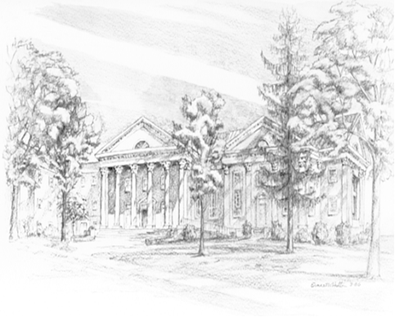

P.O. Box 877
249 South Wayne Avenue
Waynesboro, Virginia
(540) 949-8366
Church Website: www.firstpresway.org
Preschool Website: www.firstprespre.org
Email: church@firstpresway.com

