Third Sunday in Lent March 3, 2024

PRELUDE Prelude in e, BWV 555 attr. Bach (1685-1750)

WELCOME & ANNOUNCEMENTS

INTROIT Deo Gracias circa 1415

CALL TO WORSHIP
Leader: The Lord our God brought us out of the land of Egypt.
People: The Lord our God brings us out of the busy world to worship.
Leader: Let us worship God.

MORNING PRAYER

OPENING HYMN 61 Your Law, O Lord, Is Perfect Christus, der ist mein Leben

CALL TO CONFESSION
Gracious God, we confess to you how hard it is to live within the boundaries You set. We are committed to our own comfort and well-being, and so are quick to condemn those who trespass against us; yet we are just as quick to make excuses for our own behavior. Our motives do not correspond to your call. Forgive us, Lord, this and all our sin. Empower us to follow your ways, that we may live in the light of your love.

SILENT PRAYER

ASSURANCE OF PARDON

*GLORIA PATRI 581 Greatorex

FIRST SCRIPTURE READING Psalm 19 p.432

ANTHEM Bread of the World Bourgeois (1510-1559)
(text can be found in hymn 499)

SECOND SCRIPTURE READING Exodus 20:1-17 p. 58

SERMON A God of Boundaries Patrick S Pettit, Interim Pastor

*AFFIRMATION OF FAITH Apostles’ Creed p.35

THE LORD’S SUPPER
Invitation
Great Thanksgiving
Communion of the People

* HYMN 500 Be Known to Us in Breaking Bread St. Flavian

*CHARGE and BENEDICTION

POSTLUDE Fugue in e, BWV 555 attr. Bach

*Please stand if able

Hearing devices are available for your convenience.
Please be aware that they do not function until after the service begins.

Today’s link is: https://www.youtube.com/watch?v=QIWuViWAyX0

Shenandoah Nursing Home: Nancy Garber

Home: Mary Ultee, Mary Ann Maupin, Linda Sandquist, Mike &
Cathy Cunningham, Warner Sandquist, Charles Simpkins

Friends and Family: Bill Bromley, Jean Custen, Jerry Hughes, Sally McNeel,
Bill Metzel (Joyce Tipton), Col. Stuart Roberts (Mark Henderson),
Paul Watts, Kathleen Clements, (Colleen Cash),
Betsy Boswell (Curry)

Military: Carson Craig

Better together Bible study will meet March 4 at Smyrna Presbyterian Church at 1 pm

If you would like 2024 Offering envelopes, please ask Colleen for a box.

Wednesdays at noon
Barksdale Room
Book of James

FIRST PRESBYTERIAN CHURCH
WAYNESBORO, VIRGINIA

A community-minded congregation living out the love of Christ as we serve one another with humility, gentleness, and patience through God’s grace.

March 3, 2024 11:00 AM

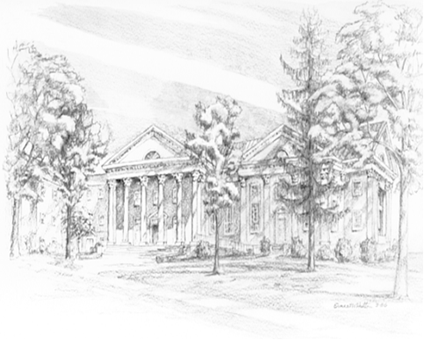

P.O. Box 877
249 South Wayne Avenue
Waynesboro, Virginia
(540) 949-8366
Church Website: www.firstpresway.org
Preschool Website: www.firstprespre.org
Email: church@firstpresway.com

