Second Sunday of Easter April 7, 2024

PRELUDE Toccata in E, BWV 566 Bach (1685-1750)

WELCOME & ANNOUNCEMENTS

INTROIT Alleluia Milburn (b. 1963)

CALL TO WORSHIP
Psalm 133
Leader: How very good and pleasant it is when kindred live together in unity!
People: It is like the precious oil on the head, running down upon the beard of Aaron, running down over the collar of his robes.
Leader: It is like the dew of Hermon, which falls on the mountains of Zion.
People: For there the LORD ordained his blessing, life forevermore.
Leader: Let us worship God.

MORNING PRAYER

OPENING HYMN 234 Come, You Faithful, Raise the Strain St. Kevin

Prayer of the Day
Leader: That which was from the beginning, which we have heard and seen with our eyes concerning the word of life, we proclaim to you.
People: Praise to you, God of light, in whom there is no darkness.
Leader: The life was made manifest, and we testify to it.
People: Praise to you, God of light, in whom there is no darkness.

SILENT PRAYER

ASSURANCE OF PARDON

*GLORIA PATRI 581 Greatorex

FIRST SCRIPTURE READING 1 John 1:1-2.2 p. 989

ANTHEM The Disciples Knew the Lord Jesus Milburn

SECOND SCRIPTURE READING Acts 4:32-37 p.888

SERMON Community Rev. Clayton Roscoe

*AFFIRMATION OF FAITH Apostles’ Creed p.35

THE LORD’S SUPPER
Invitation
Great Thanksgiving
Communion of the People

* HYMN 254 That Easter Day with Joy was Bright Puer nobis nascitur

*CHARGE and BENEDICTION

POSTLUDE Fugue in E, BWV 566 Bach

*Please stand if able

Hearing devices are available for your convenience.
Please be aware that they do not function until after the service begins.

Today’s link is: https://www.youtube.com/watch?v=zDldIIykdPo

Shenandoah Nursing Home: Nancy Garber

Home: Mary Ultee, Mary Ann Maupin, Linda Sandquist, Mike &
Cathy Cunningham, Warner Sandquist

Friends and Family: Bill Bromley, Jean Custen, Jerry Hughes, Sally McNeel,
Bill Metzel (Joyce Tipton), Col. Stuart Roberts (Mark Henderson),
Paul Watts, Kathleen Clements, Carolyn Williams (Colleen Cash),
Betsy Boswell (Curry)

Military: Carson Craig

Better Together Bible study resumes April 8, Second Presbyterian Church, Waynesboro at 1pm

Scholarship information for the 2024-2025 school year is now available on the website or church office.

We welcome Rev. Clayton Rascoe, Executive Director of Massanetta Springs Camp and Conference Center, to the pulpit this morning. With a BS from Appalachian State University and a Master of Divinity from Columbia Theological Seminary, Rev. Roscoe has been in his present position since 2016. He is married to the Rev. Kate Roscoe,
Transitional Pastor at Bridgewater Presbyterian Church.

FIRST PRESBYTERIAN CHURCH
WAYNESBORO, VIRGINIA

A community-minded congregation living out the love of Christ as we serve one another with humility, gentleness, and patience through God’s grace.

April 7, 2024 11:00 AM

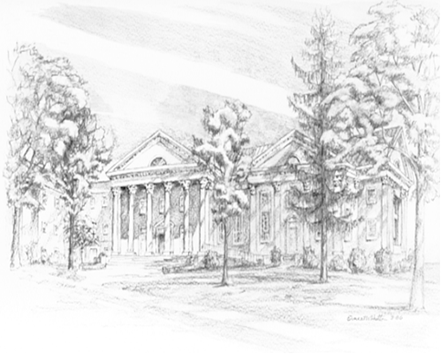

P.O. Box 877
249 South Wayne Avenue
Waynesboro, Virginia
(540) 949-8366
Church Website: www.firstpresway.org
Preschool Website: www.firstprespre.org
Email: church@firstpresway.com

