THE COLUMNS
First Presbyterian Church, Waynesboro, VA
First Presbyterian Church of Waynesboro is a community-minded
congregation living out the love of Christ as we serve one another with
humility, gentleness, and patience through God’s grace.

March 2024, Volume 62, Issue 3

So. The other day, I signed up for Shenandoah Presbytery's Mandatory Boundary Training. Every three years, pastors in the presbytery are required to participate in this continuing education event, designed to help us to serve our Lord faithfully, and to guard the welfare of our congregations. This will be my third time, and to be honest, it's hard not to see this as a less than stellar way to spend three hours on a Tuesday night. But then again, I sometimes have a bad attitude and can get a bit grouchy, especially if I haven't had my lunch.

I've eaten now, so I need to say, boundaries are profoundly important, and boundary training, while somewhat repetitious, is a crucial element for healthy pastoral relationships. As a matter of fact, boundaries are so important I have a rule about them (Rule #27).

Mending Wall is the first poem in the 1914 collection North of Boston by Robert Frost. One of the most famous poems of the modern age, it wrestles with two points of view: one playful and a little skeptical, the other stolid and unchanging. As two men walk the drystone wall that separates their properties, they retrieve the rocks that have fallen on their side, replacing them with care, in the hope they will stay. The narrator questions the need for such a barrier, even after instigating its repair; there is something vaguely offensive to them about this enforced separation. When they reach the tree line, the narrator objects, saying there is no need to divide the apple trees from the pines, for no harm can come to either from the deteriorating barrier. It is here, and again at the end, his neighbor utters that oft-quoted line:

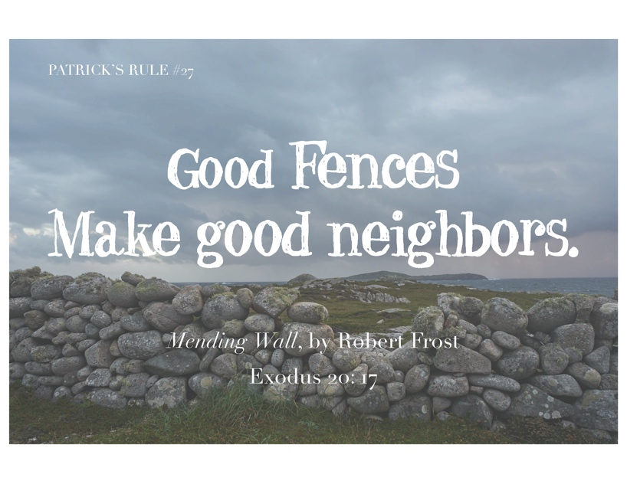

Like many of Frost's poems, Mending Wall is awash in ambiguity; if the narrator is so against walls, why does he keep fixing this one? I mean, he's the one who actually sets up this little working party. If Frost is advocating for fewer barriers in life, why have the neighbor say it not once, but twice? Why let him get the last word, so to speak?

At the risk of losing my English Major card, I would like to suggest that Frost actually makes an important point here, one which actually connects with where I started at the top of the page:

GOOD fences make good neighbors.

Boundaries define where one thing ends, and another begins. In real estate, they are imaginary lines on maps, often realized with walls or fences. In the law, they are proscriptive acts - things one is forbidden to do - and descriptive acts - things one must do. In relationships, though, boundaries are harder to describe and even more difficult to maintain, which is why it's so important to learn about them. Boundaries are vital to maintaining professional and personal relationships of all types. Although they might appear to be limitations, boundaries actually free us to interact with less worry about offending, hurting or abusing the other.

Of course, not every boundary is a good boundary; a fence, wrongly placed, will be the source of dispute - perhaps even legal action. A wall erected to protect my privacy can throw shadows on gardens and friendships alike. Barriers erected within us to insulate us from personal pain can weaken our ability to relate to others.

GOOD Boundaries are flexible but firm, adjusting to reflect new circumstances and experiences.
They reflect an agreement between parties about their location - sometimes worked out, sometimes already established. Boundaries allow each person to learn and grow, both alone and in relationships, because they grow with them, as they learn.

If you want to know more about boundary training, let me know - it's open to anyone. If you want to know more about Robert Frost, there is an award winner documentary, A Lover's Quarrel With The World, available on YouTube.

Music Notes for March

We continue our Lenten journey this month, culminating in the joy of Easter on the last day of March. Throughout the season, we will sing hymns that reflect this time of penitence.

As we do every first Sunday of the month, we will celebrate communion on 3 March. The choir will sing Bread of the World, with music by Louis Bourgeois’(1510-1599). The tune, known as Rendez à Dieu, is one of many Bourgeois composed for the Genevan Psalter. The collection of metrical Psalms was created in 1539 to encourage congregational participation during worship. The closing hymn, Be Known to Us in Breaking Bread, also refers to communion and how we respond to Jesus in our lives.

The season of Lent also brings some of the most famous passages in all of Scripture. One of the lessons for 10 March will be John 3:14-21, including the 16th verse, which reads “For God so loved the world that He gave His only begotten Son, that who so believeth in Him should have everlasting life.” The anthem for that Sunday will be What Wondrous Love is This.

The last week of March is Holy Week, and the music underscores the lessons for this most hallowed time of year. On Palm Sunday, the march into Jerusalem will be celebrated with fanfare. FPC will hold a Maundy Thursday communion service, with music that reflects the sacrifice to come. We will then celebrate the joy of Easter with some of the most uplifting hymns in Christendom, concluding with the famous Toccata from Symphony no. 5 by Charles-Marie Widor (1844-1937).

Later this month, Roger will join other musicians for the annual Bach Around the Clock celebration at Christ Lutheran Church in Staunton. On Saturday 16 March, concerts featuring the music of Johann Sebastian Bach (1685-1750) will be played all day, from 9a to 9p, by musicians from the Heifetz Institute (ensembles from which play every summer at FPC) as well as several organists, including members of the Charlottesville-Albemarle chapter of the American Guild of Organists, of which Roger is a member. The chapter’s recital is currently scheduled for 3p.

We are so thankful to First Presbyterian Church for your ongoing support of the music program. May you be blessed during this season of reflection.

With gratitude –
Roger and Kimberlea Daggy

FIRST FRIDAY ORGAN CONCERT
March 1 – 12:15 pm
LIGHT REPAST FOLLOWING IN BARKSDALE ROOM

Preschool News!

The new year is just flying by here in preschool; we can’t believe it’s already March! There have been so many fun activities going on the past few months. Our children got to walk to the Post Office and mail their valentine cards back home to their parents. It was so much fun to explore the daily routines of our postal workers. The preschool had “Parent’s Night Out” Valentine’s date night which was a huge hit. The children as well as our teachers loved the extra time spent together while the parents had free time to go have dinner “kid free”.
Ms. Carol’s classroom really enjoyed participating in spirit week! The twos also focused on heart shape for the month. Ms. Lynda’s classroom learned about shadows and how to make their own shadow with light. Our 3-year-old class learned about Abe Lincoln and George Washington, as well as how to keep teeth healthy. Ms. Aimee’s 4-year-old class focused on learning about the continents and learning their colors and numbers in Spanish. We are so proud of all our preschool children!

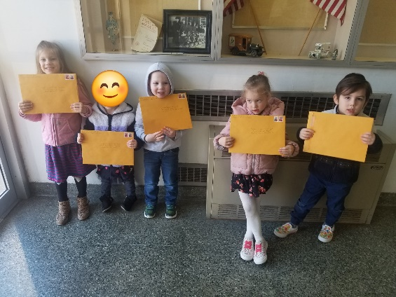

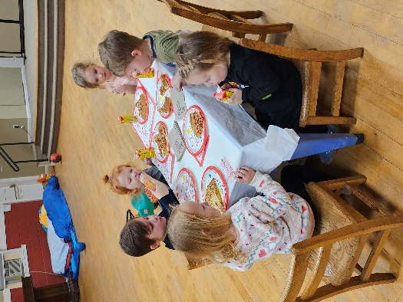

SESSION HIGHLIGHTS

A Stated Session Meeting was held February 13, 2024.
- The Clerk submitted the Church Information Form online.
- The Clerk submitted the 2023 Church Statistical Report online.
- Mike Cunningham was elected Commissioner to the online Presbytery Meeting on February 27.
- A new Preschool class for 2 to 2-1/2-year-olds will begin in the old Nursery March 4.
- Lenten Luncheons will begin February 21 in the Barksdale Room with a simple meal of soup and bread. Rev. Pettit will lead a Bible Study on the book of James.
- Cynthia Hoover submitted the January Mission/Outreach report (printed elsewhere).
- Mission/Outreach Budget of $6,000 was discussed. The considerable additional donations to the Church Food Bank are welcome and necessary. FPC will provide a packed lunch for February 28, delivered the previous evening, to WARM overnighters at Westminster Presbyterian Church.
- Globes in the Sanctuary will be cleaned during Spring Break in March.
- Session approved that Communion be held the first Sunday of each month and at special services Maundy Thursday and Christmas Eve.
- Session approved the One Great Hour of Sharing Offering for Easter Sunday, March 31.
- The Pastor Search Committee (composed of Bill Pannill, Bob Miller and Cynthia Hoover, chair), has submitted the MDP to CLC. (That’s a good thing!)
- Session approved taking appropriate action for Incorporation.
- All Session meetings are opened and closed with prayer. The next meeting will be held March 12, 2024 --Betsy Ruehl, Clerk of Session

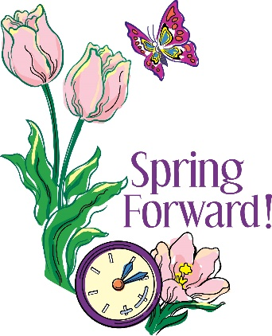

March 10, 2024
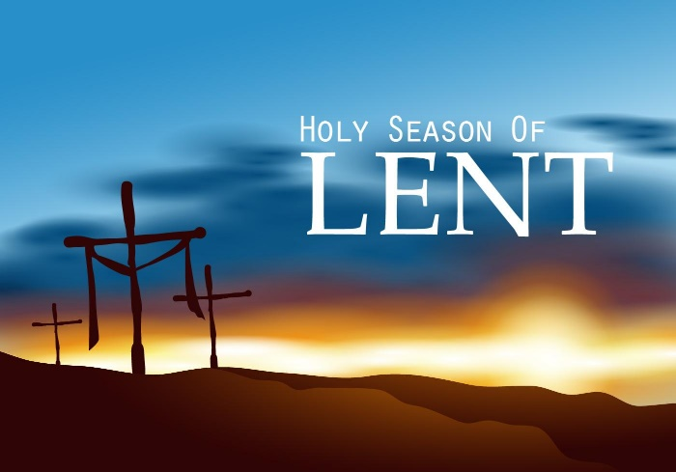

THE SEASON OF LENT

The season of Lent is a time of prayer, fasting and self-examination in preparation of the celebration of the resurrection of the Lord at Easter. It is a period of 40 days – like the flood of Genesis, Moses’ sojourn at Mt. Sinai, Elijah’s journey to Mt. Horeb, Jonah’s call to Nineveh to repent and Jesus’ time of testing in the wilderness. (The Sundays in Lent are not counted in this reckoning of the time between Ash Wednesday and Easter, as every Lord’s Day is a celebration of the resurrection of Jesus Christ.)
It is the power of the resurrection on the horizon ahead that draws us into repentance toward the cross and tomb. Through the intervention of God’s gracious resurrection, lifelong change in our values and behavior become possible. By turning from the end of the “old self” in us, Lenten repentance make it possible for us to affirm joyfully, “Death is no more!” and to aim toward the landscape of the new age. Faithfully adhering to the Lenten journey of “prayer, fasting and almsgiving” leads to the destination of Easter.
During the final week, Holy week, we hear the fullness of Christ’s passion, his death, and resurrection. From Jesus’ triumphal entry into Jerusalem and on to the Triduum (Maundy Thursday, Good Friday and Holy Saturday), all of Holy Week focuses on the passion. As his followers, we travel Christ’s path of servanthood through the Lord’s Supper and the suffering of the cross toward the glory of Easter, all of which underscore the inseparable link between the death and resurrection of Jesus.

Editor’s Note: the word “passion” come from the Latin “pati” which means “to endure, to suffer”. The Passion of Christ has become known as the time from Jesus’ prayer in the Garden of Gethsemane to His death on the cross.

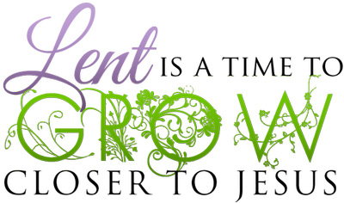

MISSION/OUTREACH JANUARY 2024

- Ordered and received food from Blue Ridge Area Food Bank on January 8 and 18. Volunteers assembled 20 pantry boxes for each order.
- Maintained temperature logs for refrigerators and freezers.
- Food Bank held January 4, 11, 18 and 25.
- Purchased eggs, bread, and margarine for Food Bank weekly.
- Updated weekly shopping list for extra options.
- Completed pantry inventory and report: Served 130 individuals and 44 households.
- Collecting chicken noddle soup for Food Bank.
- Renewed, signed and submitted contract with BRAFB for 2024. --Cynthia Hoover, Mission Chair

SUGGESTION FOR MARCH MISSION ITEMS:

FOOD BANK – CHICKEN SOUP
(Use your imagination!)

A PRAYER FOR EASTER
(Author Unknown)

Draw Us Forth

Draw us forth, God of all creation.
Draw us forward and away from limited certainty
into the immense world of your love.
Give us the capacity to even for a moment
taste the richness of the feast you give us.
Give us the peace to live with uncertainty,
with questions,
with doubts.
Help us to experience the resurrection anew
with open wonder and an increasing ability
to see you in the people of Easter.

Restoring Hope, Feeding the Hungry, Empowering the Oppressed

One Great Hour of Sharing Offering
Easter Sunday, March 31, 2024

Each gift to One Great Hour of Sharing supports efforts to relieve hunger through the Presbyterian Hunger Program, promote development through the Presbyterian Committee on Self-Development of People, and assist in areas of disaster through Presbyterian Disaster Assistance.

$3.1 million granted by PDA in the U.S. and 35 countries
90 grants impacting 22 countries given by PHP
Over 55,000 pounds of seeds and seedlings distributed for farming
228,318 Gift of the Heart Kits and Blankets distributed
291 certified PC(USA) Earth Care congregations helped care for creation
875 chickens distributed in Guatemala and Columbia
$5,500 grant helped small farmers in South Sudan
105 women became self-employed in Malawi
152 people won their land back in Sri Lanka
872 Presbyterian congregations purchased eco-palms or sustainable forestry and livelihoods.

This Offering has a sixty-nine-year history as an ecumenical endeavor that now involves nine denominations and Church World Service. Envelopes will be available in the Sanctuary or contributions may be dropped off in the Church Office.

Remember to bring flowers Easter Morning for the Cross

LENTEN SCHEDULE

Lenten Luncheons in the Barksdale Room at noon
followed by Bible Study on the book of James, led by Rev. Pettit
Wednesdays March 6, 13 and 20

Maundy Thursday, March 28
Simple Meal with Communion at noon in the Barksdale Room

Easter Sunday, March 31
Traditional Worship Service at 11:00 in the Sanctuary

Liturgists

March 3 Charles Simpkins

March 10 Betsy Ruehl

March 17 Bill Pannill

March 24 Jo Pannill

March 31 Cynthia Hoover

REV PETTIT’S WORK SCHEDULE

Monday – work at home
Tuesday and Thursday– onsite First Pres
Wednesday – visitation
Friday – off

March 8 Holly Bennett
March 14 Olive Prettyman
March 19 Art Johnson
March 20 Pam Hammock
March 22 Buck Hartley Patrick Pettit
March 25 Linda Sandquist

March Calendar
Friday, March 1
12:15pm First Friday Organ Concert
Sunday, March 3
11 am Worship Service
Monday, March 4
1 pm Bible Study Smyrna Presbyterian
Tuesday, March 5
6-10 pm Waynesboro Symphony Practice, Fellowship Hall
Wednesday, March 6
Noon Lenten Bible Study, Barksdale Room
Thursday, March 7
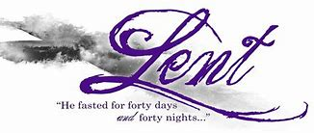
6-7:30 pm Food Bank
Sunday, March 10
11 am Worship Service
3-5 pm Chamber Concert
Monday, March 11
1 pm Bible Study Second Presbyterian
Tuesday, March 12
2:30 pm Session Room 212
6-10 pm Waynesboro Symphony Practice, Fellowship Hall
Wednesday, March 13
Noon Lenten Bible Study, Barksdale Room
Thursday, March 14
2-4pm Food Bank
Sunday, March 17
11am Worship Service
Monday, March 18
1 pm Bible Study Hermitage Presbyterian
Tuesday, March 19
6-10pm Waynesboro Symphony Fellowship Hall
Wednesday, March 20
Noon Lenten Bible Study, Barksdale Room
Thursday, March 21
2-4 pm Food Bank
Sunday, March 24 Palm Sunday
11 am Worship Service
Monday, March 25
1pm Bible Study Finley Memorial Presbyterian
Tuesday, March 26
6-10 pm Waynesboro Symphony, Fellowship Hall
Wednesday, March 27
Noon Lenten Bible Study, Barksdale Room
Thursday, March 28 Maundy Thursday
noon Service with light lunch
2-4 pm Food Bank
6-10 pm Waynesboro Symphony, Fellowship Hall
Friday, March 29 Good Friday
Sunday, March 31 Easter
11 am Worship Service

Mailing Address
P. O. Box 877
Waynesboro, VA 22980
Phone 540.949.8366
Fax 540.949.5750
E-mail: church@firstpresway.com
Website: www.firstpresway.org

Interim Pastor Music Director
Rev. Patrick S. Pettit Mr. Roger Daggy
pspettit@gmail.com firstpreswaymusic@gmail.com

Administrative Assistant Music Assistant
Mrs. Colleen Cash Mrs. Kimberlea Daggy
ccash@firstpresway.com firstpreswaymusic@gmail.com

Preschool Director Audio/Video Technician
Ms. Tami Hemp Mr. Craig Cavenaugh
preschool@firstpresway.com Mrs Cindy Cavenaugh

Maintenance Technician
Mr. Michael Griffith

