EASTER SUNDAY March 31, 2024

WELCOME & ANNOUNCEMENTS

INTROIT

CALL TO WORSHIP

MORNING PRAYER
OPENING HYMN

CALL TO CONFESSION
.

SILENT PRAYER

ASSURANCE OF PARDON

*GLORIA PATRI 581 Greatorex

SCRIPTURE READING

ANTHEM

SERMON Patrick S Pettit, Interim Pastor

*AFFIRMATION OF FAITH Apostles’ Creed p.35

PRAYERS OF THE PEOPLE & THE LORD’S PRAYER

* HYMN
*CHARGE and BENEDICTION

POSTLUDE Fanfare Soler (1729-1773)

*Please stand if able
Hearing devices are available for your convenience.
Please be aware that they do not function until after the service begins.

Today’s link is:

Shenandoah Nursing Home: Nancy Garber

Home: Mary Ultee, Mary Ann Maupin, Linda Sandquist, Mike &
Cathy Cunningham, Warner Sandquist

Friends and Family: Bill Bromley, Jean Custen, Jerry Hughes, Sally McNeel,
Bill Metzel (Joyce Tipton), Col. Stuart Roberts (Mark Henderson),
Paul Watts, Kathleen Clements, Carolyn Williams (Colleen Cash), Betsy Boswell (Curry)

Military: Carson Craig

Monday, March 25, Better Together Bible study continues at Finley Memorial Presbyterian Church in Stuarts Draft at 1pm.

Maundy Thursday Service March 28, noon in Barksdale Room; lite lunch provided.

Please support the One Great Hour of Sharing Offering to restore hope, feed the hungry and empower the oppressed in the world.

Remember to bring flowers next Sunday for the Cross

FIRST PRESBYTERIAN CHURCH
WAYNESBORO, VIRGINIA

A community-minded congregation living out the love of Christ as we serve one another with humility, gentleness, and patience through God’s grace.

March 24, 2024 11:00 AM

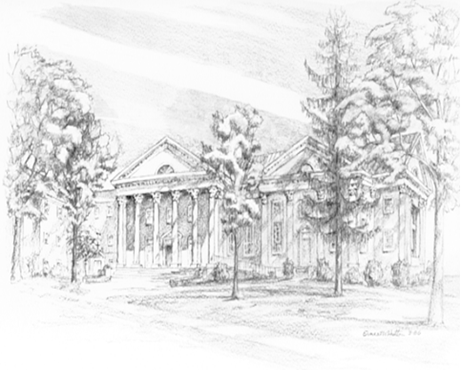

P.O. Box 877
249 South Wayne Avenue
Waynesboro, Virginia
(540) 949-8366
Church Website: www.firstpresway.org
Preschool Website: www.firstprespre.org
Email: church@firstpresway.com

