FIFTH SUNDAY OF EASTER April 28, 2024

PRELUDE Allemande and Courante Mattheson (1681-1764)

WELCOME & ANNOUNCEMENTS

INTROIT Alleluia Milburn (b. 1963)

CALL TO WORSHIP
Leader: We gather to praise and worship God, the one who created us for love.
People: We gather to worship the true vine, the one in whose love we abide.
Leader: The Lord is risen!
People: Christ is risen indeed!
Leader: Let us worship God.

MORNING PRAYER

*OPENING HYMN 238 Thine is the Glory Judas Maccabaeus

PRAYER OF CONFESSION
Gracious Lord, in your grace we find strength, and in your love, we are set free. But we do not live as people who have been freed. We act as if the resurrection never happened, desperately searching for the peace and security only found in you. Forgive us, Lord, this and all our sin. Teach us to abide in you, and rejoice in your salvation, through the risen Christ.

SILENT PRAYER

ASSURANCE OF PARDON

*GLORIA PATRI 581 Greatorex

FIRST SCRIPTURE READING Psalm 22:25-31 p. 435

SPECIAL MUSIC Sarabande Grieg (1843-1907)

SECOND SCRIPTURE READING John 15:1-8 p. 878

SERMON Opportunity Patrick S Pettit, Interim Pastor

*AFFIRMATION OF FAITH Apostles’ Creed p.35

PRAYERS OF THE PEOPLE & THE LORD’S PRAYER

*HYMN 248 Christ is Risen! Shout Hosanna! Hymn to Joy

*CHARGE and BENEDICTION

POSTLUDE Gigue Mattheson

*Please stand if able
Hearing devices are available for your convenience.
Please be aware that they do not function until after the service begins.

Today’s link is:

This week, First Presbyterian Church hosts two free concerts. This afternoon at 3, the Waynesboro Symphony Orchestra will play their final concert of the season. FPC Music Director Roger Daggy will play our mighty 1893 Woodberry and Harris pipe organ in Ottorino Respighi's Pines of Rome. Roger will also play a First Friday program on 3 May at 12:15, followed by a delicious light luncheon, generously provided by FPC. The programs, and the luncheon, are free, and all are cordially invited!

Shenandoah Nursing Home: Nancy Garber

Home: Mary Ultee, Mary Ann Maupin, Linda Sandquist, Mike &
Cathy Cunningham, Warner Sandquist

Friends and Family: Bill Bromley, Jean Custen, Jerry Hughes, Sally McNeel,
Bill Metzel (Joyce Tipton), Col. Stuart Roberts (Mark Henderson),
Paul Watts, Kathleen Clements, Carolyn Hedrick-Williams (Colleen Cash), Betsy Boswell (Curry)

Military: Carson Craig

Scholarship forms are online and available in the office.

Better Together Bible Study will meet on Monday, April 29 at 1pm at Room 212 at FPC.

Food Bank needs chicken noodle soup

FIRST PRESBYTERIAN CHURCH
WAYNESBORO, VIRGINIA

A community-minded congregation living out the love of Christ as we serve one another with humility, gentleness, and patience through God’s grace.

April 28, 2024 11:00 AM

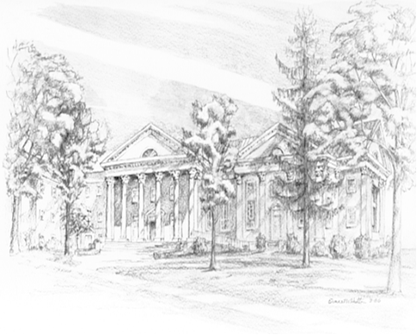

P.O. Box 877
249 South Wayne Avenue
Waynesboro, Virginia
(540) 949-8366
Church Website: www.firstpresway.org
Preschool Website: www.firstprespre.org
Email: church@firstpresway.com

