DAY OF PENTECOST May 19, 2024

PRELUDE Come, Holy Spirit BuxWV 199 Buxtehude (1637-1707)

WELCOME & ANNOUNCEMENTS

INTROIT Spirit of the Living God Iverson (1890-1977)

CALL TO WORSHIP
Acts 2:1-11 The Coming of the Holy Spirit

The Proclamation of the Pentecost.
2 When the day of Pentecost had come, they were all together in one place. 2 And suddenly from heaven there came a sound like the rush of a violent wind, and it filled the entire house where they were sitting. 3 Divided tongues, as of fire, appeared among them, and a tongue rested on each of them. 4 All of them were filled with the Holy Spirit and began to speak in other languages, as the Spirit gave them ability. 5 Now there were devout Jews from every nation under heaven living in Jerusalem. 6 And at this sound the crowd gathered and was bewildered, because each one heard them speaking in the native language of each. 7 Amazed and astonished, they asked, “Are not all these who are speaking Galileans? 8 And how is it that we hear, each of us, in our own native language? 9 Parthians, Medes, Elamites, and residents of Mesopotamia, Judea and Cappadocia, Pontus and Asia, 10 Phrygia and Pamphylia, Egypt and the parts of Libya belonging to Cyrene, and visitors from Rome, both Jews and proselytes, 11 Cretans and Arabs—in our own languages we hear them speaking about God’s deeds of power.”
Leader: Let us worship God.

MORNING PRAYER

OPENING HYMN 289 On Pentecost They Gathered Munich

CALL TO CONFESSION
O God, you are doing a new thing, actively moving in the world; but we act as if your stories have all been written. Your Spirit filled the church on Pentecost; but we remain hidden, fearing the unknown. Forgive us, Lord, this and all our sin. Wash us in your grace, and kindle your fire within us, as we venture out to follow your spirit.

SILENT PRAYER

ASSURANCE OF PARDON

*GLORIA PATRI 581 Greatorex

FIRST SCRIPTURE READING Ezekiel 37:1-14 p. 704

ANTHEM We Are One in the Spirit Scholtes (1938-2009)
(Text can be found in hymn 300)

SECOND SCRIPTURE READING Romans 8:22-27 p. 918

SERMON Hope. Patrick Pettit, Interim Pastor

*AFFIRMATION OF FAITH Apostles’ Creed p.35

PRAYERS OF THE PEOPLE & THE LORD’S PRAYER

* HYMN 298 Lord, You Give the Great Commission Abbot’s Leigh
(stanzas 1, 2, 5)

*CHARGE and BENEDICTION

POSTLUDE Come, Holy Spirit BWV 651 Bach (1685-1750)

*Please stand if able

Hearing devices are available for your convenience.
Please be aware that they do not function until after the service begins.

Today’s link is: https://www.youtube.com/watch?v=Z_EZ_ymStRw

Shenandoah Nursing Home: Nancy Garber

Home: Mary Ultee, Mary Ann Maupin, Linda Sandquist, Mike &
Cathy Cunningham, Warner Sandquist

Friends and Family: Bill Bromley, Jean Custen, Jerry Hughes, Sally McNeel,
Bill Metzel (Joyce Tipton), Col. Stuart Roberts (Mark Henderson),
Paul Watts, Kathleen Clements, Carolyn Williams (Colleen Cash), Betsy Boswell (Curry)

Military: Carson Craig

Monday, May 20, Better Together Bible study continues at Hermitage Presbyterian in Waynesboro at 1pm.

Do you enjoy reading?
Do you find discussions on books interesting?
Do you find kinship with others that love to read?
Do you remember Faith and Fiction?

If so, please consider joining a founding meeting for a book club here at First Presbyterian Church.

Formational meeting to be held on May 20 at 2PM in the parlor of First Presbyterian Church.
Questions, call Cynthia Hoover 540-255-9616.

FIRST PRESBYTERIAN CHURCH
WAYNESBORO, VIRGINIA

A community-minded congregation living out the love of Christ as we serve one another with humility, gentleness, and patience through God’s grace.

May 19, 2024 11:00 AM

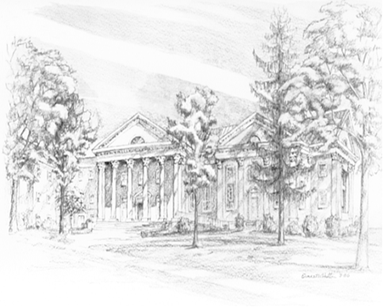

P.O. Box 877
249 South Wayne Avenue
Waynesboro, Virginia
(540) 949-8366
Church Website: www.firstpresway.org
Preschool Website: www.firstprespre.org
Email: church@firstpresway.com

