Sixth Sunday of Easter May 5, 2024

PRELUDE Concerto in a, BWV 593 Adagio Vivaldi (1678-1741)
Bach (1685-1750)

WELCOME & ANNOUNCEMENTS

INTROIT What Does the Lord Require Routley (1917-1982)

CALL TO WORSHIP
Leader: We gather as people of the resurrection!
People: We rejoice that life is stronger than death.
Leader: We worship as children of God, loved and claimed by Almighty God! The Lord is risen!
People: Christ is risen indeed!
Leader: Let us worship God.

MORNING PRAYER

OPENING HYMN 509 All Who Hunger, Gather Gladly Holy Manna

SILENT PRAYER

CONFESSION OF FAITH
O God, whose love knows no bounds, we fail to reflect your loving kindness. We turn away from the goodness of your love, and stumble over the gift of your grace. Certain that we are alone in the chaos of this world, we give in to despair. Forgive us, Lord, this and all our sin. In our weakness, lift us up and shower us with your love, for the sake of Christ, your love incarnate.

ASSURANCE OF PARDON

*GLORIA PATRI 581 Greatorex

FIRST SCRIPTURE READING Psalm 98 p. 480

ANTHEM Loaves Were Broken, Words Were Spoken Anonymous
(Text can be found in hymn 498)

SECOND SCRIPTURE READING Acts: 10:44-48 p. 895

SERMON Baptism Patrick S Pettit, Interim Pastor

*AFFIRMATION OF FAITH Apostles’ Creed p.35

THE LORD’S SUPPER
Invitation
Great Thanksgiving
Communion of the People

* HYMN 282 Come Down, O Love Divine Down Ampney

*CHARGE and BENEDICTION

POSTLUDE Concerto in a, BWV 593: Allegro Vivaldi/Bach

*Please stand if able

Hearing devices are available for your convenience.
Please be aware that they do not function until after the service begins.

Today’s link is: https://www.youtube.com/watch?v=QW6HlWu3KEc

Shenandoah Nursing Home: Nancy Garber

Home: Mary Ultee, Mary Ann Maupin, Linda Sandquist, Mike &
Cathy Cunningham, Warner Sandquist

Friends and Family: Bill Bromley, Jean Custen, Jerry Hughes, Sally McNeel,
Bill Metzel (Joyce Tipton), Col. Stuart Roberts (Mark Henderson),
Paul Watts, Kathleen Clements, Carolyn Williams (Colleen Cash),
Betsy Boswell (Curry)

Military: Carson Craig

Better Together Bible study continues, Smyrna Presbyterian Church,
Waynesboro at 1pm Monday, May 6.

FIRST PRESBYTERIAN CHURCH
WAYNESBORO, VIRGINIA

A community-minded congregation living out the love of Christ as we serve one another with humility, gentleness, and patience through God’s grace.

May 5, 2024 11:00 AM

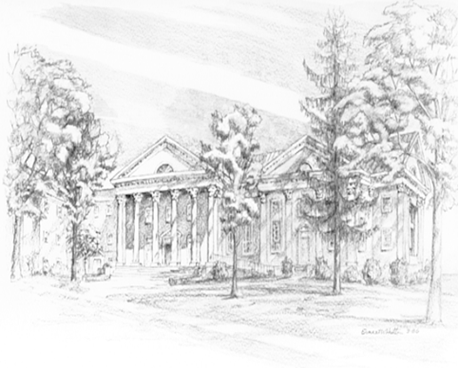

P.O. Box 877
249 South Wayne Avenue
Waynesboro, Virginia
(540) 949-8366
Church Website: www.firstpresway.org
Preschool Website: www.firstprespre.org
Email: church@firstpresway.com

