First Presbyterian Church, Waynesboro, VA

July 2024, Volume 62, Issue 7
First Presbyterian Church of Waynesboro is a community-minded
congregation living out the love of Christ as we serve one another with
humility, gentleness, and patience through God’s grace.

15 Toward evening the disciples approached him. “We’re out in the country and it’s getting
late. Dismiss the people so they can go to the villages and get some supper.”
16 But Jesus said, “There is no need to dismiss them. You give them supper.”
17 “All we have are five loaves of bread and two fish,” they said.
18-21 Jesus said, “Bring them here.” Then he had the people sit on the grass. He took the
five loaves and two fish, lifted his face to heaven in prayer, blessed, broke, and gave the
bread to the disciples. The disciples then gave the food to the congregation. They all ate
their fill. They gathered twelve baskets of leftovers. About five thousand were fed.
Matthew 14:15-21

When in doubt, always quote scripture. This is not one of the rules I have painstakingly collected over the years,
but perhaps it should be. Last month, we began with insights into basketball; for May, we are diving back into
the New Testament for illumination.
We are conditioned, I think, to look at the miraculous as magical, the theological equivalent of alchemy. Just as
the medieval alchemist sought to turn lead into gold, and thus enrich themselves without labor, we look at
miracles at least in part, as labor-saving plot devices: healing without the effort of treatment; gifts that eliminate
the need for impossible choices; rescue that makes of us passive recipients of grace. But, in the words of yet
another of my rules, God is not a magician; what we call miracles are signs of God at work in our midst - and
God hates to work alone.

In the feeding of the multitude, the disciples recognize a need - the crowd is getting hungry and the day is
mostly gone. This is a real problem, they know, but the best they can come up with is to send the crowds
back to town, where they might find some supper. But Jesus has something else in mind; not just pushing
the problem down the road, but actually doing something about the hunger of the people. He asks what
food is available, and is told, 5 rolls and 2 cooked fish - the lunch of a well-prepared young man. Jesus
then does the miraculous, but the miracle isn&#39;t magic- Jesus does not make everyone feel full, or have
manna fall from the heavens. The miracle happens through the work of the disciples. It is the disciples
who organize the people, getting them to sit down in an orderly fashion; they who oversee the distribution
of the loaves and fishes, making sure everyone is fed; even making sure the leftovers are collected. And
that, friends, leads us to Rule #10:

THE COLUMNS

First Presbyterian Church is delighted to announce a new season of ministry in Waynesboro. On July 15, the congregation welcomes the Rev. Samantha Coggins as its next pastor. A native of Fredericksburg, Rev. Coggins received her undergraduate degree at the University of Virginia, and her Masters of Divinity degree at Pittsburgh Theological Seminary in Pittsburgh, Pennsylvania. She is married to Joel, a book designer and production manager for UVA Press, and they have one daughter.

"I see God at work in FPC's ministries of compassion and care, like the food pantry, the preschool, and the 'Better Together' group of Presbyterians in Waynesboro." said Coggins. " I'm thrilled to join that work as pastor, alongside the congregation."

While First Presbyterian Church was working through their pastoral transition, the Fishburne Military School (FMS) began looking to the future with the creation of a new Campus Master Plan. More than simply neighbors, church and school have enjoyed more than a century of common history, cooperation, and partnership in the Waynesboro community.

At this decisive moment, individuals committed to the health and vitality of both institutions began to consider the long terms needs of both church and school, and where those needs might intersect. For more than a year, discussions were held regarding the benefits and possibilities of closer relationship between the two institutions. In the end, an innovative plan was conceived and approved by Shenandoah Presbytery at its May 14th meeting.

The agreement allows First Presbyterian Church to deed its building and grounds to Fishburne in return for its continued use of that property for as long as the church remains an active congregation of the Presbyterian Church (U.S.A.). The property will maintain the character, history, and utility it has represented since the church moved to Wayne Avenue in 1911, while opening the education wing to new opportunities for Fishburne.

"Our Preschool and Food Bank will continue to serve the Waynesboro area, and our relationship with the Waynesboro Symphony remains unchanged," outgoing Interim Pastor Patrick Pettit said. "Our agreement with Fishburne will burnish the legacy of both institutions in the years to come."

“Shenandoah Presbytery applauds the creative and faithful relationship between Fishburne Military School and First Presbyterian Church, Waynesboro," the Reverend Doctor Nancy Meehan Yao, Associate General Presbyter commented. "In a time when many congregations are seeing a change in ministry context, First Waynesboro has discerned a way to be both good stewards of all that has been entrusted to them, and to join with the community in building lives and creating a path forward. Their work is a model for many other congregations, both here in Shenandoah, and in the larger world.”

Samantha Coggins, Pastor
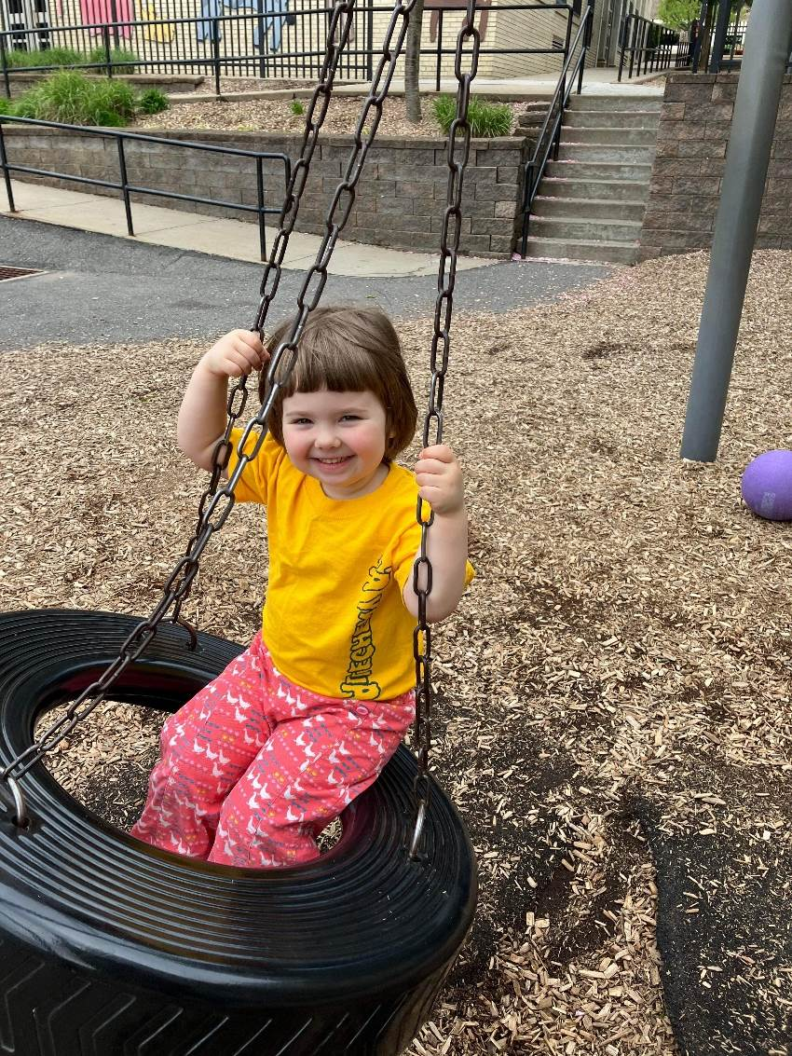
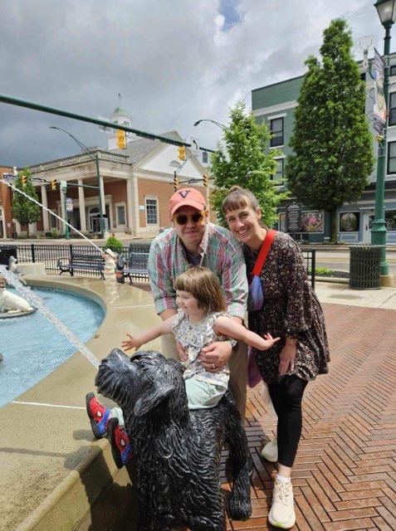
Samantha Coggins (née Lowery) is a native of Fredericksburg, VA. She grew up attending the Presbyterian Church of Fredericksburg, and did her undergraduate studies at the University of Virginia. She went to seminary in Pittsburgh Theological Seminary in Pittsburgh, PA. She was pandemic-ordained in 2021 – shortly after being pandemic-pregnant in 2020 – in nearby Morgantown, WV. There, as a brand new mother, she began her ministry as a campus pastor to college students. For the past two years, Samantha has served as Associate Pastor at John McMillan Presbyterian Church in Pittsburgh. She is married to Joel, a book designer and production manager for UVA Press. They have one 3-year-old daughter, Cosette (koh-sette), whom they call ‘Cozy’ for short. Cozy loves books, riding her bike, and negotiating with her parents about anything and everything. Samantha is excited to be making a home in central Virginia, albeit this time as a Presbyterian minister, rather than a bright-eyed first-year living in Watson dorm. Congregational care is the crux of Samantha’s ministry. For her, preaching and teaching flow alongside strong pastoral care, whether that care takes place in someone’s home, a hospital room, or in a 5-minute conversation after worship on Sunday. As she and her family get settled in the Waynesboro area, Samantha rests assured that the Spirit is already at work in First Presbyterian Church’s small-but-mighty community of faith

KINDNESS

David Hull, in an article for the Center for Healthy Churches/Pneumatrix, reminds us about kindness.

Not the “Midwestern nice,” sort, nor even the “bless your heart” version, either of which don’t really feel—or intend, necessarily—to be nice or kind.

Rather, Hull reminds us that kindness—chrestotes, in Biblical Greek, appears in three of Paul’s writings about behavior: in the list of the fruit of the Spirit, (Galatians 5: 22-23), in Galatians, we are to clothe ourselves in kindness (Gal 3: 12-17), and in 2 Corinthians 6, where Paul puts forward himself as an example of kindness. Not only that, but in Ephesians 2, we are told that God’s grace given to us (and to the world) in Jesus Christ is kindness.

Hearing that, I would hope that we would be spurred on to kindness in all our interactions. We know that many people are turned away from church because they did not experience true loving kindness in a congregation. Some hear “unkind” words from some Christians on social media, and attribute it to all congregations, whether or not we have earned it.

Now, kindness does not mean we paper over problems, to avoid difficult conversations. And it does not mean that we have conformity on all issues.

But Jesus, in Mark 3, talks about both a house divided against itself, and what true kinship involves.

A house divided against itself cannot stand (Mark 3: 25) and the true family of Jesus are those who do the will of God. (3: 35). We know there have been divisions in the church over the past 4 years of covid (and, really, much longer than that). As we continue in a fraught social climate, as we live together as those who follow Jesus, let us be kind, even in our disagreement, let us pursue doing the will of God in the grace, the kindness, that is given to us in Jesus Christ.

“You will never look into the eyes of someone God does not love.

Always be kind.” “They will know we are Christians by our love.”

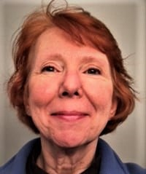
Rev.—Nancy Meehan Yao
Associate General Presbyter

FPC TIMELINE

February 3, 2020 – Pastoral relationship with Rev. George Chapman dissolved
March 18, 2020 – Last in-person Worship Service due to the pandemic.
Session continued to meet via Zoom; Food Bank continued without interruption
May 2020 – Online services spearheaded by Rev. April Cranford with FPC participation
July 2020 – Online services from our Sanctuary
July 2020 – Preschool reopened with Summer Camp
August 20 – CAT Study reviewed with Session – “We are a clergy centered church. Our strengths are Worship and Music, Hospitality and Mission.”
September 1, 2020 – Interim Pastor Patrick Pettit began his ministry
September 2020 – Approval of $67,100 for replacement of boiler and feed water tank
April 4, 2021 – In-person services resumed in our Sanctuary
July 2021 – Size of Session reduced from 9 to 6
September 2021 – Bat infestation problem resolved
September 2021 – Rev. Pettit’s contract renewed
November 2021 – Series of 2 meetings held with congregation – 1 on Finances, 2nd on Direction of mission and ministry for the future
January 2022 – Major concerns posed to Session: What is opportunity to worship in the sanctuary worth to our dwindling congregation? There is little energy among church members. Maintenance costs are exorbitant in our aging facility. Rumor around town that FPC is for sale.
February 2022 – At Annual Congregational Meeting options for next steps discussed: 1) Seek an installed pastor (full or part time), 2) Seek a supply pastor (full or part time), 3) Ask presbytery to dissolve congregation immediately, 4) Create a legacy plan.
March 2022 – Inaugural meeting of Presbyterians Better Together
March 2022 – Rescinded COVID-19 mask mandate on church property
July 2022 – At a Congregational Meeting a presentation was made outlining negotiation between FPC and Fishburne regarding the transfer of property to the school. This includes a provision that the church can continue to work and worship as long as it remains a congregation of the PC(USA).
September 2022 – Rev. Pettit’s contract renewed
March 2023 – Approved contract with Riddleberger Bros., Inc. to replace HVAC Equipment.
April 2023 – At a Congregational Meeting approved proceeding with the Sale of First Presbyterian Church to Fishburne Military School.
June 2023 – Approval of $485,000 to replace the sanctuary roof
September 2023 – Rev. Pettit’s contract renewed.
December 2023 – Pastoral Search Committee formed: Cynthia Hoover, Bob Miller & Bill Pannill
February 2024 - Ministry Discernment Profile (form seeking pastor) available.
March 2024 – Fishburne Military School shared plans for new Middle School in Educational Building
June 2024 – FPC incorporated.
June 2024 – Presbytery of Shenandoah approved sale of property from FPC to Fishburne Military School
June 2024 – Session approved contracts of Rev. Samantha Coggins as Supply Pastor
July 2024 – Supply Pastor Rev. Samantha Coggins begins her ministry

REV. PATRICK PETTIT
Interim Pastor FPC 2021-2024

We bid fond “adieu” to our Interim Pastor Patrick Pettit. We have truly walked through “the shadows” these past four years. We’ve shared joys, but also grief and sorrows on both sides of the pulpit. We have doggedly put one foot forward, one after another, searching for the future of FPC. Patrick shared his philosophy of interim ministry at the very beginning: He was not a temporary caretaker but a diagnostician to help our congregation discern who they are and what kind of pastoral leadership they need.

Patrick has a set of rules – interesting, thought-provoking and hardly the norm - some of which are listed
below:
- Patrick’s Rule #1 – It’s Never about….What it’s ABOUT.
(A new command I give you: Love one another. By this everyone will know that you are my disciples if you love one another.). John 13
- Patrick’s Rule #2 – Process is our friend.
Our Resources: Energy, Intelligence, Imagination, Love and Stewardship.
- Patrick’s Rule #15 – Failure is NOT an option. It is a FACT.
(The highest MLP lifetime batting average is .336….which means Ty Cobb hit safely less than 40% of the time.)
- Patrick’s Rule #16 – Grace transforms failure into experimentation.
(“I’ve not failed. I’ve just found 10,000 ways that won’t work.” Thomas Edison)
- Patrick’s Rule #10 – Look for miracles….and plan to work.
- Patrick’s Rule #13 – Church is not something we attend….It’s something we are.
(“Now you are the body of Christ and individually members of it.” I Corinthians 12)

Patrick had led through our four years of discernment step by step, unsure of the outcome, but knowing that what was ahead would be positive and according to God’s will. We thank him for his steadfastness and positivity in a world of disruption and chaos. He is truly a man of faith.
--Betsy Ruehl
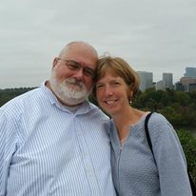

MUSIC NOTES FOR JULY

The only constant is change. We are reminded of that axiom during this transitional time at First Presbyterian Church. We wish Rev. Patrick Pettitt a fond farewell. He was an inspirational guide through the many years process of finding a new pastor. His gifts of interpreting Scripture – and clarion singing – will be sorely missed. That said, we are excited to welcome Rev. Samantha Coggins this month! The guiding hand of the Lord brought her to FPC, and we look forward to sharing the Good News together.

During the summer, various musicians share their talents at FPC. In June, Maximilian Daggy joined Roger on Father’s Day for the anthem. The following week, Patrick Fitzgibbon played guitar exquisitely for both the introit and special music. And June concluded with a Better Together duet! FPC’s Jean Hashagen and Westminster’s Mary Smith joined forces to sing at both churches at the end of the month.

July brings more guest musicians to First Pres. The Heifetz International Music Institute in Staunton brings young musicians to the valley every summer, and FPC is fortunate to provide an opportunity for a string quartet play during a service. One such ensemble will play on 7 July. The following week, Diane Kingsbury will play the organ, as we will be away, celebrating our wedding anniversary. (Many of you may recall that we were married at FPC in 1988.) And on 21 July, we will welcome our new pastor, Rev. Samantha Coggins, to FPC!

May your summer be filled with blessings and
love –

Roger and Kimberlea Daggy

FIRST FRIDAY ORGAN CONCERTS
will resume in September

SESSION HIGHLIGHTS

Session held a Stated Meeting on June 13, 2024
- Commissioner Mike Cunningham reported on the Shenandoah Presbytery Meeting at Westminster PC in Waynesboro on May 13, 2024.
- Rev. Pettit gave 30 days notice of termination of his contract with FPC. He has two weeks Study Leave and two weeks Vacation. His last day will be Sunday, June 30.
- Cynthia Hoover presented Mission/Food Bank Report (printed elsewhere).
- A major power problem was thwarted by Dominion Power at the Pole.
- The old Trustees have signed the deed to transfer property to Fishburne.
- Bob Miller has agreed to serve as Elder Class of 2027.
- Rev. Pettit submitted the docket for the June 23 Congregational Meeting.
- All Session meetings are opened and closed with prayer. --Betsy Ruehl, Clerk of Session

SUMMARY OF CONGREGATIONAL MEETING

A Congregational Meeting was held on Sunday, June 30, 2024.
- Bob Miller was elected Ruling Elder, Class of 2027.
- Copies of “The Overview of Funds of FPC, Waynesboro, presently invested in conjunction with Shenandoah Presbytery Corp.” and the “Treasurer’s Report as of June 2024” were distributed.
- An informational sheet about incorporation was distributed. On 4/18/24, FPC received a Certificate of Incorporation as a non-stock, not-for-profit corporation. Now FPC is in compliance with the Book of Order G-4.0101.
- Sale of FPC to Fishburne: FPC will be allowed to function as long as it remains a worshipping community in the PC(USA). Opening of a Fishburne Middle School, proposed to be held on the second floor of the Educational Bldg., has been postponed until 2025. The long-term plan is to educate non-military day students, grades 6-8, in our facility.
- A short biography of Rev. Samantha Coggins, including pictures of her family, was distributed. Congregational Care is the crux of her ministry. Her first day on site will be July 15, 2024.
- The meeting was opened and closed with prayer. A quorum was present.
--Betsy Ruehl, Secretary

CALLED SESSION MEETING

Session held a Called Meeting on June 2, 2024, for the purposes of approving the Contract of a Supply Pastor and to set the date for a Congregational Meeting.
Session approved the contracts of Samantha Coggins as Supply Pastor and set a Congregational Meeting for June 23, 2024. In addition, Session approved a 2024-2025 Preschool Scholarship for 3-year-old daughter Cosette.
The meeting was opened and closed with prayer.
--Betsy Ruehl, Clerk of Session

MISSION/OUTREACH MAY 2024

- Ordered and received food from Blue Ridge Area Food Bank May 7 and 14. Volunteers assembled 20 pantry boxes for each order.
- Maintained temperature logs for refrigerators and freezers.
- Food Bank held May 2, 9, 16 and 23.
- Purchased bread and margarine for Food Bank weekly. Eggs donated by Central United Methodist Church in Staunton.
- Updated weekly shopping list for extra options.
- Completed pantry inventory and report: Served 102 individuals and 39 households.
- Collected cereal and egg cartons from congregation for May.
- Disciples’ Kitchen May 16 - served 36 meals. Future Disciples’ Kitchens on August 1 and September 30.
- Completed USDA Training June 7

. --Cynthia Hoover, Mission Chair

NEEDED:

FOOD BANK – CEREAL

Preschool News!!

It is so hard to believe that we have already finished up our first month of summer camp and are heading into our final month. We have had so much fun learning about different things as well as meeting new friends. The school age summer camp class went on a field trip to the new Sunset Park in Waynesboro and had an amazing time. They got to go on a nature hike and spend time with friends. They experienced the scenery from atop the “mountain” and saw our school from afar!!
Our classrooms have been doing weekly themes and learning about different things, from Transportation to bugs and dinosaurs.
As we move into July, we look forward to more exciting moments and more field trips.

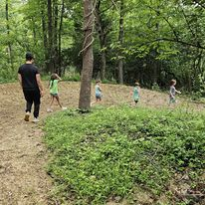
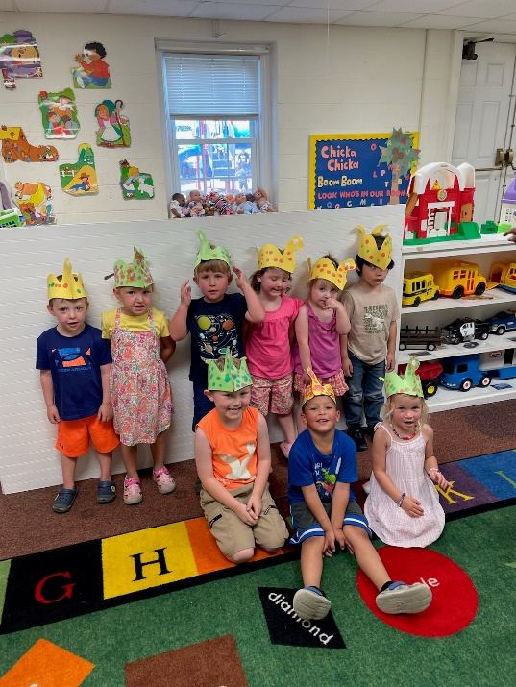
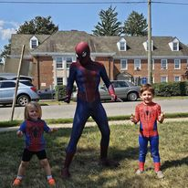

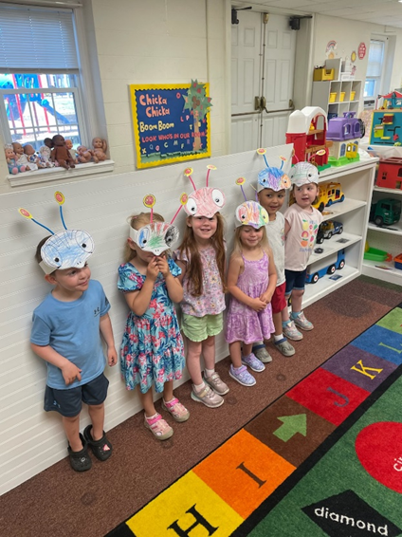
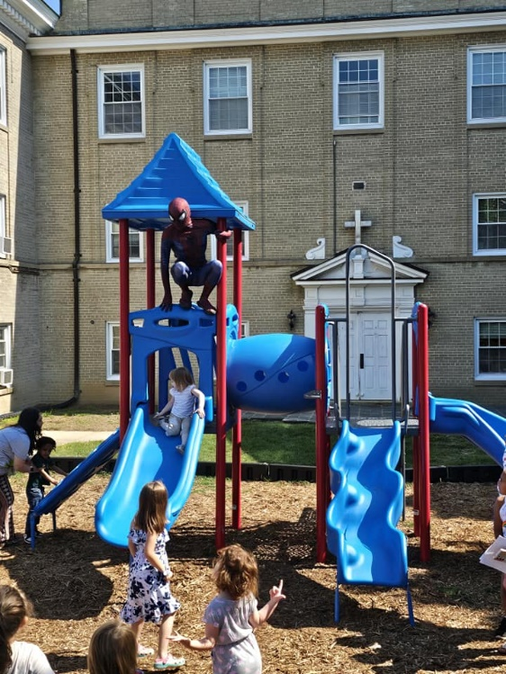

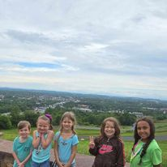

Liturgists
July 7 Betsy Ruehl

July 14 Jo Pannill

July 21 Bill Pannill

July 28 Jean Hashagen

BIRTHDAYS ANNIVERSARIES
4 - Mike Cunningham 7 - Don & Jeannie Hashagen
9 - Mary Ultee 7 - Randy & Nancy Hypes
18 - Earlene Templeman 17 - Roger & Kimberlea Daggy
21 - Ruth Quillen

July Calendar

Thursday, July 4 Holiday Office Closed
Sunday, July 7
11 am Worship Service
Thursday, June 11
2–4pm Food Bank
Sunday, July 9
11 am Worship Service
Thursday, July 18
2-4 pm Food Bank
Sunday, July 21
11am Worship Service
Thursday, July 25
6-7:30 pm Food Bank
Sunday, July 287
11 am Worship Service

Mailing Address
P. O. Box 877
Waynesboro, VA 22980
Phone 540.949.8366
Fax 540.949.5750
E-mail: church@firstpresway.com
Website: www.firstpresway.org

Interim Pastor Music Director
Rev. Patrick S. Pettit Mr. Roger Daggy
pspettit@gmail.com firstpreswaymusic@gmail.com

Administrative Assistant Music Associate
Mrs. Colleen Cash Mrs. Kimberlea Daggy
ccash@firstpresway.com firstpreswaymusic@gmail.com

Preschool Director Audio/Video Technician
Ms. Tami Hemp Mr. Craig Cavenaugh
preschool@firstpresway.com Mrs Cindy Cavenaugh

Maintenance Technician
Mr. Michael Griffith

- .

