SEVENTH SUNDAY after PENTECOST July 7, 2024

PRELUDE String Quartet in a Op. 31, no Mendelssohn (1809-1847)
Hudson Quartet

WELCOME & ANNOUNCEMENTS

INTROIT All My Hope in God is Founded Howells (1892-1983)

CALL TO WORSHIP
Leader: Rejoice in the Lord always, again I will say, Rejoice!
People: Today we choose to rejoice. Today we choose to worship and give thanks.
Leader: Seek the peace of God that will guard our hearts and minds in Christ Jesus.
People: Today we choose God’s peace; today we place our trust in God.
Leader: Turn our hearts away from the distractions and disappointments of life that will always flow in and flow out like the tide. Set your affections on things above and worship the Lord who loves and cares for us.
All: We come to worship God who alone is excellent and worthy of praise.

MORNING PRAYER

*OPENING HYMN 321 The Church’s One Foundation Aurelia

CALL TO CONFESSION
Most merciful God, we confess that we have sinned against you in thought, word, and deed, by what we have done, and by what we have left undone. We have not loved you wholeheartedly; we have not loved our neighbors as ourselves. We humbly repent. For the sake of your Son Jesus Christ, have mercy on us and forgive us; that we may delight in your will, and walk in your ways, to the glory of your Name. Amen.

SILENT PRAYER

ASSURANCE OF PARDON

*GLORIA PATRI 581 Greatorex

FIRST SCRIPTURE READING Psalm 16 p.430

SPECIAL MUSIC String Quartet in a, Op.13: II Mendelssohn

SECOND SCRIPTURE READING Philippians 4:4-7 p.955

SERMON Embracing Joy Leah Robinson, Guest

*AFFIRMATION OF FAITH Apostles’ Creed p.35

PRAYERS OF THE PEOPLE & THE LORD’S PRAYER

*HYMN 317 In Christ There Is No East or West McKee
*CHARGE and BENEDICTION

POSTLUDE Prelude in F, BWV 928 Bach (1685-1750)

*Please stand if able

Hearing devices are available for your convenience.
Please be aware that they do not function until after the service begins.

Today’s link is: https://www.youtube.com/watch?v=saL50CB1vDQ

This week marks our annual visit from musicians with the Heifetz International Music Institute in Staunton. Every summer, for six weeks, faculty from renowned conservatories and music schools train talented young musicians from around the globe, ages 13-30. This year, FPC welcomes the Hudson Quartet, with violinists John Heo (Northbrook, IL) and Cheuk Yin Fung (Hong Kong), violins; David Mar (Vancouver, BC), viola and Ching-Yu Tseng (Taiwan), cello.

Shenandoah Nursing Home: Nancy Garber

Home: Mary Ultee, Mary Ann Maupin, Linda Sandquist, Mike &
Cathy Cunningham, Warner Sandquist, Charles Simpkins

Friends and Family: Bill Bromley, Jean Custen, Jerry Hughes, Sally McNeel,
Col. Stuart Roberts (Mark Henderson),
Paul Watts, Kathleen Clements, Carolyn Hedrick-Williams (Colleen Cash),
Betsy Boswell (Curry)

Military: Carson Craig

We welcome Leah Robinson to our pulpit this morning. Leah serves as a Program Intern at Massanetta Springs. She will graduate from James Madison University this December with a BA Psychology, minoring in Religion as well as Women & Gender Studies. Outside of her education and work, Leah can be found playing pickleball, baking, and discerning where to attend seminary!

FIRST PRESBYTERIAN CHURCH
WAYNESBORO, VIRGINIA

A community-minded congregation living out the love of Christ as we serve one another with humility, gentleness, and patience through God’s grace.

July 7, 2024 11:00 AM

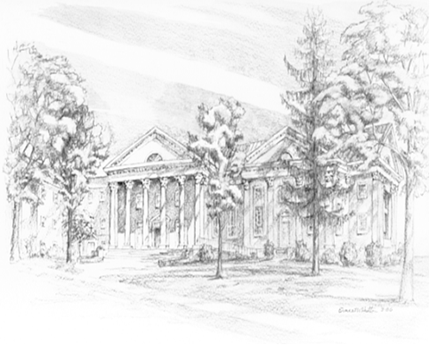

P.O. Box 877
249 South Wayne Avenue
Waynesboro, Virginia
(540) 949-8366
Church Website: www.firstpresway.org
Preschool Website: www.firstprespre.org
Email: church@firstpresway.com

