SECOND SUNDAY after PENTECOST June 2, 2024

PRELUDE Duo Clérambault (1676-1749)

WELCOME & ANNOUNCEMENTS

INTROIT Alleluia Milburn (b. 1963)

CALL TO WORSHIP

Leader: Out of the depths we cry to you, O Lord.
People: May Your ears be attentive to our cries.
Leader: Our souls wait for the Lord,
People: More than those who watch for the morning.
Leader: More than those who watch for the morning. Let us worship God.

MORNING PRAYER

*OPENING HYMN 51 Come, Behold! the feast of Heaven Llanfair

SILENT PRAYER

CONFESSION OF FAITH
Merciful God, you promise freedom from the chaos in our lives, yet we prefer confusion and turmoil. We seek to follow the whims of culture and credit popular wisdom. We are strict about the law when it benefits us, but quick to forget when it hinders our actions. Forgive us, Lord, this and all our sin. Transform our hearts, that we may know the fullness of life in Christ and his life may be made visible through us.

ASSURANCE OF PARDON

*GLORIA PATRI 581 Greatorex

FIRST SCRIPTURE READING Psalm 139:1-6. 13-18 p.503

SPECIAL MUSIC Trio Clérambault

SECOND SCRIPTURE READING Mark 2:13-28 p.813

SERMON Balancing old and new. Patrick S. Pettit, Interim Pastor

*AFFIRMATION OF FAITH Apostles’ Creed p.35

THE LORD’S SUPPER
Invitation
Great Thanksgiving
Communion of the People

* HYMN 739 O for a Closer Walk with God Caithness

*CHARGE and BENEDICTION

POSTLUDE Basse de Trompette Clérambault

*Please stand if able

Hearing devices are available for your convenience.
Please be aware that they do not function until after the service begins.

Today’s link is: https://www.youtube.com/watch?v=6cmQaxeU9YU

Shenandoah Nursing Home: Nancy Garber

Home: Mary Ultee, Mary Ann Maupin, Linda Sandquist, Mike &
Cathy Cunningham, Warner Sandquist

Friends and Family: Bill Bromley, Jean Custen, Jerry Hughes, Sally McNeel,
Bill Metzel (Joyce Tipton), Col. Stuart Roberts (Mark Henderson),
Paul Watts, Kathleen Clements, Carolyn Williams (Colleen Cash),
Betsy Boswell (Curry)

Military: Carson Craig

Following Worship service, Session will have a brief meeting.

FIRST FRIDAY CONCERT June 7,2024
with Lite Lunch 12:15pm

FIRST PRESBYTERIAN CHURCH
WAYNESBORO, VIRGINIA

A community-minded congregation living out the love of Christ as we serve one another with humility, gentleness, and patience through God’s grace.

June 2, 2024 11:00 AM

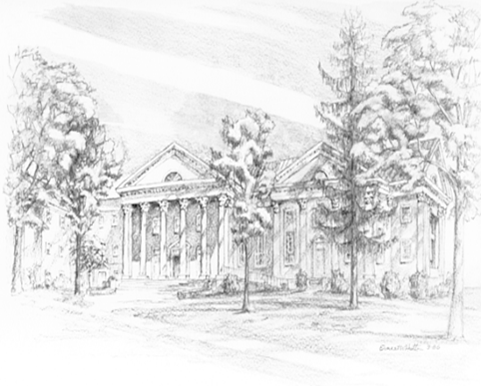

P.O. Box 877
249 South Wayne Avenue
Waynesboro, Virginia
(540) 949-8366
Church Website: www.firstpresway.org
Preschool Website: www.firstprespre.org
Email: church@firstpresway.com

