SIXTH SUNDAY after PENTECOST June 30, 2024

PRELUDE Prelude in A, BWV 536 Bach (1685-1750)

WELCOME & ANNOUNCEMENTS

INTROIT Deo Gracias circa 1415

CALL TO WORSHIP
Leader: Jesus calls us out of the world to this place,
People: to hear the word of the Lord.
Leader: Jesus will send us from this place,
People: to bring good news to the world.
Leader: Let us Worship God.

MORNING PRAYER

*OPENING HYMN 667 When Morning Gilds the Skies Laudes Domini

CALL TO CONFESSION
Almighty Lord, you sent prophets to teach us, but we have not listened to them. You sent your Son to save us, but we ignore your Living Word. In our words and deeds, we fail to live for your glory. Forgive us, Lord, this and all our sin. By your Spirit within us remove our faithlessness and restore our faith; through Jesus Christ our Lord.

SILENT PRAYER

ASSURANCE OF PARDON

*GLORIA PATRI 581 Greatorex

FIRST SCRIPTURE READING Psalm 48 p. 450

ANTHEM Gloria: Laudamus Te Vivaldi (1678-1741)
Jean Hashagen and Mary Smith, sopranos

Laudamus te, benedicimus te, adoramus te, glorificamus te.
(We praise you, we bless you, we worship you, we glorify you.)

SECOND SCRIPTURE READING 2 Corinthians 6:1-13 p.940

SERMON Freedom and its cost. Patrick S Pettit,
Interim Pastor

*AFFIRMATION OF FAITH Apostles’ Creed p.35

PRAYERS OF THE PEOPLE & THE LORD’S PRAYER

*HYMN 634 To God Be the Glory To God Be the Glory

*CHARGE and BENEDICTION

POSTLUDE 634 To God Be the Glory To God Be the Glory

*Please stand if able

Hearing devices are available for your convenience.
Please be aware that they do not function until after the service begins.
Today’s link is: https://www.youtube.com/watch?v=SWq5u51LDPU

This morning, we welcome soprano Mary Smith from Westminster Presbyterian Church. She joins FPC soprano Jean Hashagen for today’s anthem. Mary and Jean were part of the Better Together choir for the Shenandoah Presbytery service at Westminster back in May. Their positive experience led them to suggest singing this duet at both churches. We are most grateful to Mary and Jean for sharing their gifts today!

We wish a fond farewell to Rev. Patrick Pettitt. The music department appreciates his leadership through this time of transition. We will surely miss his interpretations of Scripture – and his clarion tenor voice. Godspeed, Patrick!

Shenandoah Nursing Home: Nancy Garber

Home: Mary Ultee, Mary Ann Maupin, Linda Sandquist, Mike &
Cathy Cunningham, Warner Sandquist, Charles Simpkins

Friends and Family: Bill Bromley, Jean Custen, Jerry Hughes, Sally McNeel,
Bill Metzel (Joyce Tipton), Col. Stuart Roberts (Mark Henderson),
Paul Watts, Kathleen Clements, Carolyn Hedrick-Williams (Colleen Cash),
Betsy Boswell (Curry), David Hartley (Margie)

Military: Carson Craig

FIRST PRESBYTERIAN CHURCH
WAYNESBORO, VIRGINIA

A community-minded congregation living out the love of Christ as we serve one another with humility, gentleness, and patience through God’s grace.

June 30, 2024 11:00 AM

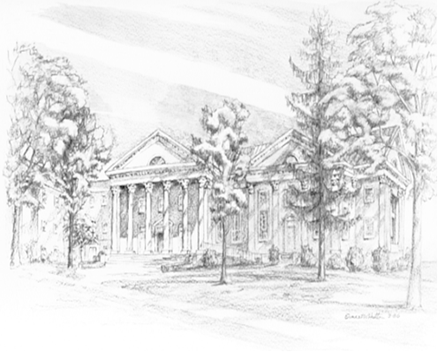

P.O. Box 877
249 South Wayne Avenue
Waynesboro, Virginia
(540) 949-8366
Church Website: www.firstpresway.org
Preschool Website: www.firstprespre.org
Email: church@firstpresway.com

