THIRD SUNDAY after PENTECOST June 9, 2024

PRELUDE Prelude, Op. 50, no. 5 Foote (1853-1937)

WELCOME & ANNOUNCEMENTS

INTROIT A Hymn of Glory Deo Gracias

CALL TO WORSHIP

Leader: I will praise you, Lord, with all my heart;
People: We will bow down toward your holy temple and praise your name.
Leader: Though I walk in the midst of trouble, you preserve my life.
People: The Lord will vindicate; the love of the Lord endures forever.
Leader: Let us worship God.

MORNING PRAYER

OPENING HYMN 475 Come, Thou Fount of Every Blessing Nettleton

CALL TO CONFESSION
Great God of mystery, we know a house divided cannot stand, yet we continue to sow division in our friendships, in our families, and in our communities. Our nature is contrary; we are willing even to hurt ourselves to avoid enriching others. Forgive us, Lord, this and all our sin. Call us again to build Your kingdom in unity, that your justice and mercy may ring strong and true.

SILENT PRAYER

ASSURANCE OF PARDON

*GLORIA PATRI 581 Greatorex

FIRST SCRIPTURE READING Psalm 138 p. 503

SPECIAL MUSIC Come, Ye Sinners, Poor and Needy Southern Harmony

SECOND SCRIPTURE READING 11 Corinthians 4:13-5:1 p.939

SERMON A Balance in our Favor. Patrick S Pettit, Interim Pastor

*AFFIRMATION OF FAITH Apostles’ Creed p.35

PRAYERS OF THE PEOPLE & THE LORD’S PRAYER

* HYMN 451 Open My Eyes, That I May See Open My Eyes

*CHARGE and BENEDICTION

POSTLUDE Postlude Foote

*Please stand if able

Hearing devices are available for your convenience.
Please be aware that they do not function until after the service begins.

Today’s link is: https://www.youtube.com/watch?v=6cmQaxeU9YU

Shenandoah Nursing Home: Nancy Garber

Home: Mary Ultee, Mary Ann Maupin, Linda Sandquist, Mike &
Cathy Cunningham, Warner Sandquist, Charles Simpkins

Friends and Family: Bill Bromley, Jean Custen, Jerry Hughes, Sally McNeel,
Bill Metzel (Joyce Tipton), Col. Stuart Roberts (Mark Henderson),
Paul Watts, Kathleen Clements, Carolyn Hedrick-Williams (Colleen Cash),
Betsy Boswell (Curry)

Military: Carson Craig

June 23, 2024
After Worship

Congregational Meeting

FIRST PRESBYTERIAN CHURCH
WAYNESBORO, VIRGINIA

A community-minded congregation living out the love of Christ as we serve one another with humility, gentleness, and patience through God’s grace.

June 9, 2024 11:00 AM

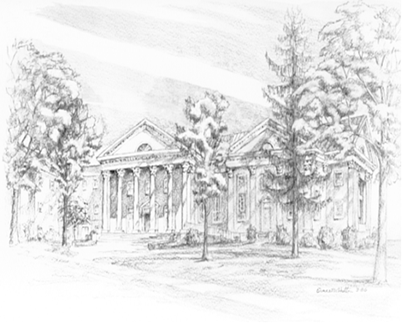

P.O. Box 877
249 South Wayne Avenue
Waynesboro, Virginia
(540) 949-8366
Church Website: www.firstpresway.org
Preschool Website: www.firstprespre.org
Email: church@firstpresway.com

