First Presbyterian Church, Waynesboro, VA

May 2024, Volume 62, Issue 5
First Presbyterian Church of Waynesboro is a community-minded
congregation living out the love of Christ as we serve one another with
humility, gentleness, and patience through God’s grace.

15 Toward evening the disciples approached him. “We’re out in the country and it’s getting
late. Dismiss the people so they can go to the villages and get some supper.”
16 But Jesus said, “There is no need to dismiss them. You give them supper.”
17 “All we have are five loaves of bread and two fish,” they said.
18-21 Jesus said, “Bring them here.” Then he had the people sit on the grass. He took the
five loaves and two fish, lifted his face to heaven in prayer, blessed, broke, and gave the
bread to the disciples. The disciples then gave the food to the congregation. They all ate
their fill. They gathered twelve baskets of leftovers. About five thousand were fed.
Matthew 14:15-21

When in doubt, always quote scripture. This is not one of the rules I have painstakingly collected over the years,
but perhaps it should be. Last month, we began with insights into basketball; for May, we are diving back into
the New Testament for illumination.
We are conditioned, I think, to look at the miraculous as magical, the theological equivalent of alchemy. Just as
the medieval alchemist sought to turn lead into gold, and thus enrich themselves without labor, we look at
miracles at least in part, as labor-saving plot devices: healing without the effort of treatment; gifts that eliminate
the need for impossible choices; rescue that makes of us passive recipients of grace. But, in the words of yet
another of my rules, God is not a magician; what we call miracles are signs of God at work in our midst - and
God hates to work alone.

In the feeding of the multitude, the disciples recognize a need - the crowd is getting hungry and the day is
mostly gone. This is a real problem, they know, but the best they can come up with is to send the crowds
back to town, where they might find some supper. But Jesus has something else in mind; not just pushing
the problem down the road, but actually doing something about the hunger of the people. He asks what
food is available, and is told, 5 rolls and 2 cooked fish - the lunch of a well-prepared young man. Jesus
then does the miraculous, but the miracle isn&#39;t magic- Jesus does not make everyone feel full, or have
manna fall from the heavens. The miracle happens through the work of the disciples. It is the disciples
who organize the people, getting them to sit down in an orderly fashion; they who oversee the distribution
of the loaves and fishes, making sure everyone is fed; even making sure the leftovers are collected. And
that, friends, leads us to Rule #10:

THE COLUMNS

15 Toward evening the disciples approached him. “We’re out in the country and it’s getting
late. Dismiss the people so they can go to the villages and get some supper.”
16 But Jesus said, “There is no need to dismiss them. You give them supper.”
17 “All we have are five loaves of bread and two fish,” they said.
18-21 Jesus said, “Bring them here.” Then he had the people sit on the grass. He took the
five loaves and two fish, lifted his face to heaven in prayer, blessed, broke, and gave the
bread to the disciples. The disciples then gave the food to the congregation. They all ate
their fill. They gathered twelve baskets of leftovers. About five thousand were fed.
Matthew 14:15-21

When in doubt, always quote scripture. This is not one of the rules I have painstakingly collected over the years, but perhaps it should be. Last month, we began with insights into basketball; for May, we are diving back into the New Testament for illumination.

We are conditioned, I think, to look at the miraculous as magical, the theological equivalent of alchemy. Just as the medieval alchemist sought to turn lead into gold, and thus enrich themselves without labor, we look at miracles at least in part, as labor-saving plot devices: healing without the effort of treatment; gifts that eliminate the need for impossible choices; rescue that makes of us passive recipients of grace. But, in the words of yet another of my rules, God is not a magician; what we call miracles are signs of God at work in our midst – and God hates to work alone.

In the feeding of the multitude, the disciples recognize a need - the crowd is getting hungry, and the day is mostly gone. This is a real problem, they know, but the best they can come up with is to send the crowds back to town, where they might find some supper. But Jesus has something else in mind; not just pushing the problem down the road, but actually doing something about the hunger of the people. He asks what food is available, and is told, 5 rolls and 2 cooked fish - the lunch of a well-prepared young man. Jesus then does the miraculous, but the miracle isn’t magic- Jesus does not make everyone feel full, or have manna fall from the heavens. The miracle happens through the work of the disciples. It is the disciples who organize the people, getting them to sit down in an orderly fashion; they who oversee the distribution of the loaves and fishes, making sure everyone is fed; even making sure the leftovers are collected. And that, friends, leads us to Rule #10:
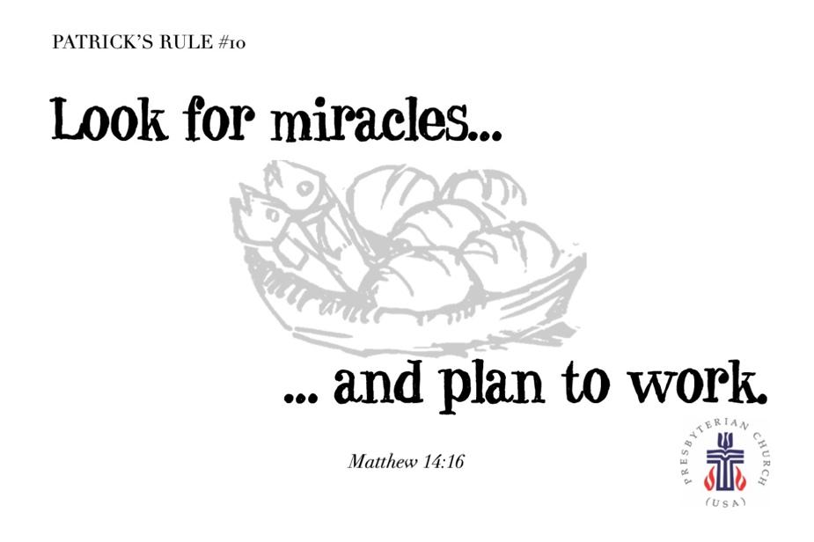

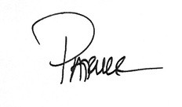

MAY MUSIC NOTES

The month of May is upon us. We are so fortunate to live here, where nature’s glory bursts forth in
gardens and forests throughout the Commonwealth.
First Presbyterian Church celebrates communion on the first Sunday of each month. The opening hymn
on 5 May will be All Who Hunger, Gather Gladly, with the tune name HOLY MANNA. The anthem will be
Loaves Were Broken, Words Were Spoken, known by the tune name BEACH SPRING. The closing
hymn, Come Down, O Love Divine, takes its text from a poem by Bianco da Siena c.1390. The tune,
DOWN AMPNEY, was composed by Ralph Vaughan Williams (1872-1958), inspired by the hundreds of
English folk tunes he collected around the turn of the 20th century.
The second Sunday of May is Mother’s Day, and the hymns for the Easter VII service will be For the
Beauty of the Earth and All Things Bright and Beautiful. These hymns reflect the joy, beauty and wonder
of creation, as we honor those who bring life into the world!
We celebrate Pentecost on the third Sunday of May, with music depicting the descent of the Holy Spirit.
The anthem will be We Are One in the Spirit, also known as They’ll Know We Are Christians By Our Love,
one of the most familiar hymns from the 1960s. The text and music for this iconic hymn were written in a
day by Peter Scholtes for his youth choir. The service opens and closes with renditions of the tune,
Komm, heiliger Geist (Come, Holy Ghost). The prelude was composed by Dieterich Buxtehude (1637-
1707), the influential composer, organist and kapellmeister (music director) who worked in Lübeck,
Germany. The postlude was composed by a man who spent months soaking in all Buxtehude could offer,
Johann Sebastian Bach. His chorale fantasia on Komm, heiliger Geist, is a musical depiction of the
swirling Holy Spirit as the chorale melody thunders in the pedals.
The final Sunday of the month rejoices in the Holy Trinity. We will praise the Father, Son and Holy Spirit
in Scripture and song. The opening hymn, Holy, Holy, Holy, is the very first selection in our hymnal. This
stirring hymn will conclude with an arrangement created by Roger decades ago. The closing hymn,
Come, Thou Almighty King, was composed by Felice di Giardini (1716-1796). The Italian composer
honed his violin skills playing in theatre orchestras before he hit his teens! Giardini played violin
throughout Europe, eventually settling in London, where he directed the Italian Opera and led the
orchestra. While in London, Giardini played for Johann Christian Bach (the youngest son of Johann
Sebastian Bach), who ran a successful concert series in the British capitol. Giardini composed music in
various genres, most notably in opera and chamber music.
On Tuesday 14 May, the Shenandoah Presbytery will hold a service at Westminster Presbyterian Church.
We have been asked to coordinate the music for the service, which will include the Better Together choir.
Musicians from First Pres, Second Pres, Smyrna, Finley, Hermitage and Westminster will join forces to
lead congregational singing. All are welcome to attend the service that day, which begins at 9:45am.
Finally, Roger will present a First Friday program on 6 June. The series will be on hiatus through the
summer and will resume in the fall.
We remain thankful for FPC’s continuous support of the music program!
Blessings –Roger and Kimberlea Daggy

SESSION HIGHLIGHTS

Session held a Stated Session Meeting on April 9, 2024.
• There needs to be a general clean up and clean out in the Educational Building in
preparation for the start-up of Fishburne’s new Middle School. Once the Library
has been cleared of FPC materials, folks will be invited to take a book or two.

• Preschool Graduation will be held May 23. Need to hire additional aide in the 4-
year-old class.

• Cynthia Hoover provided statistics for the Food Bank (printed elsewhere).

• Cynthia Hoover proposed an Organizational Meeting to restart the FPC Book Club.

• Five cameras have been installed in the Preschool and Lunchroom. Wi-Fi service
has been ramped up.

• Presbyterians Better Together will be leading worship at the May 14 Presbytery
Meeting. Jean Hashagen and Linda Field of Second FPC will coordinate.
breakfast. The Daggys will lead a Better Together volunteer choir.

• Pastor Search Committee – Progress is being made toward hiring a pastor.

• All Session meetings are opened and closed with prayer. The next meeting will
be Monday, May 13, to avoid conflict with Presbytery meeting.

--Betsy Ruehl, Clerk of Session

SUMMER BREAK
Better Together Bible Study
Last Session May 20

DAY OF PENTECOST
Sunday, May 19, 2024

The Day of Pentecost is the climax of the Great Fifty Days of Easter, celebrating as it
does the gift of the Spirit to the body of Christ – the church.

According to the Day of Pentecost story in Acts 2:1-13, God gave the gift of the Holy
Spirit to empower witnesses to the resurrection. Sounds from heaven, cosmic language, the
rush of a mighty ruach (wind, spirit, breath) invaded he house in which the apostles gathered
and appeared to them as a burning fire. Tongues of fire touched their nerve centers. A power
– the unseen power of God – moved among them and gripped them. The Holy Spirit is unseen
like the wind, which is why the Old Testament calls it ruach YHWH, “the wind, or breath of God”
(John 3:8). The Spirit is the “unseenness of God” working among us.

The book of Acts tells the story of the outcome of Pentecost’s new creation: people
witness in word and in deed to the risen Christ. At the outset, the newborn church immediately
tumbled out into the streets to witness to God’s mighty works in the languages of people all
over the world. By the end of the story, a tiny, spirit-filled community of faith that broke from
its present order has spread across the continents to bring new things into being. With the gift
of the Spirit, all things are possible.

Therefore, on the day of Pentecost, we celebrate God’s gift of the Holy Spirit which
draws us together as one people, helps us to comprehend what God is doing in the world, and
empowers us to proclaim, in word and deed, God’s plan of reconciling all people in the name of
Christ. (Ephesians 1:10)

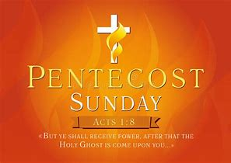

BETTER TOGETHER CHURCHES* MEETING
April 28 at Second Presbyterian

Representatives from the Better Together churches met for their quarterly meeting with
convenor Richard Schempp. They reviewed the group activities of the past year – what worked,
what didn’t work – which should be repeated or revised. Advance notice and preparation play
an important part in the success of joint ventures.

Leaders of newly formed HERO (Housing Energy Relief Organization) described its
function and procedure. They have an online form for (only) Waynesboro residents to apply for
up to $300 for utility cut-offs and evictions. Several local churches have pledged support and
they are also soliciting financial aid elsewhere. They do not have a physical location at this
time. {This worthwhile organization reminds me of CURE (Christians United Relief Effort)
which operated under the umbrella of Christians United in the ‘80s, and of which I was a part
for about 20 years. The needs in our community have not diminished!}

The next meeting will. Be July 21 at Smyrna PC with speaker Keenan Rogers from the
Board of Pensions.
--Betsy Ruehl
*Hermitage, Finley Memorial, First, Second, Smyrna and Westminster

MEMORIAL DAY
May 27, 2024

“This is the day we pay homage to all those who didn’t come home.
This is not Veterans Day. It’s not a celebration.
It is a day of solemn contemplation over the cost of freedom.” --Tamra Bolton

“And I’m proud to be an American, where at least I know I’m free.
And I won’t forget the men who died, who gave that right to me.”-Lee Greenwood

Preschool News!!

Where has the time gone??? We can’t believe it is May already!! Our preschool has enjoyed watching the flowers bloom, listening to the birds’ chirp, and watching the squirrels roam around, and on a crazy rainy day we even saw ducks hanging around on our playground. Oh boy, was that a sight for the children to see!!! We took a walking field trip to the library for story time with Ms. Jamie, and the children absolutely loved visiting with her in her environment for a change.
Mrs. Carol and her 2.5-year-olds spent last month learning all about gardening and butterflies. They had fun learning about purple and the ins and outs of the shape of a rectangle.
Mrs. Lynda’s class has almost finished learning all the letters of the alphabet and they can recognize them. Our 3-year-olds have planted flowers to take home so they have been watering them and hoping to see beautiful flowers grow, while learning about growth.
Mrs. Mary has fit in so well with the 4s class and they love having her! The 4-year-old class has improved its scissor skills and is working on assessments to see what needs to be reviewed with each child. They have done so well; we are so proud.
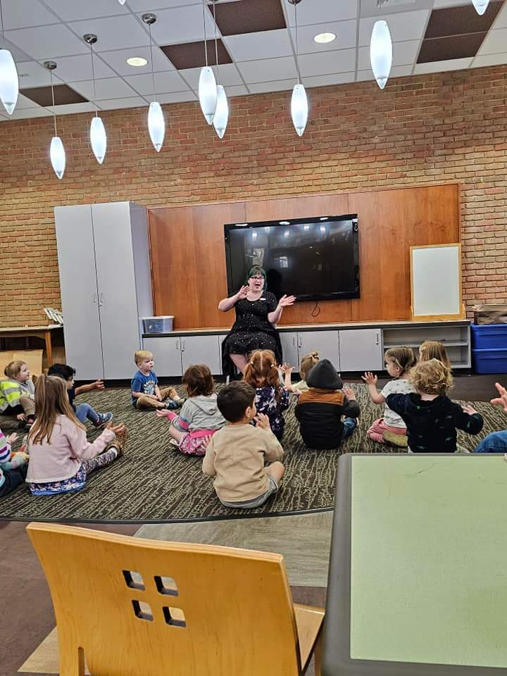

Spring Concert and Graduation
May 23,2024 at 6:30
Sanctuary

MISSION/OUTREACH MARCH 2024

• Ordered and received food from Blue Ridge Area Food Bank March 12 and 26.
Volunteers assembled 20 pantry boxes for each order.
• Maintained temperature logs for refrigerators and freezers.
• Food Bank held March 7, 14, 21 and 28.
• Purchased eggs, bread, margarine for Food Bank weekly.
• Updated weekly shopping list for extra options.
• Completed pantry inventory and report: Served 98 individuals and 37
households.
• Collecting chicken noddle soup for Food Bank.
• Next Disciples’ Kitchen is May 16.
• 2024 Mission Budget: Food Bank $15,000; Disciples’ Kitchen $1,000; WARM
Shelter $500; Preschool $150
. --Cynthia Hoover, Mission Chair

NEEDED:

FOOD BANK – CHICKEN NOODLE SOUP
(unavailable for purchase at Blue Ridge Area Food Bank)

Restoring Hope, Feeding the Hungry, Empowering the Oppressed

Total collected for 2024 was $735.00.

Liturgists

May 5 Betsy Ruehl

May 12 Bill Pannill

May 19 Jo Pannill

May 26 Cynthia Hoover

REV PETTIT’S WORK SCHEDULE

Monday – work at home
Tuesday and Thursday– onsite First Pres
Wednesday – visitation
Friday – off

BIRTHDAYS ANNIVERSARIES

May 12 Roger Bryant May 19 Burnie &Carol Powers
May 14 Don Hashagen May 24 Cary &Holly Bennett
May 15 Betty Dixon May 25 John & Cynthia Hoover
May 16 Carrol Smith May 31 Danny &Pam Leech
May 26 Ron Smith

Do you enjoy reading?
Do you find discussions on books interesting?
Do you find kinship with others that love to read?
Do you remember Faith and Fiction?

If so, please consider joining a founding meeting for a book club here at First Presbyterian Church.
Topics to be considered:

- How often and when to hold meetings? Will they be hosted in someone’s home or at the church?
- How will the meetings be run? Will there be one leader or will the responsibility be rotated?
- What genre or book list to read?

Formational meeting to be held on May 20 at 2PM in the parlor of First Presbyterian Church.
Questions, call Cynthia Hoover 540-255-9616.

May Calendar
Thursday, May 2
6-7:30 pm Food Bank
Friday, May 3
12:15pm First Friday Organ Concert
Sunday, May 5
11 am Worship Service
Monday, May 6
1 pm Bible Study, Smyrna Presbyterian
Thursday, May 9
2-4 pm Food Bank
Saturday, May 11 Sarah Braverman Recital Practice
Sunday, May 12 Mother’s Day
11 am Worship Service
Monday, May 13
1 pm Bible Study, Second Presbyterian
2:30 Session Meeting Room 212
Tuesday, May 14 Presbytery Meeting Westminster Church
Thursday, May 16
9am – 10:30 FMS Graduation Practice
6-7:30 pm Food Bank
Saturday, May 18
12-1pm FMS Graduation
3-6 pm Sarah Braverman Recital
Sunday, May 19 Pentecost
11am Worship Service
Monday, May 20
1 pm Bible Study, Hermitage Presbyterian
Thursday, May 23
2-4 pm Food Bank
6:30 pm Preschool Graduation Sanctuary
Sunday, May 26
11 am Worship Service
Monday, May 27 OFFICE CLOSED

Mailing Address
P. O. Box 877
Waynesboro, VA 22980
Phone 540.949.8366
Fax 540.949.5750
E-mail: church@firstpresway.com
Website: www.firstpresway.org

Interim Pastor Music Director
Rev. Patrick S. Pettit Mr. Roger Daggy
pspettit@gmail.com firstpreswaymusic@gmail.com

Administrative Assistant Music Associate
Mrs. Colleen Cash Mrs. Kimberlea Daggy
ccash@firstpresway.com firstpreswaymusic@gmail.com

Preschool Director Audio/Video Technician
Ms. Tami Hemp Mr. Craig Cavenaugh
preschool@firstpresway.com Mrs Cindy Cavenaugh

Maintenance Technician
Mr. Michael Griffith

