TRINITY SUNDAY May 26, 2024

PRELUDE Trio Rheinberger (1839-1901)

WELCOME & ANNOUNCEMENTS

INTROIT What Does the Lord Require Routley (1917-1982)

CALL TO WORSHIP
Leader: The voice of the Lord rings out over the waters.
People: The love of the Holy Trinity washes over the world.
Leader: Let us worship the God whose voice flashes fire and whose love cannot be bound.

MORNING PRAYER

*OPENING HYMN 1 Holy, Holy, Holy Nicaea

CALL TO CONFESSION
O God, your love for the world knows no bounds. At the right time, you came among us, feeling our pain, enhancing our joy, and blessing our broken lives. You left your spirit with us empowering us to accept your grace and follow your way. Forgive us, Lord, this and all our sin. Transform our fragile faith and send us for with your Good News.

SILENT PRAYER

ASSURANCE OF PARDON

*GLORIA PATRI 581 Greatorex

FIRST SCRIPTURE READING Psalm 29 p. 438

ANTHEM A Song of Praise Rutter (b. 1945)
Glory to you, Lord God of our fathers; you are worthy of praise; glory to you.
Glory to you for the radiance of your holy Name; we will praise you & highly exalt you forever.
Glory to you in the splendor of your temple; on the throne of your majesty, glory to you.
Glory to you, seated between the Cherubim; we will praise you and highly exalt you forever.
Glory to you, beholding the depths; in the high vault of heaven, glory to you.
Glory to you, Father, Son, and Holy Spirit; we will praise you and highly exalt you forever.

SECOND SCRIPTURE READING Isaiah 6:1-13 p. 553

SERMON No Excuses Patrick Pettit, Interim Pastor

*AFFIRMATION OF FAITH Apostles’ Creed p.35

PRAYERS OF THE PEOPLE & THE LORD’S PRAYER

* HYMN 8 Eternal Father, Strong to Save Melita

*CHARGE and BENEDICTION

POSTLUDE Pastorella: IV Bach (1685-1750)

*Please stand if able
Hearing devices are available for your convenience.
Please be aware that they do not function until after the service begins.

Today’s link is: https://www.youtube.com/watch?v=uicuScyOBxU

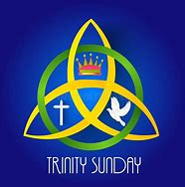

Shenandoah Nursing Home: Nancy Garber

Home: Mary Ultee, Mary Ann Maupin, Linda Sandquist, Mike &
Cathy Cunningham, Warner Sandquist

Friends and Family: Bill Bromley, Jean Custen, Jerry Hughes, Sally McNeel,
Bill Metzel (Joyce Tipton), Col. Stuart Roberts (Mark Henderson),
Paul Watts, Kathleen Clements, Carolyn Williams (Colleen Cash), Betsy Boswell (Curry)

Military: Carson Craig

Better Together Bible study will be taking a summer break and returning after Labor Day.

The office will be closed on Monday in observance of Memorial Day

FIRST PRESBYTERIAN CHURCH
WAYNESBORO, VIRGINIA

A community-minded congregation living out the love of Christ as we serve one another with humility, gentleness, and patience through God’s grace.

May 26, 2024 11:00 AM

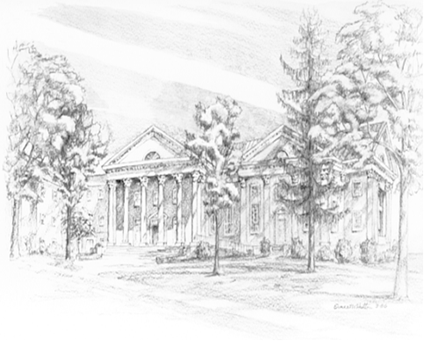

P.O. Box 877
249 South Wayne Avenue
Waynesboro, Virginia
(540) 949-8366
Church Website: www.firstpresway.org
Preschool Website: www.firstprespre.org
Email: church@firstpresway.com

