21st Sunday after Pentecost November 2, 2025
Liturgist: Betsy R

PRELUDE Prelude in g attr. Krebs (1713-1780)

WELCOME & ANNOUNCEMENTS

INTROIT What Does the Lord Require Routley (1917-1982)

CALL TO WORSHIP
Leader: The changing colors of leaves, the laughter of children playing dress-up,
the flowers and trees that become food for foraging creatures:
All: Lord, your creation boasts of your goodness.
Leader: The Sunday School teachers who taught us your Word,
the stranger who asked us if we were okay,
the parent who showed us right and wrong,
the neighbor who dropped by to say hello:
All: Lord, your creation boasts of your love.
Leader: Let us join together as a community and worship our Creator,
the author of everything that is beautiful.

MORNING PRAYER

*OPENING HYMN #326 For All the Saints SINE NOMINE

ALLL SAINT’S REMEMBRANCE SEE INSERT

CALL TO CONFESSION

PRAYER OF CONFESSION
Holy and gracious God, you are the author of every good thing.
Forgive us for the ways we fall short of the beautiful story you invite us to step into.
You ask us to look to the margins and care for the lost; we center ourselves.
You ask us to give away; we grab for more.
You ask us to love one another; we cannot see beyond our divisions.
The world is full of ugliness, from the macro to the micro.
Forgive us. Help us. We call on you, our beloved, our help, our God, our hope.

SILENT PRAYER
ASSURANCE OF PARDON

*GLORIA PATRI #581 Glory Be to the Father GLORIA PATRI

FIRST SCRIPTURE LESSON Psalm 119:137-144 p. 496

ANTHEM My Flesh is Food Indeed Urwin (b. 1950)

My flesh is food indeed, and My blood is drink indeed, says the Lord.
Those who eat My flesh and drink My blood dwell in Me, and I in them.

SECOND SCRIPTURE LESSON Luke 19:1-10 p. 854

SERMON Zacchaeus Rev. Samantha Coggins

AFFIRMATION OF FAITH (from A Brief Statement of Faith)
In a broken and fearful world, the Spirit gives us courage to pray without ceasing,
to witness among all peoples to Christ as Lord and Savior, to unmask idolatries in church and culture, to hear the voices of peoples long silenced, and to work with others for justice, freedom and peace. In gratitude to God, empowered by the Spirit, we strive to serve Christ in our daily tasks and to live holy and joyful lives, even as we watch for God’s new heaven and new earth, praying, “Come, Lord Jesus!” With believers in every time and place, we rejoice that nothing in life or in death can separate us
from the love of God in Christ Jesus our Lord. Glory to the Father, and to the Son, and to the Holy Spirit. Amen.

THE LORD’S SUPPER
Invitation
Great Thanksgiving
Communion of the People

*CLOSING HYMN #720 Jesus Calls Us GALILEE

BENEDICTION

POSTLUDE Fugue in g Krebs

This week’s liturgy is written by Rose Schrott Taylor and the Presbyterian Outlook.

LINK : https://www.youtube.com/watch?v=qFhoHiJIfHU



Shenandoah Nursing Home: Nancy Garber

Home: Mary Ultee, Mary Ann Maupin, Warner Sandquist, Polly Bare, Olive Prettyman.

Friends and Family: Bill Bromley, Jean Custen, Sally McNeel, Col. Stuart Roberts (Mark Henderson), Carolyn Hedrick-Williams, (Colleen Cash), Betsy Boswell (Curry), Shane Bennett (Bennett).

Military: Carson Craig, Michael Little

Our First Friday’s recital is this Friday, November 7th. The organ concert begins at 12:15 pm, followed by a light lunch in the Barksdale Room.

Our Christian sympathies to Lewis and Ruth Kelley. Their son, Jake Harner,
died on October 10, 2025.
Jake volunteered at our Food Bank for years. Per Jake’s wishes there will not be a
service.


Disciples’ Kitchen
Donations will be accepted until
November 11, 2025.
Collection box in the Narthex



FIRST PRESBYTERIAN CHURCH
WAYNESBORO, VIRGINIA

A community-minded congregation living out the love of Christ as we serve one another with humility, gentleness, and patience through God’s grace.

November 2, 2025 11:00 AM

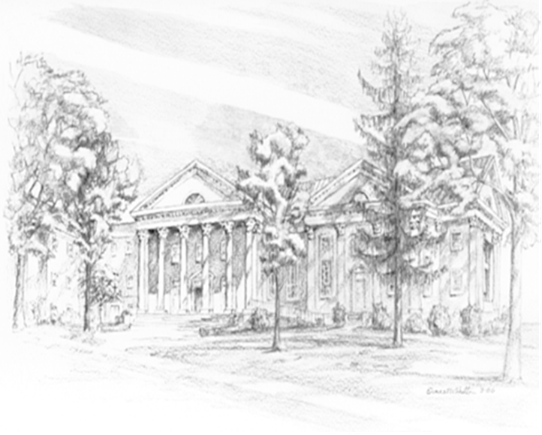

P.O. Box 877
249 South Wayne Avenue
Waynesboro, Virginia
(540) 949-8366
Church Website: www.firstpresway.org
Preschool Website: www.firstprespre.org
Email: church@firstpresway.com

