18th SUNDAY AFTER PENTECOST October 12, 2025
Liturgist: Patrick Fitzgibbon

PRELUDE Sonata in B-flat, Op. 65, no. 4: Allegretto Mendelssohn (1809-1847)

WELCOME & ANNOUNCEMENTS

INTROIT Let All the World Routley (1917-1982)

CALL TO WORSHIP
Leader: Make a joyful noise to God, all the earth!
All: Sing to the glory of God’s name.
Leader: All of creation worships, singing praise to God.
All: Sing to the glory of God’s name.
Leader: Let us give glory to God.

MORNING PRAYER

*OPENING HYMN #4 Holy God, We Praise Your Name GROSSER GOTT WIR
LOBEN DICH
CALL TO CONFESSION

PRAYER OF CONFESSION
Holy God, when we are in need, we cry out for your mercy and healing.
Yet we confess that often, we are too confident in our own strength.
We take the blessings to which we feel entitled and continue on our way,
rather than returning to you in worship and praise. Jesus, have mercy on us.
It is easy to take for granted the ease of life we so often experience,
while failing to question why others are pushed to the margins and excluded.
It is tempting to take pride in our health and strength. Jesus, have mercy on us.
Help us to grow in compassion for all people. Redirect our paths so that we return to you,
offering our praise and gratitude, now and always.

SILENT PRAYER

ASSURANCE OF PARDON

*HYMN #581 Glory Be to the Father GLORIA PATRI

FIRST SCRIPTURE LESSON Psalm 111 p. 490

ANTHEM All Praise to Thee Tallis (c.1505-1585)

All praise to thee, Our God and King, for all the blessings thou dost bring,
For loving care thou dost bestow on all thy creatures here below.
We thank thee, Lord, for thy dear Son, for all the goodness He hath done,
For all the sorrow He hath borne, for joy He brings to men forlorn.
All this for us thy love hath done, by this to thee our love is won,
For this thy loving children sing. Our thanks and praise to thee we bring.
Teach us to live that we might be most faithful followers of thee.
Keep us, o keep us, King of Kings, beneath thine own almighty wings.
Praise God, from whom all blessings flow; praise Him, all creatures here below;
Praise Him above, ye heavenly hosts; praise Father, Son and Holy Ghost.

SECOND SCRIPTURE LESSON Luke 17: 11-19 p.852

SERMON You Noticed It When? Rev. Melissa Harmon

*AFFIRMATION OF FAITH Apostles’ Creed Hymnal page 35

PRAYERS OF THE PEOPLE & THE LORD’S PRAYER

*CLOSING HYMN #546 Lord, Dismiss Us with Your Blessing SICILIAN MARINERS

*CHARGE / BENEDICTION

POSTLUDE Toccata and Fugue in a attr. Krebs (1713-1780)

This week’s liturgy is written by Stephanie Sorge and the Presbyterian Outlook.
Today’s Link: https://www.youtube.com/watch?v=HAaYRJVm9Sc

Rev. Melissa Leigh Harmon is a native of Richmond VA. She came to the Valley in 2008 to pastor 3 churches in Highland County and left those churches in 2015. Rev. Melissa became a member at large in the Shenandoah Presbytery and serves the church doing pulpit supply. Rev. Melissa and her wife live in Harrisonburg along with their 3 children. She works as a certified pharmacy technician for Sentara RMH and does a variety of activities. She grows and cans vegetables, makes embossed cards, and through her online art studio sells stained-glass items and other crafts.

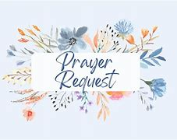

Shenandoah Nursing Home: Nancy Garber

Summitt Square: Ruth Quillen

Home: Mary Ultee, Mary Ann Maupin, Warner Sandquist, Mike & Cathy Cunningham, Polly Bare, Olive Prettyman.

Friends and Family: Bill Bromley, Jean Custen, Sally McNeel, Col. Stuart Roberts (Mark Henderson), Carolyn Hedrick-Williams, (Colleen Cash), Betsy Boswell (Curry), Shane Bennett (Bennett).

Military: Carson Craig, Michael Little


The offering plate is kept in the Narthex,

FIRST PRESBYTERIAN CHURCH
WAYNESBORO, VIRGINIA

A community-minded congregation living out the love of Christ as we serve one another with humility, gentleness, and patience through God’s grace.

October 12, 2025 11:00 AM
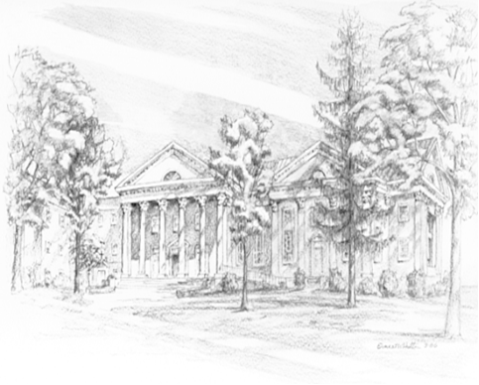

P.O. Box 877
249 South Wayne Avenue
Waynesboro, Virginia
(540) 949-8366
Church Website: www.firstpresway.org
Preschool Website: www.firstprespre.org
Email: church@firstpresway.com

