19th SUNDAY AFTER PENTECOST October 19, 2025
Liturgist: Cynthia Hoover

PRELUDE My Heart Leaps with Joy Walcha (1907-1991)

WELCOME & ANNOUNCEMENTS

INTROIT O Come Let Us Sing Unto the Lord Lantz III (b. 1956)

CALL TO WORSHIP
Leader: We lift up our eyes to the hills – from where will our help come?
All: Our help comes not from the hills, but from the Lord who
made heaven and earth.
Leader: I solemnly urge you: proclaim the message; be persistent
whether the time is favorable or unfavorable.
All: The Lord will keep your going out and your coming in
from this time on and forevermore.
Leader: With endurance, expectation, and joy, let us worship the living God!

MORNING PRAYER

*OPENING HYMN #415 Come, Ye Sinners, Poor and Needy RESTORATION

CHILDREN’S SERMON

CALL TO CONFESSION

PRAYER OF CONFESSION
God of the covenant, you promise to write your law in our hearts, that we might be faithful people who know you and your will for us. Still we stray from your ways, we fail to tell the truth, we mirror the world around us more than the good news of the gospel, and we fail to acknowledge that you are our God. Forgive us, and by your Spirit renew us. Engrave your covenant upon us once more. Grant us courage and faith that we might begin again to live what it is we say we believe.

SILENT PRAYER

ASSURANCE OF PARDON

*HYMN #581 Glory Be to the Father GLORIA PATRI

FIRST SCRIPTURE LESSON Daniel 6:16-28

ANTHEM Didn’t My Lord Deliver Daniel arr. Emerson
Randy Hypes, percussion (b. 1950)

Refrain: Didn't my Lord deliver Daniel
Then why not everyone?

He delivered Daniel from the lion's den
Jonah from the belly of the whale
And the Hebrew children from the fiery furnace
Then why not everyone? <Refrain>

I set my foot on the gospel ship,
And the ship began to sail;
It landed me over on Canaan’s shore
And I’ll never come back no more. <Refrain>

SECOND SCRIPTURE LESSON Luke 18:1-8 p.853

SERMON Serving God Consistantly Rev. Samantha Coggins

*AFFIRMATION OF FAITH Apostles’ Creed Hymnal page 35

PRAYERS OF THE PEOPLE & THE LORD’S PRAYER

*CLOSING HYMN #688 Spirit of God, Descend Upon My Heart MORECAMBE

*CHARGE / BENEDICTION

POSTLUDE A Mighty Fortress is Our God Walcha

Today’s Link: https://www.youtube.com/watch?v=Q0PIA5GUWyQ

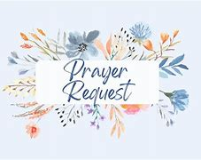

Shenandoah Nursing Home: Nancy Garber

Home: Mary Ultee, Mary Ann Maupin, Warner Sandquist, Mike & Cathy Cunningham, Polly Bare, Olive Prettyman.

Friends and Family: Bill Bromley, Jean Custen, Sally McNeel, Col. Stuart Roberts (Mark Henderson), Carolyn Hedrick-Williams, (Colleen Cash), Betsy Boswell (Curry), Shane Bennett (Bennett).

Military: Carson Craig, Michael Little


An offering plate is available in the narthex.

Fall Book Study
We continue our study of The Book of Charlie this Wednesday, October 22. For this session, please read through the end of the novel. We will meet the following Wednesday, October 29, to share our last thoughts about the book, enjoy even more fellowship, and take care of a couple administrative items.

Inside your bulletin today...
Please take note of today’s bulletin insert: a letter sent out to our Preschool families last week, notifying parents & caregivers of the logistics of Fishburne Military School’s use of space on the 2nd floor of the church’s education wing. I commend this letter to your reading. Please contact me, or a member of Session, with questions or concerns. -Samantha

FIRST PRESBYTERIAN CHURCH
WAYNESBORO, VIRGINIA

A community-minded congregation living out the love of Christ as we serve one another with humility, gentleness, and patience through God’s grace.

October 19, 2025 11:00 AM
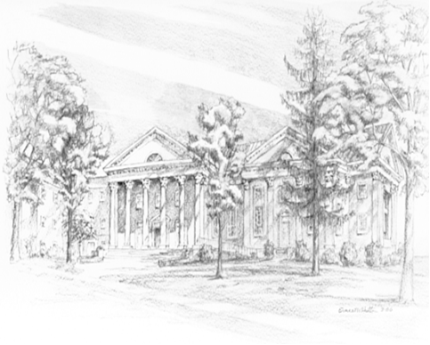

P.O. Box 877
249 South Wayne Avenue
Waynesboro, Virginia
(540) 949-8366
Church Website: www.firstpresway.org
Preschool Website: www.firstprespre.org
Email: church@firstpresway.com

