20th SUNDAY AFTER PENTECOST October 26, 2025
Liturgist: Jean Hashagen

PRELUDE Adagio in Classic Style David H. Hegarty (1945)

WELCOME & ANNOUNCEMENTS

INTROIT Moderato Dennis Eliot (1954)

CALL TO WORSHIP
Leader: All who exalt themselves will be humbled,
All: but all who humble themselves will be exalted.
Leader: We humble ourselves before our God,
All: ready to hear and receive God’s truth.

MORNING PRAYER

*OPENING HYMN #412 God Reveal Your Presence ARNSBERG

CHILDREN’S SERMON

CALL TO CONFESSION

PRAYER OF CONFESSION
Holy God, your truth is so often sharp and unsettling. We confess the ways we skirt the hard edges of your Word, turn up the volume on lesser noises, and lean into the comfort of our own certainty rather than submit to the discomfort of your challenge. You send us messengers, and we sidestep them; you challenge us, and we defend ourselves. Again and again, Holy God, we resist what we do not want to hear. And yet you keep calling. Have mercy on us. Interrupt our evasions. Soften what pride has hardened in us. Let us hear and receive your truth. Amen.

SILENT PRAYER

ASSURANCE OF PARDON

*HYMN #581 Glory Be to the Father GLORIA PATRI

FIRST SCRIPTURE LESSON Psalm 84:1-7 p.472

SPECIAL MUSIC O Waly Waly Emma Lou Diemer (1927-1924)
(Where Love is Found)

SECOND SCRIPTURE LESSON Luke 18:9-14 p.853

SERMON How to Pray Rev. Samantha Coggins

*AFFIRMATION OF FAITH
Christ Jesus, though he was in the form of God, did not regard equality with God
as something to be exploited, but emptied himself, taking the form of a slave,
being born in human likeness. And being found in human form he humbled himself
and became obedient to the point of death—even death on a cross. Therefore God also highly exalted him and gave him the name that is above every name, so that at the name of Jesus
every knee should bend, in heaven and on earth and under the earth, and every tongue should confess to the glory of God: Jesus Christ is Lord! Amen.

PRAYERS OF THE PEOPLE & THE LORD’S PRAYER

*CLOSING HYMN #824 There Is a Place of Quiet Rest MC AFEE

*CHARGE / BENEDICTION

POSTLUDE Rejoice Greatly, O My Soul James Mansfield (1927-1918)

This week’s liturgy is provided by Teri McDowell Ott and the Presbyterian Outlook.

Today’s Link: https://www.youtube.com/watch?v=l6hKyzFOkCg

We gladly welcome our guest organist, Diane Kingsbury, to our sanctuary this morning. Diane has graciously helped us on numerous occasions over the years, and we are most grateful to her for providing music for our worship service this morning!



Shenandoah Nursing Home: Nancy Garber

Home: Mary Ultee, Mary Ann Maupin, Warner Sandquist, Mike & Cathy Cunningham, Polly Bare, Olive Prettyman.

Friends and Family: Bill Bromley, Jean Custen, Sally McNeel, Col. Stuart Roberts (Mark Henderson), Carolyn Hedrick-Williams, (Colleen Cash), Betsy Boswell (Curry), Shane Bennett (Bennett).

Military: Carson Craig, Michael Little


An offering plate is available in the narthex.

Final Fall Book Study Meeting this Wednesday
Thank you for your patience with the cancellation of book study last week. We will meet to discuss the end of The Book of Charlie this Wednesday, October 29th, at 10:00 a.m. in the Barksdale Room. We are currently planning to convene again in January to study another book!



Disciples’ Kitchen
Donations will be accepted until
November 11, 2025.
Collection box in the Narthex

FIRST PRESBYTERIAN CHURCH
WAYNESBORO, VIRGINIA

A community-minded congregation living out the love of Christ as we serve one another with humility, gentleness, and patience through God’s grace.

October 26, 2025 11:00 AM
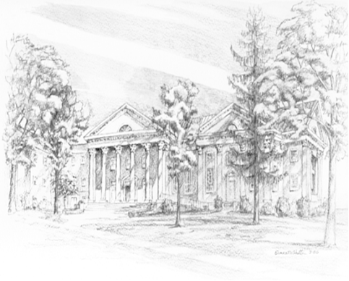

P.O. Box 877
249 South Wayne Avenue
Waynesboro, Virginia
(540) 949-8366
Church Website: www.firstpresway.org
Preschool Website: www.firstprespre.org
Email: church@firstpresway.com

