17th Sunday after Pentecost October 5, 2025
Liturgist: Betsy Ruehl

PRELUDE Prelude in F attr. Fischer (1656-1746)

WELCOME & ANNOUNCEMENTS

INTROIT Now Enter In Hebble (1934-2020)

CALL TO WORSHIP
Leader: The earth is the Lord’s and all that is in it,
All: the world and those who live in it.
Leader: What shall we return to the Lord for all the good things God
has done for us?
All: We will lift the cup of salvation and call on the name of the Lord.

MORNING PRAYER

*OPENING HYMN #509 All Who Hunger, Gather Gladly HOLY MANNA

CHILDREN’S SERMON

CALL TO CONFESSION

PRAYER OF CONFESSION
As we come today to your great table, O God, we realize how small we have made our own tables. Our vision of your grace is too narrow. Our awareness of your mercy is too limited. Our understanding of your kingdom always falls short.

We fail to measure up to the people you have called us to be. Hear our prayers and forgive our shortcomings. Raise our eyes, lift our hearts, and inflate our spirits, so that we may live joyfully and abundantly in the manner of Jesus. Amen.

SILENT PRAYER

ASSURANCE OF PARDON

*GLORIA PATRI #581 Glory Be to the Father GLORIA PATRI

FIRST SCRIPTURE LESSON Habakkuk 1:1-4, 2:1-4 p.762

ANTHEM Jesus, Thou Joy of Loving Hearts Baker (1835-1910)
(text can be found in hymn 494)

SECOND SCRIPTURE LESSON Luke 13:18-19 p.848

SERMON The Mustard Seed Rev. Samantha Coggins

THE LORD’S SUPPER
Invitation
Great Thanksgiving
Communion of the People

*CLOSING HYMN #498 Loaves Were Broken, Words Were Spoken BEACH SPRING

- BENEDICTION

POSTLUDE Fugue in F attr. Fischer

Today’s liturgy is written by John Wurster, Keatan King, and the Presbyterian Outlook

LINK : https://www.youtube.com/watch?v=PZOEKdu4cEw

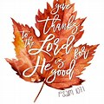

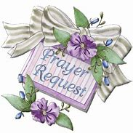

Shenandoah Nursing Home: Nancy Garber

Home: Mary Ultee, Mary Ann Maupin, Warner Sandquist, Mike & Cathy Cunningham, Polly Bare, Olive Prettyman.

Friends and Family: Bill Bromley, Jean Custen, Sally McNeel, Col. Stuart Roberts (Mark Henderson), Carolyn Hedrick-Williams, (Colleen Cash), Betsy Boswell (Curry), Shane Bennett (Bennett).

Military: Carson Craig, Michael Little

‘Bapterian’ Fellowship for World Communion Sunday
Share a meal & fellowship with our neighbors from First Baptist Church at Ridgeview Park, in celebration of World Communion Sunday. We will gather at the River Shelter — the shelter closest to the pool and playground — at 4:30 pm. Dinner will start between 5:00 and 5:30 pm, with First Baptist providing the main course of hot dogs and burgers. If you plan to attend, please bring a side or dessert to share, as well as a blanket or chair to sit on.


Offering plate is in the Narthex

FIRST PRESBYTERIAN CHURCH
WAYNESBORO, VIRGINIA

A community-minded congregation living out the love of Christ as we serve one another with humility, gentleness, and patience through God’s grace.

September 7, 2025 11:00 AM

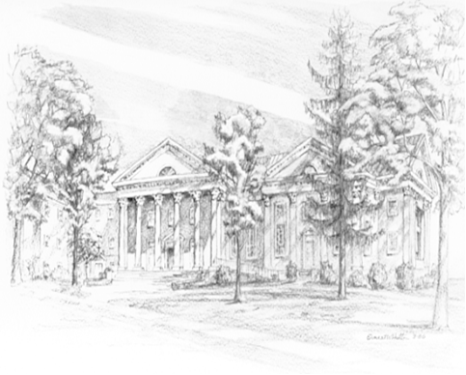

P.O. Box 877
249 South Wayne Avenue
Waynesboro, Virginia
(540) 949-8366
Church Website: www.firstpresway.org
Preschool Website: www.firstprespre.org
Email: church@firstpresway.com

