

THE COLUMNS
First Presbyterian Church, Waynesboro, VA
November 2025, Volume 63, Issue 11
First Presbyterian Church of Waynesboro is a community-minded
congregation living out the love of Christ as we serve one another with
humility, gentleness, and patience through God’s grace.

15 Toward evening the disciples approached him. “We’re out in the country and it’s getting
late. Dismiss the people so they can go to the villages and get some supper.”
16 But Jesus said, “There is no need to dismiss them. You give them supper.”
17 “All we have are five loaves of bread and two fish,” they said.
18-21 Jesus said, “Bring them here.” Then he had the people sit on the grass. He took the
five loaves and two fish, lifted his face to heaven in prayer, blessed, broke, and gave the
bread to the disciples. The disciples then gave the food to the congregation. They all ate
their fill. They gathered twelve baskets of leftovers. About five thousand were fed.
Matthew 14:15-21

When in doubt, always quote scripture. This is not one of the rules I have painstakingly collected over the years,
but perhaps it should be. Last month, we began with insights into basketball; for May, we are diving back into
the New Testament for illumination.
We are conditioned, I think, to look at the miraculous as magical, the theological equivalent of alchemy. Just as
the medieval alchemist sought to turn lead into gold, and thus enrich themselves without labor, we look at
miracles at least in part, as labor-saving plot devices: healing without the effort of treatment; gifts that eliminate
the need for impossible choices; rescue that makes of us passive recipients of grace. But, in the words of yet
another of my rules, God is not a magician; what we call miracles are signs of God at work in our midst - and
God hates to work alone.

In the feeding of the multitude, the disciples recognize a need - the crowd is getting hungry and the day is
mostly gone. This is a real problem, they know, but the best they can come up with is to send the crowds
back to town, where they might find some supper. But Jesus has something else in mind; not just pushing
the problem down the road, but actually doing something about the hunger of the people. He asks what
food is available, and is told, 5 rolls and 2 cooked fish - the lunch of a well-prepared young man. Jesus
then does the miraculous, but the miracle isn&#39;t magic- Jesus does not make everyone feel full, or have
manna fall from the heavens. The miracle happens through the work of the disciples. It is the disciples
who organize the people, getting them to sit down in an orderly fashion; they who oversee the distribution
of the loaves and fishes, making sure everyone is fed; even making sure the leftovers are collected. And
that, friends, leads us to Rule #10:

November 2025
Dear members & friends of First Presbyterian Church,

With Fishburne Military School (FMS) cadets beginning to use rooms on the 2nd floor of our Education wing, as of October 20th, the staff at FPC has been thinking critically & prayerfully about the best practices for keeping our building secure. Lately, we have been finding that some practices need to be changed and improved upon, especially as they relate to hospitality at our church.

With our thriving preschool ministry and food bank ministry, and burgeoning relationships with organizations in the community – like Fishburne Military School and the Waynesboro Symphony Orchestra – we are fortunate to have many folks benefitting from our church building.

In an effort to be good stewards of our building maintenance funds, we currently do not have a daily cleaning crew in place for our sanctuary or the first floor of the education wing.

As we seek to be Christ’s body in the world, as a smaller congregation, these are the new parameters for using the building that our Property & Maintenance committee has approved.

This policy will be shared with all organizations using our building, including FMS and the WSO. The Session and staff of FPC ask that you read & strive to abide by the parameters below, for good stewardship of the space our church currently occupies.

Grace & peace,
Samantha

FPC Building Usage Policy
- Entering & Leaving
  - Leave rooms (e.g. Barksdale room) set up the way you found them. Please default to our typical Sunday morning fellowship setup: small tables only, spread out cafe-style, with 3-4 chairs around each table. If you are not familiar with this setup, or need help moving longer tables, please
  - contact Colleen Cash in the church office.
    - Ensure that all trash bags containing food waste are removed and place a new bag in the can.
    - If any dishes were used, wash and dry them in the kitchen.
    - When leaving, lock any & all doors that were unlocked when you entered.
      - Please pay attention to the main sanctuary doors. Note that the bars on the inside of the doors ought to be popped out when in the locked position.
        - For location of the key to these doors, see Samantha or Colleen.
    - Return chairs and tables to their original position unless other specific arrangements are made.
  - Fob key holders: do not share your fob.
    - As a rule of thumb, stay with your assigned fob key.
    - While it is understandable that you may occasionally need to give someone else access to the building, you must accompany that person.
    - This prevents fobs from being passed to folks who are not signed up to be in possession of them and prevents fobs from getting lost or becoming missing-in-action.
(Do not enter the church building between the hours of 9:00 pm and 7:00 a.m.
- Only staff – of the church or preschool – are permitted to be in the building during these
- late-night and early-morning hours.
  - This policy is for the management of our legal liability for accidents that might occur in the building, but it is also aligned with our mission as a church. For our aging congregation, FPC’s Session and staff are committed to preventing situations in which church members find
  - themselves alone inside the church building, dealing with an accident or a health emergency, without others present to help.
  - Unless prior arrangements have been made for a planned event (e.g. preschool Parents’ Night Out, symphony concerts, evening food bank hours), all doors must remain locked from 9:00 pm to 7:00 a.m.
  - If you are a fob key holder and you forget something at church, please use your best judgment as to whether it is appropriate to enter the church to retrieve it.
  - Bear in mind that we house 48 preschool-aged children every weekday from 7:00 a.m. to 6:00 pm. It is tantamount to the safety of our children, and the preschool teachers who care for them, that we are mindful of who is entering the building.
    - Hosting meetings or other gatherings
    - We are fortunate to have an abundance of space that can be used by in our community, and by ourselves for fellowship.
    - Appoint yourself or a member of your group, to provide any food or refreshments that might be needed
    - The church has budgeted funds to reimburse you for expenses that are related to church activities. For reimbursement, please keep receipts and bring them to Colleen in the church office.


MUSIC NOTES FOR NOVEMBER

November is upon us, and with it, a month filled with holidays, beginning with All Saints Day on the first and All Souls Day on the second. Veterans Day falls on the eleventh, and Thanksgiving comes just two weeks later. November also marks the end of one church year and the beginning of another, with the first Sunday of Advent on the thirtieth. We have so many ways to worship and praise the Lord!

As we do on the first Sunday of every month, we celebrate the Lord’s Supper on 2 November. The anthem, My Flesh is Food Indeed, was composed by one of Roger’s colleagues in California. Ray Urwin currently serves as Minister of Music at St. Michael and All Angels Episcopal Church in Costa Mesa and Temple Beth Ohr in La Mirada. Urwin’s anthem is included in the 1982 hymnal for the Episcopal Church.

The closing hymn on the Sunday before Thanksgiving will be Now Thank, We All Our God. The postlude is based on the same hymn, a glorious interpretation of Martin Luther’s well-known hymn, composed by Sigfrid Karg-Elert (1877-1933).

The last Sunday in November is actually the first Sunday of the church year. On 30 November, the first Sunday of Advent, the anthem will be My Lord by Joyce Eilers (1941-2009). It is one of hundreds of compositions by Eilers, who taught music at every level, from elementary school through college. Our resident percussionist, Randy Hypes, will join the choir for this upbeat anthem!

Friday 7 November marks the final First Friday organ concert and light luncheon of the year, as the Waynesboro Symphony Orchestra will play holiday concerts the first weekend of December. First Fridays will return 6 February, complete with the delightful repast so generously provided by First Pres. We thank Joe Earhart, Terry Crickenberger, Jean Hashagen, Janet Shaner, Patrick Fitzgibbon and Maximilian Daggy for their efforts in making these delightful luncheons possible!

We are grateful to First Presbyterian Church for the continued support of the music program. May you be showered with His blessings during this time of Thanksgiving!

Blessings –
Roger and Kimberlea Daggy

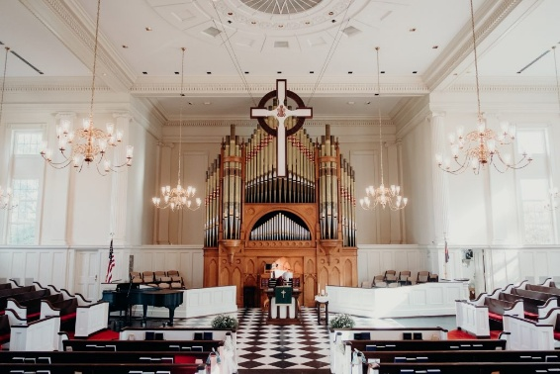

FIRST FRIDAY ORGAN CONCERT

November 7, 2025
12:15 pm followed by Lite Lunch

CHURCH OFFICERS:
Treasurer – Colleen Cash
Members of Session - Jean Hashagen, Betsy Ruehl
Cynthia Hoover, Bob Miller and Nancy Hypes.



COLLECTING PERSONAL CARE ITEMS FOR FOOD BANK
Shampoo, Soap, Deodorant & Toothpaste

COLLECTING NON-PERISHABLE ITEMS for
WAYNESBORO HIGH SCHOOL FOOD BANK
Healthy snacks like granola bars and grab-and-go items

MISSION/OUTREACH SEPTEMBER 2025

- Ordered and received food from Blue Ridge Area Food Bank September 9 and 23. Volunteers assembled 20 pantry boxes for each order.
- Maintained temperature logs for refrigerators and freezers.
- Food Bank was held September 4, 11, 18 and 25.
- Purchased bread and margarine for Food Bank weekly.
- Increased availability of fresh produce.
- Completed pantry inventory and report: Served 134 individuals and 42 households.
- Weekly cleaned all surfaces, vacuumed and mopped floors.
- CROP Walk September 21: Our team members included Samantha Coggins, the Shaner/Fitzgibbon family including Janet, Bill, Patrick and Lenore, Jean Hashagen, John and Cynthia Hoover, Phil Floyd, John Ong, Joe Earhart and friend. FPC raised $975. 25% of the funds stay locally and are donated to Meals on Wheels, Disciples’ Kitchen, and Blue Ridge Area Food Bank.
- Presented summary of the food pantry mission at Westminster PC September 28
- Next Disciples’ Kitchen is November 11.
- Collecting socks, hats and gloves for Disciples’ Kitchen Christmas effort. --Cynthia Hoover, Mission Chair



BENEFIT TO SUPPORT
Waynesboro Area Refuge Ministry (WARM)
Dinner and Concert by Schola Cantorum
First Baptist Church
November 23, 5-7:30 p.m.
$60 all inclusive
Tickets can be purchased by calling 540-324-8166.

Founded in 2011, WARM is a Christian community that organizes cold weather shelter as well as transitional housing and outreach programs in Waynesboro and Augusta County. It provides emergency and temporary housing to individuals and families who lack the financial resources to maintain stable housing.
Housing during the winter months is primarily in area churches. In addition, Ruth’s WARM house on Fairfax Avenue helps moms work towards financial, emotional and spiritual stability that ensures their long-term success.
The leaders, staff and volunteers of WARM believe that it is our community responsibility – but more importantly our brotherly duty – to feed the hungry, give shelter to the homeless, and in by doing so show God’s great love for them.

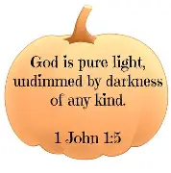


SESSION HIGHLIGHTS

Session held a Stated Meeting on October 21.
- The transition of classes at FPC by Fishburne cadets has been smooth.
- In recognition of high-quality work for memorial services and transitions with Fishburne Military School, above and beyond the call of duty, a bonus was approved for Colleen Cash.
- Jean Hashagen was elected Commissioner to the meeting of Shenandoah Presbytery on November 15.
- Cynthia Hoover was elected to serve as a FPC trustee of Shenandoah Presbytery Corporation.
- The Clerk attended at workshop at Massanetta Springs presented by the Presbyterian Historical Society regarding preservation of church records.
- Pastor’s Report: Samantha will be nominated to serve as representative from Shenandoah Presbyterian to the 2026 meeting of General Assembly. Appointed to Presbytery Committee Commission of Preparation for Ministry (CPM) effective January 2026. Emphasis on pastoral care when possible. Present Book Study concluding October 26; planning for new Book Study in January. Rev. Melissa Leigh Harmon presided at worship on October 12.
- Session approved Building Security policy which will be conveyed to congregation.
- Colleen Cash, Joe Earhart and Jean Hashagen were delegated to sort out the Barksdale Room kitchen.
- Mission/Outreach Report provided (published elsewhere).
- Preschool – Children enjoyed having police dog on site. Several teachers have accepted invitations to lunch at Fishburne.
- P&M – Hole in section of eaves facing Wayne Ave. Fishburne is monitoring all alarms including sanctuary and Preschool. Elevator has serious issues, is too old to be repaired, and needs to be replaced.
- Presbyterians Better Together church representatives met at FPC October 19. Second PC will host a Blue Christmas service on December 7. There will be joint worship and seed-packing event on February 22.
- The 2026 “Asking Budget” (pledge to Presbytery) was received.
- All Session meetings are opened and closed with prayer. The next Stated Session Meeting will be November 11.
--Betsy Ruehl, Clerk of Session

“BETTER TOGETHER’ BIBLE STUDY

1:00 p.m. Mondays
November 3 – FPC, November 10 - Second PC
November 17 – Hermitage, November 24 – Finley Memorial, Stuarts Draft

FIRST PRESBYTERIAN SAINTS

November 1, 2024 – October 31, 2025
Celebrating the lives of
Nancy Snyder, Margie Hartley, Jean Droughman and Joyce Neufeld

Preschool News!!

We have had a fantastic October with so many exciting events happening here at the preschool. The children got to experience Endless View Farms pumpkin patch. They had so much fun with so many options for things to do. The corn maze and the giant slide enticed most children as well as the adults! Officer Danich and K-9 Nala came for a visit to talk about safety on the streets and how to approach a K-9, as well as their duties when working. The preschool held their 2nd annual Trunk-or-Treat for the community, and we had a wonderful turnout again this year!!
Our preschool will have the pleasure of helping one of our families in need for Thanksgiving as well as Christmas.

Upcoming dates to remember:
October 30th: Trick-or-Treat- 10:30am Barksdale Room
November 26th-28th- Closed for Thanksgiving break



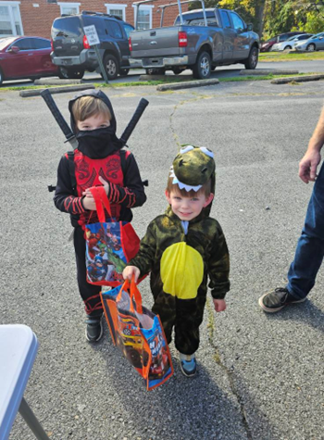

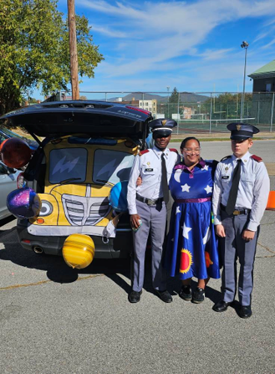

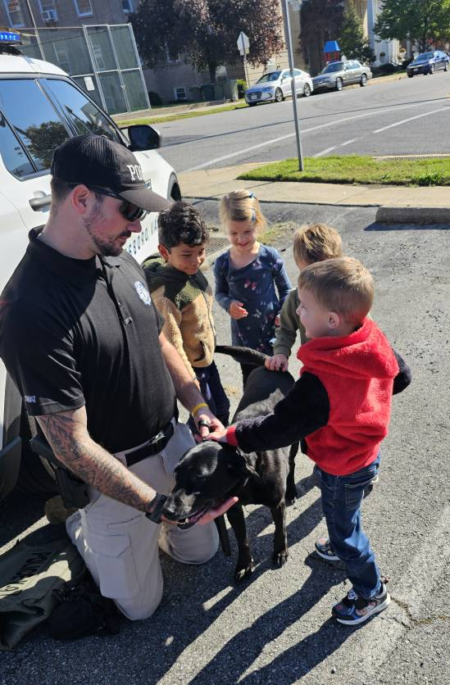


LITURGISTS

2 -- Betsy Ruehl

9 – Patrick Fitzgibbon

16 – Cynthia Hoover

23-




6 - Betty Johnson 30 - Joe Earhart/Terry Crickenberger

9 - Max Daggy

29 – Richard Curry

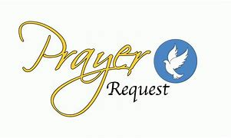
30 – Mitchell Lawrence

Shenandoah Nursing Home: Nancy Garber

Home: Mary Ultee, Mary Ann Maupin, Warner Sandquist, Polly Bare, Olive Prettyman.

Friends and Family: Bill Bromley, Jean Custen, Sally McNeel, Col. Stuart Roberts (Mark Henderson), Carolyn Hedrick-Williams, (Colleen Cash), Betsy Boswell (Curry), Shane Bennett (Bennett).

Military: Carson Craig, Michael Little



Our Christian sympathies to Lewis and Ruth Kelley. Their son, Jake Harner, died on October 10, 2025.
Jake volunteered at our Food Bank for years. Per Jake’s wishes there will not be a service.

THANKSGIVING PRAYER, BOOK OF COMMON PRAYER

Accept, O Lord, our thanks and praise for all that you have done for us. We thank you for the splendor of the whole creation, for the beautification of this world, for the wonder of life, and for the mystery of love.
We thank you for the blessing of family and friends, and for the loving care which surrounds us on every side.
We thank you for setting us at tasks which demand our best efforts, and for leading us to accomplishments which satisfy and delight us.
We thank you also for these disappointments and failures that lead us to acknowledge our dependence on you alone.
Above all, we thank you for your Son Jesus Christ, for the truth of his word and the example of his life, for his steadfast obedience, by which he overcame temptation; for his dying, through which he overcame death; and for his rising to life again, in which we are raised to the life of your kingdom.
Grant us the gift of your Spirit, that we may know Christ and make him known, and through him, at all times and in all places, may give thanks to you in all things. Amen


THESE DAYS
Daily Devotions for Living by Faith

These Days is a quarterly publication by the Presbyterian Publishing Corp which reminds me of The Upper Room. The daily articles include scripture and prayer and are written by both pastors and laymen. Selections will appear in forthcoming newsletters. --Betsy Ruehl

The Gift of Time
“You know what time it is.” Romans 13:11a

As I write this reflection, we just gone through another daylight savings time change. One Sunday morning, I got lulled into thinking I could sleep an hour longer because it was so dark outside. I sprang up when I checked the bedroom clock and realized I was going to be late for church. That same evening, I stayed out rocking on our veranda and lost track of time. I was judging time by daylight rather than the clock.
Those reading or hearing Paul’s letter were wondering when the time would come for Jesus to return as he had promised. Paul cautions them and us not to spend time speculating about when that time will be. Instead, Paul urges us to be ready for Jesus’ promised return. Let us give thanks for the time we are given to be ready for the Lord and to spread more of God’s love in the world.
O Lord, grant us the energy and the insight to use our time wisely.
--June Begany, Bradenton, Florida

VETERANS DAY


Veterans Day is a nationally observed public holiday celebrated on November 11 each year. It honors the signing of the armistice that ended World War I. It is distinct from other U.S. holidays that honor veterans in that it is dedicated to all who served.
It is customary to fly the American flag at half-mast during at least a portion of the day. It I traditional to observe two minutes of silence or prayer at 11 a.m. The moment of silence is supposed to be on the eleventh hour of the eleventh day of the eleventh month of the year.

BY GOD’S GRACE
A Thanksgiving Message

Thanksgiving is simply not forgetting, St. Paul said, everything is God’s grace. He said, “I am who I am by God’s grace.”
The fact that I can breathe is God’s grace. That I can have a good and peaceful sleep at night is God’s grace.
People who don’t feel God’s grace live with the tremendous burden that everything depends on them. That’s sad. Life is more than what they can make with their own hands.
Sometimes our suffering is God’s hidden blessing. Some things you can never learn without suffering – such as humility and your limitations. Without suffering you cannot learn that life is about helping each other. You cannot learn that you can be stronger without suffering. Suffering will always be there; do not let it make you weak.
Don’t fall into spiritual amnesia. Every day learn to appreciate small things. Verbalize your appreciation. Express it – to others, to yourself, and to God. Spiritual people are filled with thanksgiving.
Don’t make your life complicated. Be thankful for the roses. But also be thankful for the thorns. That is life’s secret.
Thankfulness opens your life. Complaints and criticism close your life. When you are thankful, you will see a path you didn’t see before.
Thanksgiving will give you life’s confidence.
This is Paul’s confession: “Not that I am referring to being in need, for I have learned to be content with whatever I have. I know what it is to have little, and I know what it is to have plenty. In any and all circumstances I have earned the secret of being well-fed and of going hungry, of having plenty and of being in need. I can do all things through him who strengthens me.” (Philippians 4:11-13).
He said, “I can do all things.” Not because of his own abilities but because of the one who strengthened him.
Don’t forget that life is a gift. Enjoy it and be thankful.

Happy Thanksgiving!

(Excerpts from a Thanksgiving Day sermon at St. Timothy
Presbyterian Church in Toronto, Canada)

REAL NEED FOR ADDITIONAL FOOD IN OUR COMMUNITY

Our Mission Chair Cynthia Hoover, in charge of FPC’s weekly Food Bank, reports a surge of clients at our Food Bank in October. Normally we serve 18 people (households) weekly. On October 21 twenty-seven folks showed up, including nine new faces, and essentially wiped out our pantry. Our freezers were empty. An additional trip to the Blue Ridge Area Food Bank in Verona in October was necessary.
A meeting will be held at the Blue Ridge Area Food Bank to discuss the coming changes in the SNAP (food stamps) benefits. Most SNAP recipients live paycheck to paycheck and will be direly affected by their discontinuation.
Homelessness is a real continuing problem in our community. A couple of years ago it was noted that there were 109 homeless students at the high school. 65% qualified for food assistance during school.
Requests during the holidays always increase. Please consider contributions to our church during the coming two months in the form of financial support, foodstuffs - or both. If you’ve been doing a little, try to do a lot.
Jesus said, “It is more blessed to give than to receive.” Let those of us who can, give, and give generously. --Betsy Ruehl







Daylight Saving Time End Saturday Night
November 1, 2025



Sunday,
November 2

11

am Worship

Monday,
November 3

1 pm

Better Together
Bible Study

First Presbyterian

Tuesday
,

November 4

6 pm

Symphony
Dress
Rehearsal Sanctuary

Thursday,
November

6

6 pm Symphony
Dress Rehearsal Sanctuary

6
-
7:30

pm

Food Bank

Friday, November
7

12:15 pm First Friday Organ
Concert with Lite Lunch
Sunday,
November

9

11 am Worship

Monday,
November

10

1 pm Better
Together

Bible Study Second P
resbyterian
Tuesday, November

11

2:30

pm
Session

Meeting

Barksdale

Room

6 pm Symphony Chamber Dress Rehearsal

Thursday,
November

13

2
-
4 pm

Food Bank

Friday, November 14

Bridge Tournament

Sunday,
November

16

11 am Worship

3 pm

Symphony Concert

Monday

November
17

1 pm Better Together Bible Study Hermitage Presbyterian
Thursday, November 20

6
-
7:30 pm Food Bank

Sunday November
23

11 am

Worship

Monday,
November
24

1 pm Better Together

Bible Study Finley Memorial Stuarts Draft

Thursday, November
27

Thanksgiving Day

Friday, November 28

Office Closed

Sunday, November 30

1
st

Sunday in Advent

11 am Worship

