22nd SUNDAY AFTER PENTECOST November 9, 2025
Liturgist: Patrick Fitzgibbon

PRELUDE Our Father in Heaven, BWV 683 Bach (1685-1750)

WELCOME & ANNOUNCEMENTS

INTROIT Rejoice, Ye Pure in Heart Dirksen (1921-2003)

CALL TO WORSHIP
Leader: Make a joyful noise to the Lord, all the earth!
All: We will break forth into joyous songs and sing praises.
Leader: Sing praises to the Lord.
All: Make a joyful noise with trumpet and the sound of the horn.
Leader: Let the sea roar, and all that fills it, the world and those who live in it.
All: The floods clap their hands, and the hills sing out together.
Leader: Let us join in the joyful song of creation.

MORNING PRAYER

*OPENING HYMN #363 Rejoice, The Lord is King! DARWALL’S 148TH

CHILDREN’S SERMON

CALL TO CONFESSION

PRAYER OF CONFESSION
Gracious God, we confess that we are too easily influenced by peddlers of despair and alarm, too quick to sink into numbness and apathy, too tired to imagine another way. Our hopes have crumbled, and our hearts are faint. Breathe new life into us, we pray. Help us to be mindful of your promises, your faithfulness, and your presence as we face the challenges of our lives. Restore our vision and give us courage to live in your truth. Amen.

SILENT PRAYER

ASSURANCE OF PARDON

*HYMN #581 Glory Be to the Father GLORIA PATRI

FIRST SCRIPTURE LESSON Haggai 2:1-9 p. 768

ANTHEM God, Whose Giving Knows No Ending arr. Wood (1921-2003)
(text can be found in hymn 716)

SECOND SCRIPTURE LESSON 2 Thessalonians 2:1-5, 13-17 p.961

SERMON Prosperity in This Place Rev. Samantha Coggins

*AFFIRMATION OF FAITH p. 35

PRAYERS OF THE PEOPLE & THE LORD’S PRAYER

*CLOSING HYMN #837 What a Fellowship, What a Joy Divine SHOWALTER

*CHARGE & BENEDICTION

POSTLUDE The King Sitteth at His Table, Op. 18, no. 5 Dupré (1886-1971)

This week’s liturgy is written by Haley Ballast and the Presbyterian Outlook.

Today’s Link: https://www.youtube.com/watch?v=5JDwBCavYFs



NOVEMBER 11, 2025


Shenandoah Nursing Home: Nancy Garber

Home: Mary Ultee, Mary Ann Maupin, Warner Sandquist, Polly Bare, Olive Prettyman.

Friends and Family: Bill Bromley, Jean Custen, Sally McNeel, Col. Stuart Roberts (Mark Henderson), Carolyn Hedrick-Williams, (Colleen Cash), Betsy Boswell (Curry), Shane Bennett (Bennett).

Military: Carson Craig, Michael Little


An offering plate is available in the narthex.

Decorating for Advent & Christmas
We will decorate our church building for Christmas on Saturday, November 22 (the Saturday before Thanksgiving) at 10:30 a.m. This year we are looking for folks to hang garland in the balcony. Please contact Samantha if you plan to help!



Disciples’ Kitchen
Donations will be accepted until
November 11, 2025.
Collection box in the Narthex

Serving dinner for WARM shelter
Our church will serve dinner for the WARM cold weather shelter at Westminster Presbyterian Church on Saturday, December 20th at 5:30 pm. Volunteers are needed to provide dessert, and to serve the meal from roughly 6 pm onward. We will prepare for 30 guests, 5 WARM volunteers, and our dinner crew, for a total of 40 individuals. We will stay until roughly 7:45 pm, cleaning up the kitchen after serving. Please contact Samantha if you plan to help.

FIRST PRESBYTERIAN CHURCH
WAYNESBORO, VIRGINIA

A community-minded congregation living out the love of Christ as we serve one another with humility, gentleness, and patience through God’s grace.

November 9, 2025 11:00 AM
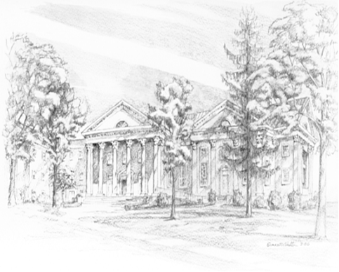

P.O. Box 877
249 South Wayne Avenue
Waynesboro, Virginia
(540) 949-8366
Church Website: www.firstpresway.org
Preschool Website: www.firstprespre.org
Email: church@firstpresway.com

