

THE COLUMNS
First Presbyterian Church, Waynesboro, VA
December 2025, Volume 63, Issue 12
First Presbyterian Church of Waynesboro is a community-minded
congregation living out the love of Christ as we serve one another with
humility, gentleness, and patience through God’s grace.

15 Toward evening the disciples approached him. “We’re out in the country and it’s getting
late. Dismiss the people so they can go to the villages and get some supper.”
16 But Jesus said, “There is no need to dismiss them. You give them supper.”
17 “All we have are five loaves of bread and two fish,” they said.
18-21 Jesus said, “Bring them here.” Then he had the people sit on the grass. He took the
five loaves and two fish, lifted his face to heaven in prayer, blessed, broke, and gave the
bread to the disciples. The disciples then gave the food to the congregation. They all ate
their fill. They gathered twelve baskets of leftovers. About five thousand were fed.
Matthew 14:15-21

When in doubt, always quote scripture. This is not one of the rules I have painstakingly collected over the years,
but perhaps it should be. Last month, we began with insights into basketball; for May, we are diving back into
the New Testament for illumination.
We are conditioned, I think, to look at the miraculous as magical, the theological equivalent of alchemy. Just as
the medieval alchemist sought to turn lead into gold, and thus enrich themselves without labor, we look at
miracles at least in part, as labor-saving plot devices: healing without the effort of treatment; gifts that eliminate
the need for impossible choices; rescue that makes of us passive recipients of grace. But, in the words of yet
another of my rules, God is not a magician; what we call miracles are signs of God at work in our midst - and
God hates to work alone.

In the feeding of the multitude, the disciples recognize a need - the crowd is getting hungry and the day is
mostly gone. This is a real problem, they know, but the best they can come up with is to send the crowds
back to town, where they might find some supper. But Jesus has something else in mind; not just pushing
the problem down the road, but actually doing something about the hunger of the people. He asks what
food is available, and is told, 5 rolls and 2 cooked fish - the lunch of a well-prepared young man. Jesus
then does the miraculous, but the miracle isn&#39;t magic- Jesus does not make everyone feel full, or have
manna fall from the heavens. The miracle happens through the work of the disciples. It is the disciples
who organize the people, getting them to sit down in an orderly fashion; they who oversee the distribution
of the loaves and fishes, making sure everyone is fed; even making sure the leftovers are collected. And
that, friends, leads us to Rule #10:

Dear members & friends of First Presbyterian Church,

I commend to you our schedule of Advent & Christmas worship services, found below. This year we will have two (2) services of Lessons and Carols (12/14, 12/24) and one hymn sing (12/28), enabling us to enjoy familiar hymns of preparation and familiar hymns of Christmas, as one congregation.

I look forward to worshiping alongside you, during this season that begins with darkness and ends with the light of Christ. May you behold God. May you be held by God.
Behold and be held.

Grace & peace,
Samantha

Sunday, December 7 - The Second Sunday in Advent
Worship at 11:00 a.m. We light a candle for Peace.

Sunday, December 14 - The Third Sunday in Advent
A service of Lessons & Carols at 11:00 a.m. We light a candle for Joy.

Sunday, December 21 - The Fourth Sunday in Advent
Worship at 11:00 a.m. We light a candle for Love.

Wednesday, December 24 - Christmas Eve
A service of Lessons & Carols at 4:30 pm. We light the Christ candle.

Sunday, December 28 - The First Sunday of Christmas
Worship via hymn sing at 11:00 a.m.




DECEMBER MUSIC NOTES

We embark on a new church year with the season of Advent. This month, we will sing familiar carols and hear other seasonal pieces that help us prepare our hearts and minds for the coming of our Lord and Savior.

We open the season with one of the most ancient of all Advent hymns, O Come, O Come Emmanuel. The tune has been sung for over a millennium, originally intoned by monks in the 8th century. It has been used by scores of composers ever since, including Ottorino Respighi (1879-1936), who quoted the melody in “The Gift of the Magi” movement of his Three Botticelli Pictures. The tune also found its way into Samuel Barber’s (1910-1981) Die Natale. More recent renditions include U2’s 2009 song, “White As Snow” and Kelly Clarkson’s version in her 2013 holiday album, Wrapped in Red.

For the second week of Advent, we will sing two selections preparing for the way of the Lord. The opening hymn, Prepare the Way, O Zion, is a Swedish melody first published in 1697 in a collection called Then Swenska Psalmboken (The Swedish Psalm Book). Franz Michael Franzén (1772-1847) paired the popular Swedish tune with the Advent text. The English version was created by Augustus Nelson (1863-1949), a Swedish immigrant who settled in Minnesota in 1883 and was ordained as a Lutheran minister in 1898.

The choir will then sing Prepare the Way of the Lord, composed in 1987 by William Rowan (b. 1951). The native of San Diego, CA, received undergraduate and graduate degrees from Southern Illinois University, and a Masters degree from the University of Michigan. Rowan is currently the Director of Music at St. Rita Parish in Dallas, Texas.

Advent III will be the first of two Lessons and Carols services this month. On 14 December, the focus will center on Mary and her response to hearing the news that she will bear the Son of God. This service features music that helps us prepare for the coming of the Lord, with familiar hymns including Come Thou, Long Expected Jesus; Lo, How a Rose and Let All Mortal Flesh Keep Silence. Soprano Jean Hashagen will respond to the Magnificat singing Mary, Did You Know. This popular modern tune was composed by Buddy Greene (b. 1953) in 1991.

On the fourth Sunday of Advent, the choir will sing Wait for the Lord, one of many tunes written for the Taizé community in Burgandy, France. The chant, one of many written by Jacques Berthier and Joseph Gelineau for the Taizé brethren, features simple short phrases repeated again and again to create a meditative state of mind and ultimately bringing people closer to God.

This year, FPC’s Christmas Eve Lessons and Carols service will commence at 4:30, when we will sing many of the ancient carols associated with the birth of Christ, including O Come, All Ye Faithful, The First Nowell, It Came Upon a Midnight Clear and Silent Night. Other musical selections include The People that Walked in Darkness from Messiah by Handel and the perennial favorite, O Holy Night by Adam. The choir will also sing what has become an annual tradition, Roger Emerson’s Rise Up, Shepherd. We are thrilled that our resident percussionist extraordinaire, Randy Hypes, will play with the choir!

On the final Sunday of December, we will celebrate the Christmas season with a Hymn Sing. We look forward to singing familiar carols and hymns that spring forth with the joy of the birth of Christ.

We remain grateful to First Presbyterian Church for the unwavering support of the music program. May you and your loved ones enjoy a blessed Advent and Christmas season!

Roger and Kimberlea Daggy

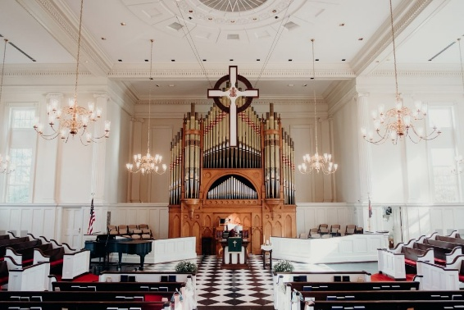

FIRST FRIDAY ORGAN CONCERTS
(No Concert in January)
February 6 – 12:15 in the Sanctuary
followed by a light lunch in the Barksdale Room

CHURCH OFFICERS:
Treasurer – Colleen Cash
Members of Session - Jean Hashagen, Betsy Ruehl
Cynthia Hoover, Bob Miller and Nancy Hypes.

“BETTER TOGETHER’ BIBLE STUDY
1:00 p.m. Mondays
December 3 – FPC, December 10 - Second PC
On hiatus the rest of December



MISSION/OUTREACH OCTOBER 2025

- Ordered and received food from Blue Ridge Area Food Bank October 7 and 21. Volunteers assembled 20 pantry boxes for each order.
- Maintained temperature logs for refrigerators and freezers.
- Food Bank held October 2, 9, 16 and 23.
- Purchased bread and margarine for Food Bank weekly.
- Increased availability of fresh produce.
- Completed pantry inventory and report: Served 155 individuals and 59 households.
- Weekly cleaned all surfaces, vacuumed and mopped floors.
- Presented summary of the food pantry mission to Boy Scouts at Westminster PC September 28.
- Prepared schedule to staff Food Bank for November and December.
- Experienced unprecedented use of Food Bank on October 23 (27 clients) which emptied the pantry and required an extra order from BFAFB.
- WARM Shelter Meal at Westminster PC on Friday, December 19, at 5:30, will be prepared and served by FPC.
- Collecting socks, hats and gloves for Disciples’ Kitchen Christmas effort.
- Baby Drive being organized. --Cynthia Hoover, Mission Chair


COLLECTING
Socks, hats and gloves for Disciples’ Kitchen
Deadline extended – Collection Box in the Narthex
Merry Christmas!

SESSION HIGHLIGHTS

Session held a Stated Meeting on November 11, 2025.
- The transition of classes at FPC by Fishburne cadets has been smooth.
- Pastor’s Report: Samantha will be out of the office for Thanksgiving. She met with the Daggys and Nancy Hypes to discuss worship during advent.
- Samantha’s contract renewal is due by December 4. Bob Miller will take charge following Session’s review.
- As trustees of FPC, Session is interested in reviewing its endowed/invested funds with Shenandoah Presbytery.
- Mission/Outreach Report provided (published elsewhere).
- Preschool – Christmas program will be December 18. At the request of Preschool Principal Tami Hemp, Session approved holding a second class for 4-year-olds. Rationale: Need for care of Preschool age children in the community and FPC having the capacity to fill this need.
- P&M – Hole in section of eaves facing Wayne Ave. still needs repair. Men’s toilet has been repaired. Fishburne cleans its classrooms and environs.
- Presbyterians Better Together church representatives will meet at FPC November 19 regarding Second PC’s Blue Christmas service on December 7 and a joint worship and seed-packing event on February 22.
- Motion: Session pledged $5,100 to Presbytery in 2026 (75 members x $68).
- All Session meetings are opened and closed with prayer. The next Stated Session Meeting will be December 16 (change from 2nd Tuesday).
--Betsy Ruehl, Clerk of Session

HIGHLIGHTS of the
HIGHLIGHTS OF THE SHENANDOAH PRESBYTERY MEETING

The meeting was called to order at 9:30 on November 15 at Covenant Presbyterian Church in Staunton. The choir of Covenant plus Rev. Jeff Binder of Staunton PC and youth from Presbytery led worship.
Rev. Doug Sterrett, retired, who has moved into our presbytery, was introduced, as was Dr. Rebecca Lister, who has accepted a call to Cook’s Creek PC.
Reports were heard from Keenan Rodgers on the Board of Pensions’ Shared Pastoral Leadership program and from Lauren Rogers on the four Special Offerings. There will now be three, effective in 2026: One Great Hour of Sharing, the World Community Offering, and the Christmas Joy Offering.
The following have been selected as Commissioners to the 227th General Assembly in Milwaukee in June 2026: Ruling Elders Mark Facknitz, Trinity PC, and Joe Crockett, Bridgewater PC; Teaching Elders Samantha Coggins of Waynesboro First and Rob Vaughan, Romney PC.
The 2026 Presbytery budget was approved. Questions were answered about the per capital assessment for 2026.
The Youth of the Presbytery made a 35-minute presentation of their experiences in youth faith formation and retreats as well as opportunities for youth at Presbytery, Synod and Denominational levels.
Reports were given on both the most recent Presbytery mission trip to aid in North Carolina Hurricane recovery and about Cents-ability and Hunger Funds.
Shenandoah Presbytery Corp. gave its annual report.

Preschool News!!

November has been full of crazy weather, but we have all enjoyed the extra time spent outside playing in the leaves and watching the squirrels gather their nuts for when the cold weather comes all at once without warning.
We had our first career week here at the preschool and it was a great hit. The children loved having parents come and talk to them about what types of jobs they did during the day. We had visits from landscapers, plant growers, dental workers and even an IT worker for the US Army!
All our classrooms have been learning about Thanksgiving and how to be thankful for everything we are blessed to have in our lives. We had our Thanksgiving lunch with all our friends and teachers on Tuesday before the children went home for break.
Upcoming dates in December:
December 6th- Waynesboro Christmas Parade 6:00pm
December 18th- Christmas Program 6:30pm
December 29th- January 2nd- Winter Break (Return back to Preschool January 5, 2026)
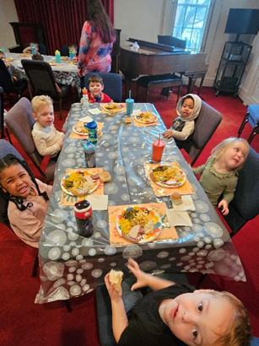

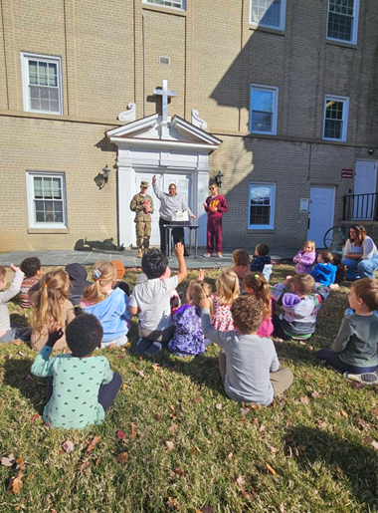




LITURGISTS

7– Patrick Fitzgibbon

14 – Cynthia Hoover

21 –

24 –

28 -


4- Jean Hashagen

12 – Connie Sachlis

14 – Nancy Garber, Roger Daggy

24 – Joyce Tipton

27 – Judy Tomey, Hunter Trimble

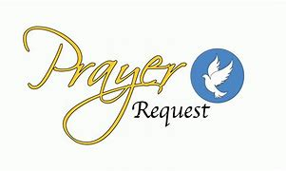
Shenandoah Nursing Home: Nancy Garber

Home: Mary Ultee, Mary Ann Maupin, Warner Sandquist, Polly Bare, Olive Prettyman.

Friends and Family: Bill Bromley, Jean Custen, Sally McNeel, Col. Stuart Roberts (Mark Henderson), Carolyn Hedrick-Williams (Colleen Cash), Betsy Boswell (Curry), Shane Bennett (Bennett).

Military: Carson Craig, Michael Little


IN MEMORIAM
Mitchell “Mitch” Payne Lawrence
November 30, 1927 – November 2, 2025

Rev. Dr. Howard W. Boswell
Pastor of Buena Vista Presbyterian Church
Husband of Shenandoah Presbytery General Presbyter and Stated Clerk
Rev. Bronwen Boswell
November 17, 2025



Needing Harking Time
But the angel said to them, ”Do not be afraid, for see,
I am bringing you good news of great joy for all the people.” Luke 2:10

On Christmas Eve when singing “Hark the Herald Angels Sing,” I find myself lingering on the old English word hark. It means “pay attention” or “listen up.” The shepherds, amid their daily labor were frightened yet awed as they looked up, listened and paid attention. And after a journey to a manger they experienced great joy!
For several years I have established a “harking practice” particularly when I am rushing here or there. I will stop, look, and listen, seeking what I call “God moments.” Often like the shepherds, I will look up. Many times, when I am engulfed in the natural world, I will inhale the moment with my whole being. I will take a picture of the moment and share it on my blog. I will experience great joy because I took harking time.

Incarnate Word help me this day to join the triumph of the skies. Amen.

--Bob Naylor, Mashpee, Massachusetts


Tuesday, December 2
6 pm Symphony Sanctuary Practice
Thursday, December 4
6 – 7:30 pm Westminster Food Bank
Saturday, December 6
3 pm Waynesboro Symphony Concert
Sunday, December 7
11 am Worship
1-6 pm Sarah Braveman Recital Practice
Monday, December 8
1 pm Better Together Bible Study, Second Presbyterian Waynesboro
Wednesday, December 10
10 am POD Study
Thursday, December 11
2 – 4 pm Food Bank
Saturday, December 13
1-5 pm Sarah Braverman Holiday Recital
Sunday, December 14
11 am Worship
Tuesday, December 16
2:30 pm Session Barksdale Room
Thursday, December 18
6-7:30 pm Westminster Food Bank
6 pm Preschool Christmas Program
Friday, December 19
5:30 pm Desserts to Westminster for WARM
Sunday, December 21
11 am Worship
Wednesday, December 24
4:30 pm Candlelight Service
Thursday, December 25 Merry Christmas
Friday, December 26
4 pm Smith Wedding Rehearsal
Saturday, December 27

2:30 pm Smith Wedding
Sunday, December 28
11 am Hymn Sing

