23rd SUNDAY AFTER PENTECOST November 16, 2025
Liturgist: Cynthia Hoover

PRELUDE Prelude in F, BuxWV 145 Buxtehude (1637-1707)

WELCOME & ANNOUNCEMENTS

INTROIT Let All the World in Every Corner Sing Routley (1917-1982)

CALL TO WORSHIP
Leader: We gather today as hungry people. Our spirits hunger for the truth of the gospel. Our
neighbors hunger for a meal.
All: Jesus fed the hungry with food. Jesus fills pits of despair with hope.
Leader: Jesus quenched thirst with water.
All: Our spirits will not stay dry. In Christ, we are baptized with living water.
Leader: Because of Jesus Christ, our cups overflow, and we are nourished.

MORNING PRAYER

*OPENING HYMN #645 Sing Praise to God Who Reigns Above MIT FREUDEN ZART

CHILDREN’S SERMON

CALL TO CONFESSION

PRAYER OF CONFESSION
Gracious and loving God, we confess that we are troubled by the events of our lives and the state of this world. Headlines are full of wars, insurrections, suffering, earthquakes, famine, and death. These things are enough to shake our faith and undermine our confidence in your promise. Lord, we believe; help our unbelief. Deliver us from speculation that distracts us from faithful living and loving service. Forgive us when we doubt your promises.
Help us to endure, that we may gain our souls, always bearing witness to your love and grace in Jesus Christ our Lord. Amen.

SILENT PRAYER

ASSURANCE OF PARDON

*HYMN #581 Glory Be to the Father GLORIA PATRI

FIRST SCRIPTURE LESSON Isaiah 12 p. 558

ANTHEM Alleluia, Praise! Cherubini (1760-1842)
arr. Wagner (b. 1952)

Alleluia, O praise the Lord,
In songs that echo the joy we have this day,
So celebrate the joy;
With music ringing, ever singing now,
O praise the Lord

SECOND SCRIPTURE LESSON Luke 21:5-19 p. 856

SERMON Livelihood Gains Rev. Samantha Coggins

*AFFIRMATION OF FAITH
In life and in death we belong to God. Through the grace of our Lord Jesus Christ,
the love of God, and the communion of the Holy Spirit, we trust in the one triune God, the Holy One of Israel, whom alone we worship and serve.

In gratitude to God, empowered by the Spirit, we strive to serve Christ in our daily tasks
and to live holy and joyful lives, even as we watch for God’s new heaven and new earth,
praying, "Come, Lord Jesus!”

With believers in every time and place, we rejoice that nothing in life or in death
can separate us from the love of God in Christ Jesus our Lord.

PRAYERS OF THE PEOPLE & THE LORD’S PRAYER

*CLOSING HYMN #610 O For a Thousand Tongues to Sing AZMON

*CHARGE & BENEDICTION

POSTLUDE Fugue in F, BuxWV 145 Buxtehude

This week’s liturgy was written by Samantha, and the Presbyterian Outlook (Philip Gladden)

Today’s Link: https://www.youtube.com/watch?v=x-MYjQAoe4A

Shenandoah Nursing Home: Nancy Garber

Home: Mary Ultee, Mary Ann Maupin, Warner Sandquist, Polly Bare, Olive Prettyman.

Friends and Family: Bill Bromley, Jean Custen, Sally McNeel, Col. Stuart Roberts (Mark Henderson), Carolyn Hedrick-Williams, (Colleen Cash), Betsy Boswell (Curry), Shane Bennett (Bennett).

Military: Carson Craig, Michael Little

Our Christian sympathies to the family of Mitchell Lawrence, Jr. who died November 2, 2025, in Leesburg VA.


Decorating for Advent & Christmas
We will decorate our church building for Christmas on Saturday, November 22, (the Saturday before Thanksgiving) at 10:30 a.m. This year we are looking for folks to hang garland from the balcony. Please contact Samantha if you plan to help!



Disciples’ Kitchen
Donations will be accepted thru November
Collection box in the Narthex

Serving Dinner for WARM Shelter
Our church will serve dinner for cold weather shelter at Westminster Presbyterian Church on Saturday, December 20 at 5:30 pm. Volunteers are needed to provide dessert, and to serve the meal from roughly 6 pm onward. We will prepare for 30 guests, 5 WARM volunteers, and our dinner crew, for a total of 40 individuals. We will stay until roughly 7:45 pm, cleaning up the kitchen after serving. Please contact Samantha if you plan to help.


An offering plate is available in the narthex.

FIRST PRESBYTERIAN CHURCH
WAYNESBORO, VIRGINIA

A community-minded congregation living out the love of Christ as we serve one another with humility, gentleness, and patience through God’s grace.

November 16, 2025 11:00 AM
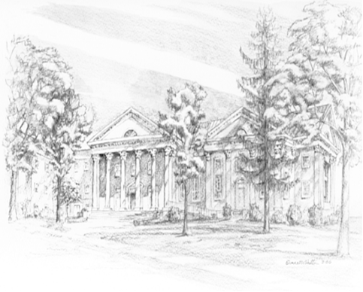

P.O. Box 877
249 South Wayne Avenue
Waynesboro, Virginia
(540) 949-8366
Church Website: www.firstpresway.org
Preschool Website: www.firstprespre.org
Email: church@firstpresway.com

