The First Sunday of Christmas Hymn Sing December 28, 2025
Welcome to our Christmas hymn sing at First Presbyterian Church. Today our worship takes the form of song, as we celebrate the coming of Emmanuel by selecting hymns that bring us joy as a community. You will be invited by our music staff to request a hymn, where indicated. Let us worship God with hymnody!

Prelude: Noel VIII d’Aquin (1694-1772)
Call to Worship (Samantha)
*Opening Hymn #113 Angels We Have Heard on High GLORIA
Children’s Message
Hymn: congregational request #1
Hymn: congregational request #2

Call to Confession
Prayer of Confession
Hymn: congregational request #3
Hymn: congregational request #4
Gospel Reading: Matthew 2:13-23 p.784
Prayer for Illumination
Homily Terry Crickenberger
Prayers of the People & The Lord’s Prayer
Hymn: congregational request #5
Hymn: congregational request #6
*Closing Hymn #119 Hark the Herald Angels Sing MENDLESSOHN
*Benediction
Postlude Noel XII d’Aquin…
Choose from the following: Congregational Requests
116 The Snow Lay on the Ground
118 While Shepherds Watched Their Flocks
121 O Little Town of Bethlehem
123 It Came Upon a Midnight Clear
124 Still, Still, Still
130 Break Forth, O Beauteous Heavenly Light
136 Go, Tell It on the Mountain
140 Once in Royal David’s City
143 Angels, from the Realms of Glory
144 In the Bleak Midwinter
146 Gentle Mary Laid Her Child (Good King Wenceslas)
(or choose a selection from hymns 108-156)

Today’s link https://www.youtube.com/watch?v=3NwQcPlKaBY

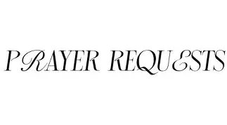

Shenandoah Nursing Home: Nancy Garber
Home: Mary Ultee, Mary Ann Maupin, Warner Sandquist, Polly Bare, Olive Prettyman.
Friends and Family: Bill Bromley, Jean Custen, Sally McNeel, Col. Stuart Roberts (Mark Henderson), Carolyn Hedrick-Williams (Colleen Cash), Betsy Boswell (Curry), Damon Prettyman (Olive Prettyman).
Military: Carson Craig, Michael Little

Book Study Fellowship is back in 2026. Meetings are on Wednesdays at 10:00 a.m. in the Barksdale Room. We will resume after the holidays starting on January 7 and January 21 (please note we will not meet January 14 or January 28) and continue weekly through the month of February. The book is Lila by Marilynne Robinson, continuing in the ‘Gilead’ series. There will be a small stock of books available in the church office. To claim a book, e-mail Samantha.


An offering plate is available in the narthex.

FIRST PRESBYTERIAN CHURCH
WAYNESBORO, VIRGINIA

A community-minded congregation living out the love of Christ as we serve one another with humility, gentleness, and patience through God’s grace.

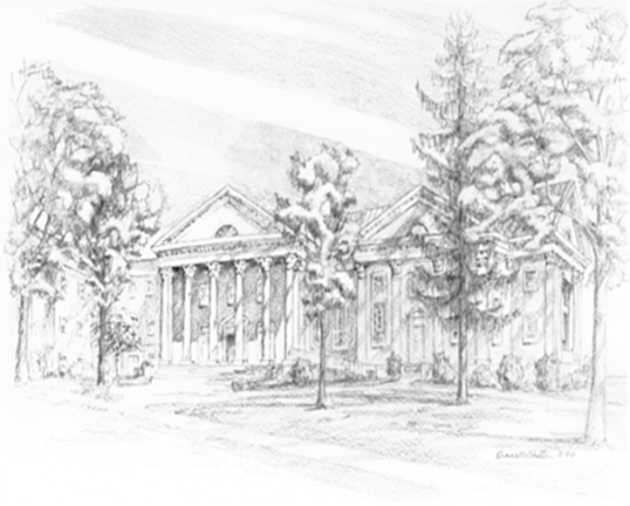
December 28, 2025, 11:00 AM
P.O. Box 877
249 South Wayne Avenue
Waynesboro, Virginia
(540) 949-8366
Church Website: www.firstpresway.org
Preschool Website: www.firstprespre.org
Email: church@firstpresway.com

