

THE COLUMNS
First Presbyterian Church, Waynesboro, VA
January 2026, Volume 64, Issue 1
First Presbyterian Church of Waynesboro is a community-minded
congregation living out the love of Christ as we serve one another with
humility, gentleness, and patience through God’s grace.

15 Toward evening the disciples approached him. “We’re out in the country and it’s getting
late. Dismiss the people so they can go to the villages and get some supper.”
16 But Jesus said, “There is no need to dismiss them. You give them supper.”
17 “All we have are five loaves of bread and two fish,” they said.
18-21 Jesus said, “Bring them here.” Then he had the people sit on the grass. He took the
five loaves and two fish, lifted his face to heaven in prayer, blessed, broke, and gave the
bread to the disciples. The disciples then gave the food to the congregation. They all ate
their fill. They gathered twelve baskets of leftovers. About five thousand were fed.
Matthew 14:15-21

When in doubt, always quote scripture. This is not one of the rules I have painstakingly collected over the years,
but perhaps it should be. Last month, we began with insights into basketball; for May, we are diving back into
the New Testament for illumination.
We are conditioned, I think, to look at the miraculous as magical, the theological equivalent of alchemy. Just as
the medieval alchemist sought to turn lead into gold, and thus enrich themselves without labor, we look at
miracles at least in part, as labor-saving plot devices: healing without the effort of treatment; gifts that eliminate
the need for impossible choices; rescue that makes of us passive recipients of grace. But, in the words of yet
another of my rules, God is not a magician; what we call miracles are signs of God at work in our midst - and
God hates to work alone.

In the feeding of the multitude, the disciples recognize a need - the crowd is getting hungry and the day is
mostly gone. This is a real problem, they know, but the best they can come up with is to send the crowds
back to town, where they might find some supper. But Jesus has something else in mind; not just pushing
the problem down the road, but actually doing something about the hunger of the people. He asks what
food is available, and is told, 5 rolls and 2 cooked fish - the lunch of a well-prepared young man. Jesus
then does the miraculous, but the miracle isn&#39;t magic- Jesus does not make everyone feel full, or have
manna fall from the heavens. The miracle happens through the work of the disciples. It is the disciples
who organize the people, getting them to sit down in an orderly fashion; they who oversee the distribution
of the loaves and fishes, making sure everyone is fed; even making sure the leftovers are collected. And
that, friends, leads us to Rule #10:

Dear members & friends of First Presbyterian Church,

Below are several opportunities for fellowship, worship, mission and outreach at our church this winter. I invite you to participate in these activities as the Spirit moves you, heeding our continued call in 2026 to witness to God’s goodness in our midst!

As the new year takes off, may the manifested light of God at Epiphany be yours.

Grace & peace,
Samantha

Book Study Fellowship - Lila by Marilynne Robinson
Wednesdays at 10:00 a.m., Barksdale Room

Please note we will reconvene on January 7, then meet once more in the month of January. We resume meeting weekly in February. Depending on the group’s desired pace of reading, we will conclude on or before March 11. If you still need a copy of Lila, please contact Samantha or stop by the church office. Books are available at no charge.

January 7
January 21
February 4
February 11
February 18
February 25
March 4
March 11

Better Together Service of Worship & Mission:
Sunday, February 22, 11:00 a.m., at FPC

On the first Sunday in Lent, we will worship alongside folks from all six (6) of our Better Together congregations (Smyrna, Finley, Westminster, Second Pres, Hermitage and our own
First Pres). We will begin in our sanctuary at 11:00 and then do a brief mission activity in our fellowship hall. We will be led by the Society of St. Andrew – a gleaning organization whose mission is to end hunger and food insecurity – in a mission project of packing garden seeds. We will celebrate Communion together, and then have lunch, concluding at 1:00 pm. To sign up to provide food and/or serve lunch, please contact Samantha or Colleen in the church office.

Mr. Rogers Day
Mr. Rogers Day, our denomination celebration of the ministry & life of Fred Rogers, is March 20 this year. During that week, we will host our 2nd annual free meal & time of worship, geared toward the children in our community (as we did last year!). Stay tuned for a confirmed date & time.
MUSIC NOTES

Happy New Year!

As we embark on yet another new year, we reflect on the many ways in which God pours out His many blessings on First Presbyterian Church. We are thankful that FPC has trusted us to provide music for services and ceremonies throughout the year. We are also comforted by the relationships we have built, from people Roger knew growing up in Waynesboro to those acquaintances made more recently.

We are immensely thankful to the members of the choir. They commit time and energy, make themselves available and enhance the worship experience of those who attend FPC, either in person or virtually. Choir members include altos Betsy Ruehl and Susan Elder, sopranos Jean Hashagen and Janet Shaner and Basses Patrick Fitzgibbon and Maximilian Daggy. This past year, we also welcomed returning members Cathy Cunningham, soprano, Terry Crickenberger and Joe Earhart, tenors. And in this new year, Sue Wool will once again sing in the alto section! Alas, we were saddened by the departure of tenor Bill Pannill, as he and Jo now live in Charlottesville. And let us remember the contributions of Randy Hypes, whose percussion prowess brings added energy to the anthems on which he plays!

In addition to services, FPC hosts many musical programs in our fine Sanctuary, from concerts by the church’s ensemble-in-residence, the Waynesboro Symphony Orchestra, to piano recitals by students in Sarah Braverman’s studio to the First Friday Organ Concerts and Light Luncheons. These programs have become a staple for many in Waynesboro and beyond, providing the opportunity to hear the beautiful sounds that emanate from the 1893 Woodberry and Harris pipe organ. The added bonus is the delightful luncheon afterward, now beautifully coordinated by Joe Earhart, with wonderful assistance from Terry Crickenberger, Janet Shaner, Patrick Fitzgibbon and Max Daggy – and desserts made by members of the congregation! Again and again, those in attendance have told us how much they enjoy fellowship with others who appreciate the music.

We are thankful for not only the fabulous organ, but also the lovely Boston piano and double harpsichord in the Sanctuary. These instruments enhance the worship experience by allowing us to faithfully execute centuries of sacred music!

And finally, we are most grateful for the people who make First Presbyterian Church the spiritual home it is. Thanks to the congregation for attending services each week and participating in the worship experience. Thanks to the choir for enhancing the service with their joyful music. And, most importantly, we give thanks to God for the gift of music!

May your lives be filled with blessings in this new year -

Roger and Kimberlea Daggy



MISSION/OUTREACH REPORT – NOVEMBER 2025

- Ordered food from Blue Ridge Area Food Bank November 4, 11 and 25. Volunteers assembled 20 boxes of pantry dry goods.
- Maintained temperature logs, weekly cleaned all surfaces, vacuumed, mopped floors.
- Extra order to stock the pantry after increased number of clients on November 13.
- Food Bank distribution: November 6, 13 and 30.
- 99 individuals and 44 households served during the month.
- Disciples’ Kitchen: Served 71 meals on November 10; next dates are January 5 and March 30.
- Will serve WARM Shelter dinner at 5:30 on December 19.
- Collecting personal care items in December and January
--Cynthia Hoover, chair

SESSION HIGHLIGHTS

Session held a Stated Meeting on December 16, 2025.
A letter of thanks for her bonus was received from Colleen Cash.
Motion: Session reaffirmed that 2.8% COLA be given to church and preschool staff, effective January 1, 2026 (approved previously by email).
A report fromthe November 15 Presbytery Meeting was given. Cynthia Hoover was elected a member of the Shenandoah Presbytery Corp. She attended a meeting of the corporation following the Presbytery meeting.
Samantha attended a retirement lunch for Summit Square’s chaplain, David Wolfe and met his replacement, Tammy Persinger.
The new building insurance policy was received from Brotherhood Mutual.
Preschool: Samantha attended the staff Secret Santa Luncheon on December 13. She plans to resume chapel with the Twos in the new year. She will give the welcome and read the Nativity Story at the Christmas program.
Administration: Annual reviews will be held in December/January.
Mission/Outreach: Separate article elsewhere in the newsletter.
Worship: Samantha preached at a Fishburne chapel service on December 4 at the invitation of the chaplain. Ruling Elder Terry Crickenberger filled in for Samantha at FPC November 23.
Motion: Session approved serving Communion at the Christmas Eve service.
Motion: Session approved serving Communion in worship on January 11 (Baptism of the Lord Sunday) instead of January 4.
Motion: Session approved holding the Sunday morning worship service on February 22 in the Fishburne gym, part of a special program organized by the Better Together churches.
Motion: Session approved asking Fishburne’s chaplain Bob Phillips to preach at FPC in March.
P&M: Responsibilities between FPC and Fishburne are being worked out. eg. Fishburne will handle snow removal during the week, our Michael Griffith on the weekends. A meeting is scheduled for December 18. Lights are being left on after hours.
The church roll was reviewed. Several names were removed. Several more members will be contacted regarding their desired status with FPC.
All Session meetings are opened and closed with prayer. The next scheduled Stated Meeting is Tuesday, January 13.
--Betsy Ruehl, Clerk of Session
BAPTISM OF THE LORD
Celebrated Sunday, January 11, 2026

At the beginning of his public ministry, Jesus presents himself to John to be baptized in the Jordan.
The heavens open, the Holy Spirit descends as a dove and we hear the voice of God: “You are my Son,
the Beloved; with you I am well pleased” (see Psalm 2:7).
At this festival of the Christian year, we not only remember Jesus’ baptism, but we celebrate our own:
the baptism we share with Christ. Accordingly, this Sunday is an appropriate time to celebrate the sacrament of baptism or the reaffirmation of the baptismal covenant. It also foreshadows the season of Lent, as Jesus was immediately driven into the wilderness for 40 days after his own baptism.

EXCERPTS FROM A ‘THANK YOU LETTER’ TO MEMBERS
OF FIRST PRESBYTERIAN CHURCH
From
BLUE RIDGE AREA FOOD BANK IN VERONA

I want to extend my sincere thanks for the meaningful work you do to support your community. We’re proud to call you a partner. Together we’re doing much more than distributing groceries – we are meeting people with dignity and care and building stronger, healthier communities.
To help celebrate our shared accomplishments, we’ve compiled a summary of the resources and services provided to your organization during 2025. This illustrates the impact of our work together.
Regular (repeat) Individuals served - 1,452 - plus 416 more
Regular (repeat) Households served – 509 - plus 153 more.
2,573 lbs. of Produce - valued at $4,889
10,138 lbs. of Purchased Food – valued at $7,755
824 lbs. of Donated Food – valued at $1,566
8,997 lbs. of TEFAP/CSFP Foods – valued at $17,095
445 lbs. of Cultural Inclusive Foods – valued at $228
Your Organization Share Costs. - $5,816
These numbers represent more than just data – they reflect our trust and support of your work. They tell the story of your team’s dedication to creating a space where people feel respected, supported, and seen.
This year brought many challenges: rising food costs, strained resources, and deepening needs across our communities. You’ve helped transform hardship into hope for so many.
We look ahead to 2026 with deep appreciation of your partnership and impact.

--Karl Jorgensen Diener, Chief Executive Officer, Blue Ridge Area Food Bank



Preschool News!!
Our Christmas program was a HUGE success this year! We had so many parents, grandparents and friends who came to watch and support us. We couldn’t have asked for a better outcome for our children!! We had our Polar Express night for preschoolers as well as siblings with an amazing turnout, as always, with 22 on board our train to fun! The preschool joined the Waynesboro Christmas parade for the 2nd year and our teachers and families walked with us. A huge thank you to our parent volunteers that decorated their vehicle to show support for our children and preschool. With the second half of our school year quickly approaching, there are so many fun events and activities to look forward to. We will be celebrating our 100th day of school on Wednesday, January 8th!!

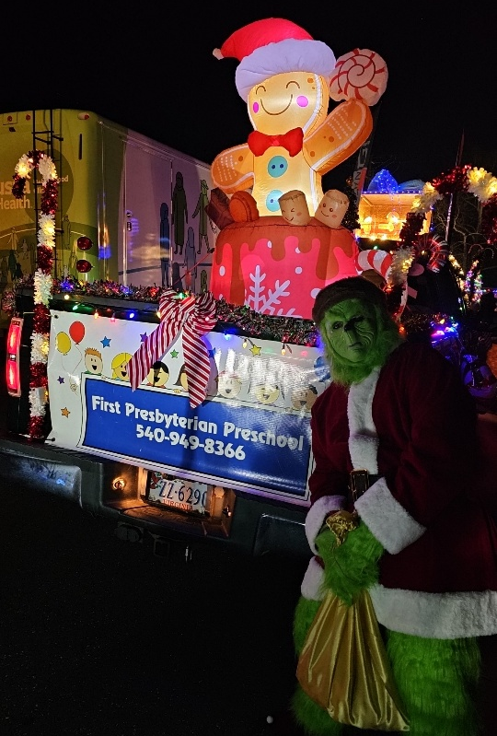
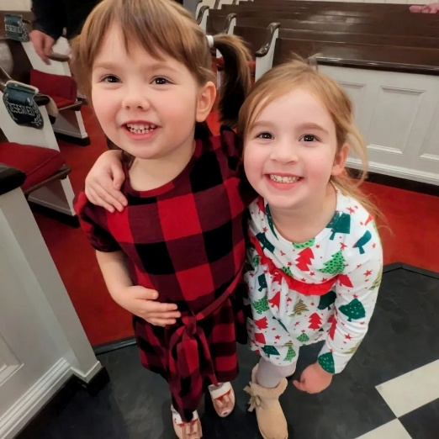


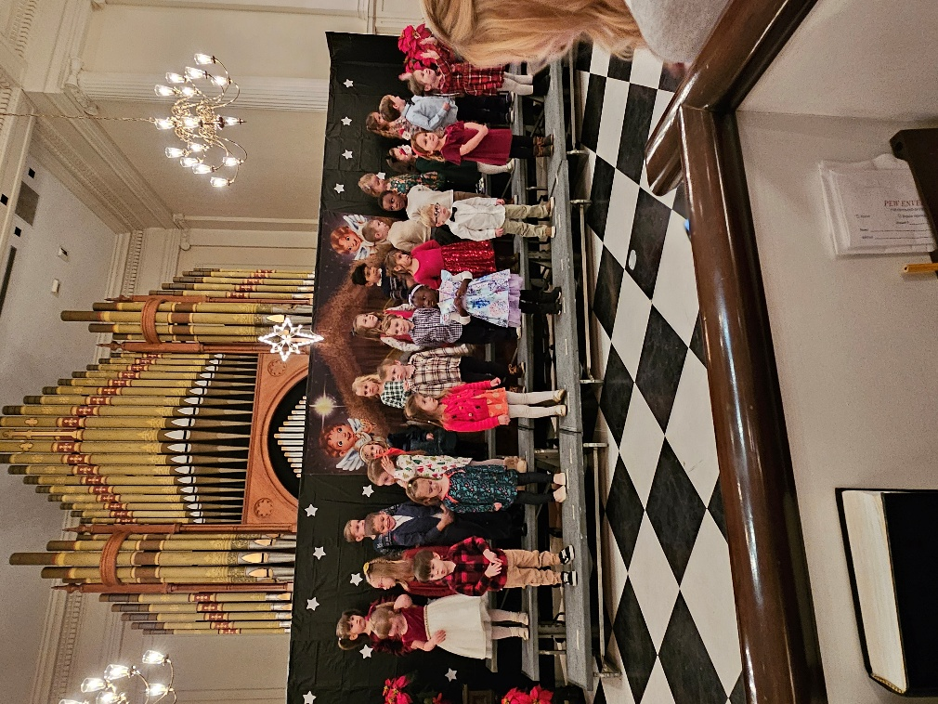

LITURGISTS

January 4 Betsy Ruehl

January 11 Joe Earhart

January 18

January 25

January Birthdays

6- Ann Epes, Michael Griffith


8 – Bruce Bosselman

11- Jeanne Hashagen

26 – Samantha Coggins

28 – Celia Daggy

31 – Randy Hypes


Shenandoah Nursing Home: Nancy Garber

Home: Mary Ultee, Mary Ann Maupin, Warner Sandquist, Polly Bare, Olive Prettyman, Mike and Cathy Cunningham.

Friends and Family: Bill Bromley, Jean Custen, Sally McNeel, Col. Stuart Roberts (Mark Henderson), Carolyn Hedrick-Williams (Colleen Cash), Betsy Boswell (Curry), Damon Prettyman (Olive Prettyman).

Military: Carson Craig, Michael Little


BETTER TOGETHER BIBLE STUDY

1:00 Mondays
January 12 – Second PC; January 19 - Hermitage.
January 26 – Finley Memorial; February 2 – FPC

FPC BOOK STUDY
“Lila” by Marilynne Robinson
Part of the series with the summer Bible Study book “Gilead”

“Lila, homeless and alone after years of roaming the countryside….. becomes the
wife of a minister and widower, John Ames, and begins a new existence while trying
to make sense of the days that preceded her new-found security.

10:00 on Wednesdays January 7 & 21, all 4 Wednesdays in February,
and probably on into March.



A PRAYER TO WELCOME THE NEW YEAR

As we stand on the threshold of a new year, we come before you with hearts full of anticipation and gratitude. We thank you for the gift of life and for the journey that has brought us to this moment.
Lord, we acknowledge the highs and lows of the past year – the joys and sorrows, the victories and challenges. Through it all, your presence has been our constant source of strength and hope.
As we welcome this new year, we place it in your capable hands. We trust in your plan and purpose for our lives, knowing that your ways are higher than our ways, and your thoughts are higher than our thoughts.
We pray for your guidance in the coming year. Lead us in the paths of righteousness and wisdom. Help us to discern your will in all that we do and to walk in obedience to your Word.
Fill our hearts with hope, joy, and peace. May your love and grace shine brightly in our lives and be a source of light in a world that often needs it.
Lord, grant us the courage to face the unknown with faith and trust. In times of uncertainty, remind us that you are our anchor, our refuge and our strength.
We thank you for the lessons and blessings of the past and look forward to the opportunities and adventures
that the future holds. May we use our time, talents, and resources to bring glory to your name and to be a blessing to others.
We welcome the new year with open hearts, renewed faith, and the confidence that you will be with us every step of the way. Amen.

BIBLE VERSES for the NEW YEAR

Isaiah 43:18-19- “Remember not the former things, nor consider the things of old. Behold, I am doing a new thing; now it springs forth, do you not perceive it? I will make a way in the wilderness and rivers in the desert.”

2 Corinthians 5:17 – “Therefore, if anyone is in Christ, he is a new creation. The old has passed away; behold, the new has come.

Hebrews 10:24-25 – And let us consider how to stir up one another to love and good works, not neglecting to meet together, as is the habit of some, but encouraging one another, and all the more as you see the Day drawing near.

CHURCH OFFICERS:
Treasurer – Colleen Cash
Members of Session - Jean Hashagen, Betsy Ruehl
Cynthia Hoover, Bob Miller and Nancy Hypes.



Sunday, January 4
11 a.m. Worship
Monday, January 5 Disciples Kitchen, Fishburne and Preschool Return
Tuesday, January 6
7-10 p.m. Symphony-Fellowship Hall
Wednesday, January 7
10 a.m. Book Study, Barksdale Room
Thursday, January 8
2-4 p.m. Food Bank
Saturday, January 10
9 - ? a.m. Remove Decorations
Sunday, January 11
11 a.m. Worship
Monday, January 12
1 p.m. Better Together Bible Study - Second Presbyterian
Tuesday, January 13
2:30 Session - Barksdale Room
5p.m Symphony Board Meeting – Barksdale
Symphony -Fellowship
Wednesday, January 14 No Book Study
Thursday, January 15
6-7:30 p.m. Food Bank
Sunday, January 18
11 a.m. Worship
Monday, January 19
1p.m. Better Together Bible Study – Hermitage Presbyterian
Tuesday, January 20
7-9:30 p.m. Symphony Fellowship
Wednesday, January 21
10 a.m. Book Study Barksdale Room
Thursday, January 22
2-4 p.m. Food Bank
Sunday, January 25
11 a.m. Worship

Monday, January 26
1 p.m. Better Together Bible Study - Finley Memorial Stuarts Draft
Tuesday, January 27
7-9:30 Symphony Fellowship
Wednesday, January 28 No Book Study
Thursday, January 29 No Food Bank

