BAPTISM OF THE LORD January 11, 2026
Liturgist: Joe Earhart
PRELUDE Trio Rheinberger (1839-1901)

WELCOME & ANNOUNCEMENTS

INTROIT Alleluia Milburn (b. 1963)

CALL TO WORSHIP
Leader: The voice of the Lord is powerful and full of majesty.
All: May the Lord bless us with God’s Peace!
Leader: The voice of the Lord proclaimed Jesus as God’s beloved.
All: In our own baptisms, we are claimed as God’s beloved.

MORNING PRAYER

*OPENING HYMN #509 All Who Hunger, Gather Gladly HOLY MANNA

CHILDREN’S SERMON

CALL TO CONFESSION

PRAYER OF CONFESSION
Merciful God, we confess that we are estranged from you and from one another. We treat others as strangers rather than as people created in your image and fellow children of God. We exploit the earth as though it were our possession, rather than a gift entrusted to our care and a reflection of your image and glory. Forgive us our sins and transform us by your Spirit, that we might live as people who have been baptized as your own children. Amen.

SILENT PRAYER

ASSURANCE OF PARDON

*GLORIA PATRI #581 Glory Be to the Father GLORIA PATRI

FIRST SCRFRIPTURE READING Isaiah 42:1-9 p.584

ANTHEM Eat This Bread Berthier (1923-1994)
(text can be found in hymn 527)

SECOND SCRIPTURE READING Matthew 3:13-17 p.784

SERMON Yet You Come To Me? Rev. Samantha Coggins

AFFIRMATION OF FAITH
We trust in God the Holy Spirit, everywhere the giver and renewer of Life.
The Spirit justifies us by grace through faith, sets us free to accept ourselves and to love God and neighbor, and binds us together with all believers in the one body of Christ, the Church.
The same Spirit who inspired the prophets and apostles rules our faith and life in Christ through Scripture, engages us through the Word proclaimed, claims us in the waters of baptism, feeds us with the bread of life and the cup of salvation, and calls women and men to all ministries of the Church.

THE LORD’S SUPPER
Invitation
Great Thanksgiving
Communion of the People

*CLOSING HYMN #498 Loaves Were Broken, Words Were Spoken BEACH SPRING

BENEDICTION

POSTLUDE Fugue Muffat (1690-1770)

This morning’s liturgy is written by Roger Gench and the Presbyterian Outlook.

LINK : https://www.youtube.com/watch?v=0xkqg8mh-64



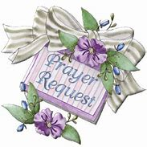

Shenandoah Nursing Home: Nancy Garber

Home: Mary Ultee, Mary Ann Maupin, Warner Sandquist, Polly Bare, Olive Prettyman, Mike and Cathy Cunningham.

Friends and Family: Bill Bromley, Jean Custen, Sally McNeel, Col. Stuart Roberts (Mark Henderson), Carolyn Hedrick-Williams (Colleen Cash), Betsy Boswell (Curry) Damon Prettyman (Olive Prettyman).

Military: Carson Craig, Michael Little

BETTER TOGETHER BIBLE STUDY

1:00 Mondays
January 12 – Second PC; January 19 - Hermitage.
January 26 – Finley Memorial; February 2 – FPC

FPC BOOK STUDY
“Lila” by Marilynne Robinson

Part of the series with the summer Bible Study book “Gilead”

“Lila, homeless and alone after years of roaming the countryside….. becomes the
wife of a minister and widower, John Ames, and begins a new existence while trying
to make sense of the days that preceded her new-found security.

10:00 on Wednesdays January 7 & 21, all 4 Wednesdays in February,
and probably on into March.

Childcare available on Sunday mornings
Childcare is available during worship for babies & children, ages 0-10. At any time during our service, you are welcome to bring your child to our preschool area - through the Narthex and brown double doors - for play & care. Children ages 2 and up are invited to stay in worship through the children’s sermon (after the opening hymn).


An offering plate is available in the narthex.

FIRST PRESBYTERIAN CHURCH
WAYNESBORO, VIRGINIA

A community-minded congregation living out the love of Christ as we serve one another with humility, gentleness, and patience through God’s grace.

January 11, 2026 11:00 AM

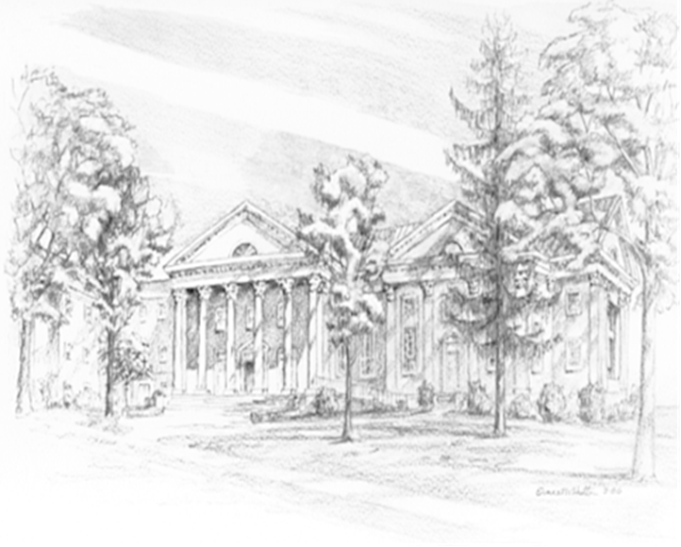

P.O. Box 877
249 South Wayne Avenue
Waynesboro, Virginia
(540) 949-8366
Church Website: www.firstpresway.org
Preschool Website: www.firstprespre.org
Email: church@firstpresway.com

