SECOND SUNDAY OF CHRISTMAS January 4, 2026
Liturgist: Betsy Ruehl

PRELUDE How Brightly Shines the Morning Star I Buxtehude (1637-1707)

WELCOME & ANNOUNCEMENTS

INTROIT O Morning Star, How Fair and Bright Nicolai (1556-1608)
Bach (1685-1750)

CALL TO WORSHIP
Leader: Sing aloud with gladness for Jacob, and raise shouts for the chief of
the nations;
All: Give praise, and say, “Save, O Lord, your people.”
Leader: They shall come and sing aloud on the height of Zion;
All: They shall be radiant over the goodness of the Lord, their life shall become like a watered garden, and they shall never languish again.
Leader: With expectation and joy as we begin a new year, let us worship the living God!

MORNING PRAYER

*OPENING HYMN #152 What Star is This PUER NATUS

CHILDREN’S TIME

CALL TO CONFESSION

PRAYER OF CONFESSION
We cry out: “Save, O Lord, your people, the remnant of Israel,” for we are a people in need of saving. You promise to gather your people, but we confess that we want to put limitations on who is saved. We want you to save those we define as strong and beautiful and wise; You call the blind and the lame, the children and those in labor. Forgive us, O Holy God, for our prejudice and narrow vision. Forgive us for our lack of faith. Forgive us for doubting your promise and declining your invitation. By your Spirit, renew us. Turn our mourning into joy and our sorrow into gladness, that we might return to you and your way.

SILENT PRAYER

ASSURANCE OF PARDON

*GLORIA PATRI #581 Glory Be to the Father GLORIA PATRI

FIRST SCRIPTURE LESSON Psalm 147:12-20 p. 507

ANTHEM We Three Kings Hopkins, Jr. (1820-1891) Patrick Fitzgibbon, Maximilian Daggy, Roger Daggy,
(text can be found in hymn 151)

SECOND SCRIPTURE LESSON Matthew 2:1-12 p.783

SERMON The Path of the Star Rev. Samantha Coggins

AFFIRMATION OF FAITH
In life and in death we belong to God. Through the grace of our Lord Jesus Christ,
the love of God, and the communion of the Holy Spirit, we trust in the one triune God, the Holy One of Israel, whom alone we worship and serve.

We trust in Jesus Christ, fully human, fully God. Jesus proclaimed the reign of God:
preaching good news to the poor and release to the captives, teaching by word and deed
and blessing the children, healing the sick and binding up the brokenhearted, eating with outcasts, forgiving sinners, and calling all to repent and believe the gospel. Unjustly condemned for blasphemy and sedition, Jesus was crucified, suffering the depths of human pain and giving his life for the sins of the world. God raised this Jesus from the dead, vindicating his sinless life, breaking the power of sin and evil, delivering us from death to life eternal.

PRAYERS of the PEOPLE and LORD’S PRAYER

*CLOSING HYMN #156 Sing of God Made Manifest SALZBURG

BENEDICTION

POSTLUDE How Brightly Shines the Morning Star II Buxtehude

This morning’s liturgy is written by Matthew A. Rich and the Presbyterian Outlook.

LINK : https://www.youtube.com/watch?v=8Wfr6IK7UKg


Shenandoah Nursing Home: Nancy Garber

Home: Mary Ultee, Mary Ann Maupin, Warner Sandquist, Polly Bare, Olive Prettyman.

Friends and Family: Bill Bromley, Jean Custen, Sally McNeel, Col. Stuart Roberts (Mark Henderson), Carolyn Hedrick-Williams (Colleen Cash), Betsy Boswell (Curry), Shane Bennett (Bennett) Damon Prettyman (Olive Prettyman).

Military: Carson Craig, Michael Little

Book Study Fellowship is back in 2026. Meetings are on Wednesdays at 10:00 a.m. in the Barksdale Room. We will resume on January 7 and January 21 (please note we will not meet January 14 or January 28) and continue weekly through the month of February. The book is Lila by Marilynne Robinson, continuing in the ‘Gilead’ series. There will be a small stock of books available in the church office. To claim a book, e-mail Samantha.

Offering envelopes are available, please let Colleen know if you would like a box.

The year end financials will be closed Thursday, January 8, 2026.

Undecking The Halls will be Saturday, Jan 10, after 9am.


An offering plate is available in the narthex.

FIRST PRESBYTERIAN CHURCH
WAYNESBORO, VIRGINIA

A community-minded congregation living out the love of Christ as we serve one another with humility, gentleness, and patience through God’s grace.

January 4, 2026, 11:00 AM

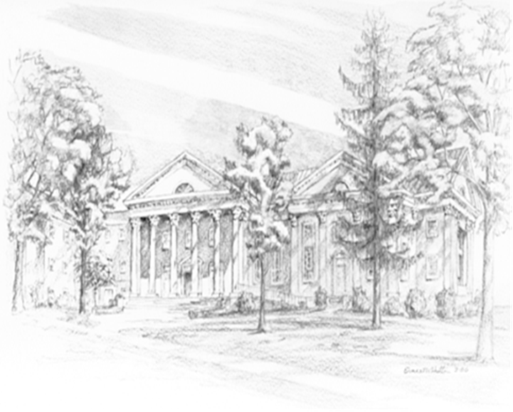

P.O. Box 877
249 South Wayne Avenue
Waynesboro, Virginia
(540) 949-8366
Church Website: www.firstpresway.org
Preschool Website: www.firstprespre.org
Email: church@firstpresway.com

