TRANSFIGURATION of the LORD February 15, 2026

PRELUDE Prelude in E-flat, Op. 50, no. 5 Foote (1853-1937)

WELCOME & ANNOUNCEMENTS

INTROIT Now Enter In Hebble (1934-2020)

CALL TO WORSHIP
Leader: Our God is holy and mighty, a leader who loves justice, who
established honesty, justice, and righteousness.
All: God has done this! We exalt you, O God! We worship at your footstool. You are holy!
Leader: Miriam, Moses and Aaron were among them, and Samuel, too
was among those who invoked the Name; they called on God, and God answered them.
All: We exalt you, O Lord our God, and we worship you at your holy mountain;
for you, O God, are holy!

MORNING PRAYER

*OPENING HYMN #193 Jesus, Take Us to the Mountain UNSER HERRSCHER

CHILDREN’S SERMON

CALL TO CONFESSION

PRAYER OF CONFESSION
God of radiant light, we confess that we are a people who are sometimes too comfortable dwelling in darkness. We say we want things to change, that we do not accept the way things are. But, in reality, we want someone else to take care of the changing. We resist transformation and sometimes do not even believe it is possible. Forgive our unbelief. Soften our hearts toward one another and ourselves. May your Spirit move through and among us. Make us light bearers for your sake, and for the sake of your people. Amen.

SILENT PRAYER

ASSURANCE OF PARDON

*GLORIA PATRI #581 Glory Be to the Father GLORIA PATRI

FIRST SCRIPTURE LESSON Exodus 24:12-18 p.62

ANTHEM Arise, My Soul, Arise Wood (1934-2003)

Arise, my soul, arise! Stretch forth to things eternal,
And haste thee to the feet of thy Redeemer God.
Though hid from mortal eyes, He dwells in light supernal,
Yet worship Him in humbleness and own Him Lord.
His banquet of love awaits thee above;
Behold, the marriage festal of the Lamb is come!
Rejoice, my soul, rejoice, to heaven lift up thy voice. Alleluia!
List to the harps of heaven! Hark to the song victorious,
The never-ending anthem sounding through the sky.
To mortals is not given to chant its strains all glorious.
Yet sing, my soul, the praise of Him who reigns on high.
Who bought with His blood the ransomed of God,
To Him be everlasting power and victory.
And let the great Amen resound through heaven again. Alleluia!

SECOND SCRIPTURE LESSON Matthew 17:1-9 p.798

SERMON Seeing No One Except Jesus Rev. Samantha Coggins

* AFFIRMATION OF FAITH
We believe in one God, the Father, the Almighty, maker of heaven and earth,
of all that is, seen and unseen.
We believe in one Lord, Jesus Christ, the only Son of God, eternally begotten of the Father,
God from God, Light from Light, true God from true God, begotten, not made,
of one Being with the Father; through him all things were made. For us and for our salvation
he came down from heaven, was incarnate of the Holy Spirit and the Virgin Mary
and became truly human. For our sake he was crucified under Pontius Pilate;
On the third day he rose again in accordance with the Scriptures; he ascended into heaven
and is seated at the right hand of the Father. He will come again in glory to judge the living and the dead, and his kingdom will have no end. We believe in the Holy Spirit, the Lord, the giver of life, who proceeds from the Father and the Son, who with the Father and the Son is worshipped and glorified, who has spoken through the prophets. We believe in one holy catholic and apostolic Church. We acknowledge one baptism for the forgiveness of sins.
We look for the resurrection of the dead, and the life of the world to come. Amen.

THE LORD’S SUPPER
Invitation
Great Thanksgiving
Communion of the People

*CLOSING HYMN #156 Sing of God Made Manifest SALZBURG

BENEDICTION

POSTLUDE Concerto in G: Presto Ernst (1696-1715)
Bach (1685-1750)

This morning’s liturgy is written by Rev. Anna Owens and the Presbyterian Outlook.

LINK: https://www.youtube.com/watch?v=Wv0zadyVc4E



Shenandoah Nursing Home: Nancy Garber

Home: Mary Ultee, Mary Ann Maupin, Warner Sandquist, Polly Bare, Olive Prettyman, Nancy Hypes.

Friends and Family: Carolyn Hedrick-Williams (Colleen Cash), Betsy Boswell (Curry), Prettyman (Olive Prettyman).

Military: Carson Craig, Michael Little


An offering plate is available in the narthex.

FIRST PRESBYTERIAN CHURCH
WAYNESBORO, VIRGINIA

A community-minded congregation living out the love of Christ as we serve one
another with humility, gentleness, and patience through God’s grace.

February 15, 2026 11:00 AM

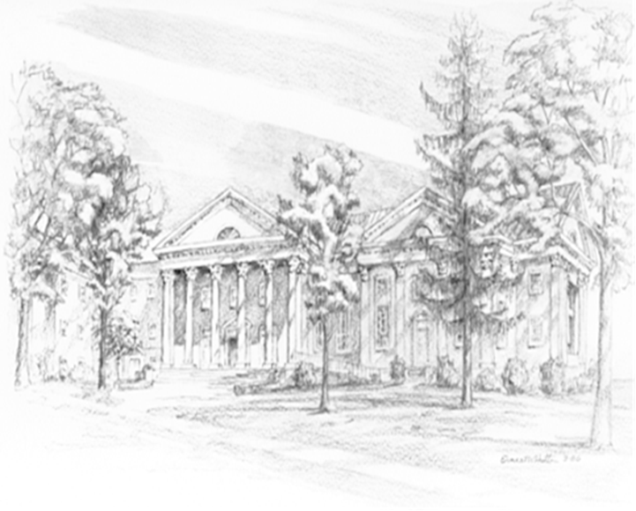

P.O. Box 877
249 South Wayne Avenue
Waynesboro, Virginia
(540) 949-8366
Church Website: www.firstpresway.org
Preschool Website: www.firstprespre.org
Email: church@firstpresway.com

