

THE COLUMNS
First Presbyterian Church, Waynesboro, VA
February 2026, Volume 64, Issue 2
First Presbyterian Church of Waynesboro is a community-minded
congregation living out the love of Christ as we serve one another with
humility, gentleness, and patience through God’s grace.

15 Toward evening the disciples approached him. “We’re out in the country and it’s getting
late. Dismiss the people so they can go to the villages and get some supper.”
16 But Jesus said, “There is no need to dismiss them. You give them supper.”
17 “All we have are five loaves of bread and two fish,” they said.
18-21 Jesus said, “Bring them here.” Then he had the people sit on the grass. He took the
five loaves and two fish, lifted his face to heaven in prayer, blessed, broke, and gave the
bread to the disciples. The disciples then gave the food to the congregation. They all ate
their fill. They gathered twelve baskets of leftovers. About five thousand were fed.
Matthew 14:15-21

When in doubt, always quote scripture. This is not one of the rules I have painstakingly collected over the years,
but perhaps it should be. Last month, we began with insights into basketball; for May, we are diving back into
the New Testament for illumination.
We are conditioned, I think, to look at the miraculous as magical, the theological equivalent of alchemy. Just as
the medieval alchemist sought to turn lead into gold, and thus enrich themselves without labor, we look at
miracles at least in part, as labor-saving plot devices: healing without the effort of treatment; gifts that eliminate
the need for impossible choices; rescue that makes of us passive recipients of grace. But, in the words of yet
another of my rules, God is not a magician; what we call miracles are signs of God at work in our midst - and
God hates to work alone.

In the feeding of the multitude, the disciples recognize a need - the crowd is getting hungry and the day is
mostly gone. This is a real problem, they know, but the best they can come up with is to send the crowds
back to town, where they might find some supper. But Jesus has something else in mind; not just pushing
the problem down the road, but actually doing something about the hunger of the people. He asks what
food is available, and is told, 5 rolls and 2 cooked fish - the lunch of a well-prepared young man. Jesus
then does the miraculous, but the miracle isn&#39;t magic- Jesus does not make everyone feel full, or have
manna fall from the heavens. The miracle happens through the work of the disciples. It is the disciples
who organize the people, getting them to sit down in an orderly fashion; they who oversee the distribution
of the loaves and fishes, making sure everyone is fed; even making sure the leftovers are collected. And
that, friends, leads us to Rule #10:

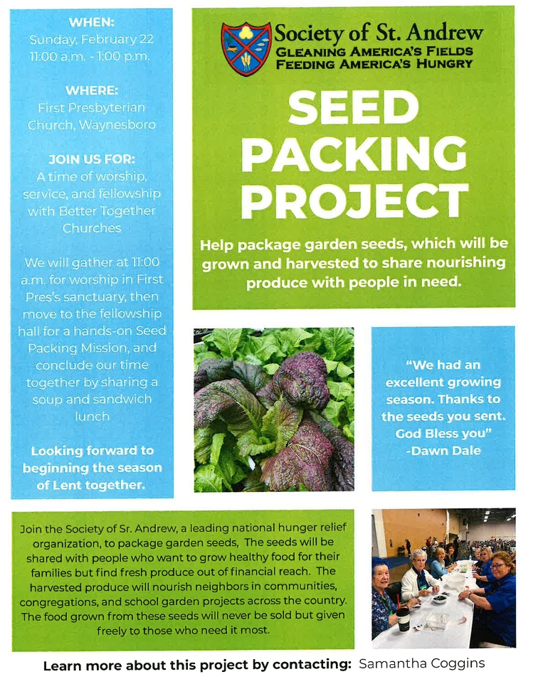



Music Notes for February

What a way to open the month – encased in ice! We’re definitely experiencing a true winter this season, complete with snow and extreme cold. Wherever we are, we are warmed by the Holy Spirit and the knowledge of God’s everlasting love.

Alas, we will not gather in person on February 1st, but, fingers crossed, we will worship together on the second Sunday of February. The first reading will be Matthew 5: 1-12, also known as the Beatitudes, in which Jesus extols the blessings bestowed upon those who follow His teachings. The choir will sing a beautifully rendered version of the Beatitudes, a Russian Orthodox chant arranged by American composer Richard Proulx (1937-2010).

On February 15th, the anthem will be Arise, My Soul, Arise. The melody comes from a Finnish folk tune, arranged by Dale Wood (1934-2003). Over the course of his life, Wood arranged hundreds of tunes for church choirs. From 1967 until his death, Wood was honored annually by the American Society of Composers, Authors and Publishers (ASCAP) for his "very important contribution towards the creation and development of contemporary American Music."

The season of Lent begins with FPC hosting two services with congregants from various churches in Waynesboro. On 18 February, FPC welcomes worshipers for an ecumenical service to mark Ash Wednesday. First Baptist, Grace Lutheran, Main Street United Methodist, St. John’s Episcopal and Union Baptist are all invited to mark the beginning of Lent. Singers from each of the churches will join together to sing the anthem, God So Loved the World, by John Stainer.

Just four days later, FPC will host the Better Together churches to mark the first Sunday of Lent. For the anthem that day, a quartet of men from Westminster, Second and First Presbyterian churches will sing Ah, Holy Jesus.

We are so grateful for all who will worship at FPC on the 18th and 22nd!

In other musical news, FPC Director of Music/Organist Roger Daggy will present a First Friday Organ Recital in February, beginning at 12:15 – weather permitting! The program will be followed by light luncheon, generously coordinated by Joe Earhart. Both the recital and luncheon are free, and all are welcome!

The ensemble-in-residence at FPC, the Waynesboro Symphony Orchestra, will play their winter concert on Sunday 22 February at 3pm. Arrive early to snag your preferred seat!

As always, we are immensely thankful to FPC for the enthusiastic support of the music program. May the blessings of the Holy Spirit be upon you during this – and every – month.

Peace,
Roger and Kimberlea Daggy

FIRST FRIDAY ORGAN CONCERT
February 6 – 12:15 p.m. in the Sanctuary
followed by a light lunch in the Barksdale Room



ASH WEDNESDAY, FEBRUARY 18

Ash Wednesday marks the start of the 40-day Lenten season – a time in which Christians are called to prayer, fasting and repentance before celebrating Easter. The 40 days (excluding Sundays) reflect the time that Jesus spent in the wilderness being prepared for His public ministry. In a similar way Christians are challenged to maintain a posture of humility, acknowledging our dependence on God’s grace and mercy. Lent is a time to study and reflect on our thoughts, actions, and attitudes that separate us from the life God intends for His children.
Many denominations around the world hold a special service on Ash Wednesday which includes dipping a thumb in a bowl of ashes and making the sign of the cross on a congregant’s forehead. The ashes, made by burning the palm branches from the previous year’s Palm Sunday, serve as a sign of humanity and reminder of mortality.

ECUMENICAL ASH WEDNESDAY SERVICE
Including First Baptist, Grace Lutheran, Main Street United Methodist,
St. John’s Episcopal and Union Baptist
at
FIRST PRESBYTERIAN CHURCH
Wednesday evening, February 18, 7p.m.



BETTER TOGETHER WORSHIP SERVICE
FIRST PRESBYTERIAN CHURCH
February 22, at 11:00 a.m. Worship in the Sanctuary
followed by
Lunch and Society of St. Andrews Seed Packing Project
in the Fellowship Hall
Child care available
ALL ARE INVITED!

VALENTINE’S DAY

The origins of Valentine’s Day are somewhat ambiguous. Many historians trace it back to ancient Roman festivals, like Lupercalia, which celebrated fertility and spring. The figure of Cupid, often associated with love, has roots in Greek mythology, particularly the god Eros from 700 B.C. Some believe the holiday emerged in the middle ages as a Christian alternative to pagan festivities. The most widely accepted theory is that it was named after Saint Valentine, a 3rd-century martyr. (Actually, the holiday is named for several saints named Valentine.) Not until the mid-19th C. did Valentine’s Day see a significant commercial boom.
The first recorded Valentine’s letter was penned by Charles, Duke of Orleans, in 1415. At the age of 21, Charles wrote to his wife while imprisoned in the Tower of London.
The first Valentine’s Day cards were handmade. People crafted cards decorated with lace, ribbon, and images of cupids and heart. In the 1840s U.S. companies began to mass produce Valentine’s Day cards.
The first heart-shaped candy box was introduced in 1862 by Richard Cadbury, son of chocolatier and Cadbury founder John Cadbury. Today upwards of 36 million heart-shaped boxes of chocolates are sold each year, amounting to a whopping 58 million pounds of chocolate.
By some estimates, as many as 250 million roses are grown each year in anticipation of Valentine’s Day. Countries like Kenya, Columbia and Ecuador cultivate these flowers and ship them to regions with cooler climates.
Ultimately, the best Valentine’s gift comes from the heart.



TRUE LOVE

“Love is patient, love is kind. It does not envy, it does not boast. It is not proud. It does
not dishonor others. It is not self-seeking, it is not easily angered, it keeps no record of
wrongs. Love does not delight in evil but rejoices with the truth. It always protects,
always trusts, always hopes, always perseveres. Love never fails.” I Corinthians 13:4-8 NIV

Imagine the daunting task of accurately defining love. Most dictionaries rely on synonymous phrases. Love is “a strong affection,” “a warm attachment,” “a benevolent concern for others.” Dictionaries define love through the language of emotion.
The apostle Paul understood that love is more than a feeling. When he sat down to write his famous description of love in I Corinthians 13:4-8, instead of defining the word love, he explained what love is – love is the demonstration of selfless acts toward others.
Paul explained that true love is displayed through the unselfish behaviors of patience, kindness, humility, forgiveness, protection, trust, hopefulness and perseverance. This is the kind of love that Jesus showed toward others and that God shows toward us every day. God’s kind of love never fails.
The words “I love you” slip easily from the lips and drift away. The passionate feeling of love sometimes grows cold. But God’s love doesn’t change. It is always pure, unconditional, and forever.
Heavenly Father, remind me of Paul’s words today. Help me to love others not only through my words, but also through my actions. Amen.

(from Daily Devotions for a Woman of Faith)



Mission/Outreach – December 2025

- Ordered and received food from BRAFB December 9. Volunteers assembled 20 pantry boxes for each order.
- Maintained temperature logs for refrigerators and freezers.
- Food Bank was held December 4, 11 and 18.
- Purchased bread and margarine for Food Bank weekly.
- Updated weekly shopping list for extra options.
- Completed pantry inventory and report: Served 69 individuals and 27 households.
- Requesting Personal Care items for Food Bank for January and February
Warm Shelter at Westminster Presbyterian Church December 19 - served dinner for 45.
Seed packing and lunch at FPC: February 22 following worship.
Disciples’ Kitchen: January 5 and March 30
Cynthia Hoover, Chair

COLLECTING PERSONAL CARE ITEMS FOR FOOD BANK



NO STATED SESSION MEETING WAS HELD IN JANUARY

due to illness and weather.

Preschool News!!

Our preschoolers were excited and ready to come back to school after their Christmas break and get back to learning. Although they were also happy to have a few extra days off due to the snowstorm to play at home with their families.

We have some fun events planned for the month of February. For the second year in a row we are participating in “Hearts around the World”, exchanging valentines with fellow preschools around the world. The children love this activity, and it teaches them about kindness and friendship. On February 7 we will be having our “Parents Night Out”.

Our preschoolers will be walking to the Post Office to mail our Valentine’s Day cards home to our families.

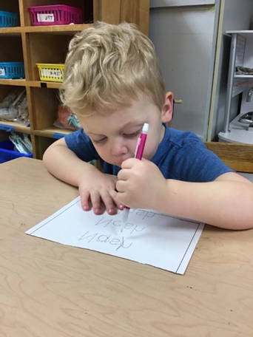









Shenandoah Nursing Home: Nancy Garber

Home: Mary Ultee, Mary Ann Maupin, Warner Sandquist, Polly Bare,
Olive Prettyman, Mike and Cathy Cunningham.

Friends and Family: Carolyn Hedrick-Williams (Colleen Cash), Betsy Boswell (Curry), Damon Prettyman (Olive Prettyman).

Military: Carson Craig, Michael Little


BETTER TOGETHER BIBLE STUDY

1:00 Mondays
February 2 – FPC, February 9 - Second Presbyterian,
Hermitage - February 16, Finley February 23

FPC BOOK STUDY
“Lila” by Marilynne Robinson
Part of the series with the summer Bible Study book “Gilead”

“Lila, homeless and alone after years of roaming the countryside….. becomes the
wife of a minister and widower, John Ames, and begins a new existence while trying
to make sense of the days that preceded her new-found security.

10:00 on Wednesdays in the Barksdale Room during February
and probably into March.



2 – Terry Crickenberger

7- Cathy Cunningham

16 – Sandi Henderson, Cozy Coggins

18 – Phyllis Poluito, Valerie Purcell



CHURCH OFFICERS:
Treasurer – Colleen Cash
Members of Session - Jean Hashagen, Betsy Ruehl
Cynthia Hoover, Bob Miller and Nancy Hypes.


Sunday, February 1
11 a.m. Worship CANCELLED
Monday, February 2 Better Together Bible Study - First Presbyterian
Tuesday, February 3
7-10 p.m. Symphony-Fellowship Hall
Wednesday, February 4
10 a.m. Book Study, Barksdale Room
Thursday, February 5
6-7:30 p.m. Food Bank
Friday, February 6
12:15 p.m. First Friday Organ concert with lite lunch
Sunday, February 8
11 a.m. Worship
Monday, February 9
1 p.m. Better Together Bible Study - Second Presbyterian
Tuesday, February 10
2:30 p.m. Session - Barksdale Room
5p.m. Symphony Board Meeting – Barksdale
7 p.m. Symphony -Fellowship
Wednesday, February 11
10 a.m. Book Study – Barksdale Room
Thursday, February12
2-4 p.m. Food Bank
Saturday, February 14 Valentine’s Day
Sunday, February 15
11 a.m. Worship
Monday, February 16
1p.m. Better Together Bible Study – Hermitage Presbyterian
Tuesday, February 17
7-9:30 p.m. Symphony Fellowship
Wednesday, February 18
10 a.m. Book Study Barksdale Room
7 p.m. Ash Wednesday, Community Gathering
Thursday, February 19
6-7:30 p.m. Food Bank
Sunday, February 22
11 a.m. Worship
Monday, February 23
1 p.m. Better Together Bible Study - Finley Memorial Stuarts Draft
Tuesday, February 24
7-9:30 p.m. Symphony Fellowship
Wednesday, February 25
10 a.m. Book Study -Barksdale Room
Thursday, February 26
2-4 p.m. Food Bank



