FIRST SUNDAY IN LENT February 22, 2026

PRELUDE Meditation, Op. 31, no. 7 Vierne (1870-1937)

WELCOME & ANNOUNCEMENTS

CALL TO WORSHIP Jonathan Steck (Westminster)
Leader: We gather from many congregations as the one body of Christ this first Sunday in Lent.
We remember the words of the prophet Isaiah:
All: The fast that I choose is to deal bread to the hungry.
Leader: The glory of the Lord will be our reward.
All: May all taste and see that the Lord is good!

*OPENING HYMN #498 Loaves Were Broken, Words Were Spoken BEACH SPRING

CHILDREN’S SERMON John Tindall (Westminster)

ANTHEM Ah, Holy Jesus Crüger (1598 – 1662)
(text can be found in hymn 218)

Better Together Quartet
Ed Crawford, (Westminster)
Glenn Fields, (Second)
Patrick Fitzgibbon, (First)
Roger Daggy, (First)

SCRIPTURE LESSON Matthew 4:1-11 p. 785
Anne Flory (Smyrna Pres)

HOMILY Rev. Jennifer Davis Sensenig

THE LORD’S SUPPER Revs. Amy Fetterman & April Cranford
Invitation
Great Thanksgiving
Communion of the People

BENEDICTION & DIRECTIONS FOR MISSION Pastor Jennifer Davis Sensenig
Director of Church Relations, Society of St Andrews
Link: https://www.youtube.com/watch?v=zsOarXdL-YE


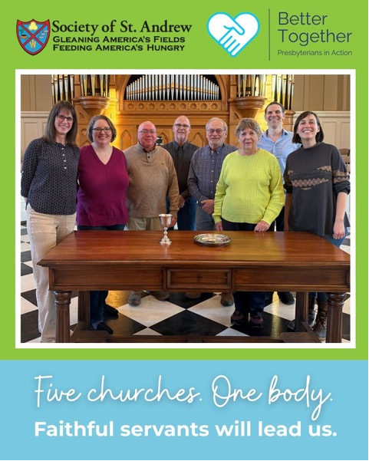

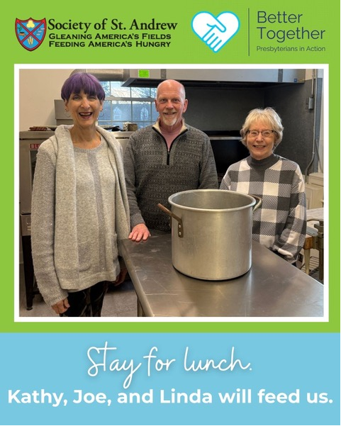
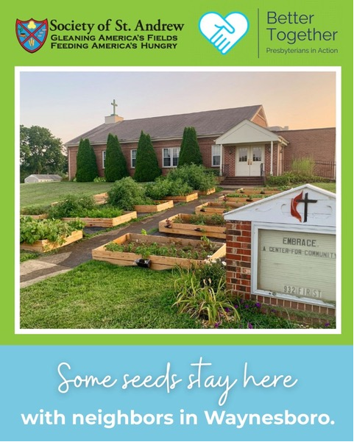

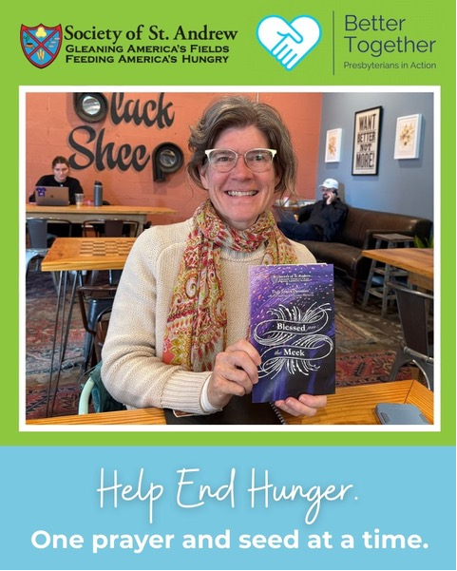



Shenandoah Nursing Home: Nancy Garber
Home: Mary Ultee, Mary Ann Maupin, Warner Sandquist, Polly Bare, Olive Prettyman, Nancy Hypes.
Friends and Family: Carolyn Hedrick-Williams (Colleen Cash), Betsy Boswell (Curry), Prettyman (Olive Prettyman) Maria Costello (Cunningham)
Military: Carson Craig, Michael Little


An offering plate is available in the narthex.

FIRST PRESBYTERIAN CHURCH
WAYNESBORO, VIRGINIA

A community-minded congregation living out the love of Christ as we serve one
another with humility, gentleness, and patience through God’s grace.

February 22, 2026 11:00 AM

P.O. Box 877
249 South Wayne Avenue
Waynesboro, Virginia
(540) 949-8366
Church Website: www.firstpresway.org
Preschool Website: www.firstprespre.org
Email: church@firstpresway.com

