SECOND SUNDAY AFTER EPIPHANY January 18, 2026
Liturgist: Patrick Fitzgibbon

PRELUDE Pastorale I, BWV 590 Bach (1685-1750)

WELCOME & ANNOUNCEMENTS

INTROIT Now Enter In Hebble (1934-2020)

CALL TO WORSHIP
Leader: God calls us here together — each of us, all of us, our whole selves.
All: We bring our questions, our longings, our hopes, our dreams and our fears.
Leader: Jesus invites us to come and see where God is at work.
All: Across the street and across the globe, Jesus is present.
Leader: Within these walls and within our hearts, God is here.
All: Let us worship the God who reaches out in love and invites us to come and see!

MORNING PRAYER

*OPENING HYMN #837 What a Fellowship, What a Joy Divine SHOWALTER

CHILDREN’S SERMON

CALL TO CONFESSION

PRAYER OF CONFESSION
Saving God, we confess that we often have not waited patiently for you. We have preferred to sing our own song, to go our own way, and to put our trust in idols, institutions and individual strength rather than trusting you. We confess that it is easier to bring you sacrifices and offerings, rather than offering our lives to you. We search for delight in all the wrong places. We keep quiet about the ways we have experienced your love and presence, and we fail to invite others to come and see you, the source of life and love, at work all around us. Forgive us, God. Abide in us until your new song of hope and redemption pours from our lips, and your love is shared in our words and deeds. Amen.

SILENT PRAYER

ASSURANCE OF PARDON

*GLORIA PATRI #581 Glory Be to the Father GLORIA PATRI

FIRST SCRIPTURE LESSON 1 Corinthians 1:1-9 p. 926

ANTHEM O Jesus, I Have Promised Finnish folk song
(text can be found in hymn 725)

SECOND SCRIPTURE LESSON Psalm 40:1-11 p. 446

SERMON Undecorated Before God Rev. Samantha Coggins

AFFIRMATION OF FAITH
We know our efforts cannot bring in God’s kingdom. But hope plunges us into the struggle for victories over evil that are possible now in the world, the church, and our individual lives.
Hope gives us courage and energy to contend against all opposition, however invincible it may seem, for the new world and the new humanity that are surely coming. Jesus is Lord! He has been Lord from the beginning. He will be Lord at the end. Even now he is Lord.

PRAYERS of the PEOPLE and LORD’S PRAYER

*CLOSING HYMN #353 My Hope is Built on Nothing Less SOLID ROCK

BENEDICTION

POSTLUDE Pastorale IV, BWV 590 Bach

LINK : https://www.youtube.com/watch?v=GC3zmd5cSTE

This morning’s liturgy is written by Stephanie Sorge and the Presbyterian Outlook.


Kneeling notes have been updated. If you or someone you know
would like to be added, please let Samantha or Colleen know.

Shenandoah Nursing Home: Nancy Garber

Home: Polly Bare, Olive Prettyman. Mike and Cathy Cunningham, Nancy Hypes.

Friends and Family: Carolyn Hedrick-Williams (Colleen Cash), Betsy Boswell (Curry), Damon Prettyman (Olive Prettyman).

Military: Carson Craig, Michael Little

ANNOUNCEMENTS
Lila Book Study Fellowship

Book Study Fellowship is back in 2026. Meetings are on Wednesdays at 10:00 a.m. in the Barksdale Room. We will resume on January 21 (please note we will not meet on January 28) and continue weekly through the month of February. The book is Lila by Marilynne Robinson, continuing in the ‘Gilead’ series.

February 22 Worship & Mission: Seed-Packing with Better Together Churches
On Sunday, February 22, FPC will host our Better Together churches (Hermitage, Smyrna, Finley, Westminster, Second) here in our sanctuary, for worship & Communion. We will then do a seed-packing mission and have lunch in the 3rd floor social hall. We will conclude at 1:00 pm. Lunch will be potluck-style: soup & trays of sandwiches and cookies. Those who plan to contribute soup or sandwiches, please contact Samantha for drop-off details. The enclosed flyer has more information about the mission project with the Society of St. Andrew, which serves local communities and folks in Appalachia where there is land, soil and know-how, but not enough seeds for growing.

February 18 Ecumenical Ash Wednesday service
On the evening of Ash Wednesday — Wednesday, February 18 — FPC will host an ecumenical worship service for several downtown Waynesboro churches (including First Baptist, Main Street UMC, Grace Lutheran, to name just a few!), marking the beginning of Lent. Last year this service was hosted at Main Street UMC, with leadership by several pastors and a combined choir. Mark your calendar to participate in this service and receive ashes, to start our journey to Easter alongside siblings in Christ from other denominations!

FIRST PRESBYTERIAN CHURCH
WAYNESBORO, VIRGINIA

A community-minded congregation living out the love of Christ as we serve one another with humility, gentleness, and patience through God’s grace.

January 18, 2026, 11:00 AM

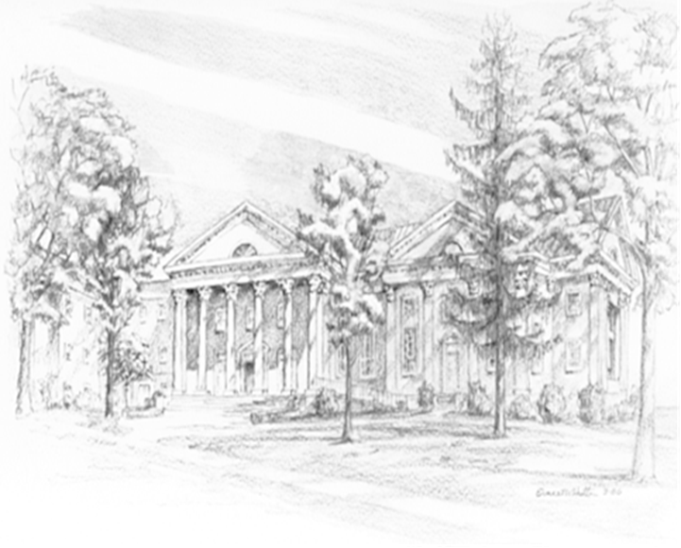

P.O. Box 877
249 South Wayne Avenue
Waynesboro, Virginia
(540) 949-8366
Church Website: www.firstpresway.org
Preschool Website: www.firstprespre.org
Email: church@firstpresway.com

