THIRD SUNDAY AFTER EPIPHANY January 25, 2026
Liturgist:

PRELUDE Prelude in A, BWV 536 Bach (1685-1750)

WELCOME & ANNOUNCEMENTS

INTROIT Let All the World Routley (1917-1982)

CALL TO WORSHIP
Leader: The Lord is my light and my salvation; whom shall I fear?
All: The Lord is the stronghold of my life; of whom shall I be afraid?
Leader: We gather in the presence of God. Let us open our hearts and minds
in worship.

MORNING PRAYER

*OPENING HYMN #415 Come, Ye Sinners, Poor and Needy

CHILDREN’S SERMON

CALL TO CONFESSION

PRAYER OF CONFESSION
Gracious God, when despair and suffering overwhelm us, we cry
out for you and feel abandoned. We doubt your presence and your
promises. We believe you have turned away from us in anger. We
ask why you have forsaken us. In these moments, strengthen us
in faith and fill our hearts with courage. We believe, God. Help our
unbelief. Amen.

SILENT PRAYER

ASSURANCE OF PARDON

*GLORIA PATRI #581 Glory Be to the Father GLORIA PATRI

FIRST SCRIPTURE LESSON Micah 6:1-8 p.757

ANTHEM The Beatitudes Russian Orthodox/arr.
Proulx (1937-2010)

Remember Your servants, Lord, when You come in your kingly power.
Blessed are the poor in spirit, for theirs is the kingdom of heaven.
Blessed are those who mourn, for they shall be comforted.
Blessed are the meek, for they shall inherit the earth.
Blessed are those who hunger and thirst after righteousness, for they shall be satisfied.

Blessed are the merciful, for they shall obtain mercy.
Blessed are the pure in heart, for they shall see God.
Blessed are the peacemakers, for they will be called children of God.
Blessed are those who are persecuted for righteousness’ sake, for theirs is the kingdom of heaven.
Blessed are you when the world reviles you and persecutes you and utters all manner of evil against you falsely for my sake.
Rejoice and be exceedingly glad, for great is your reward in heaven.
Remember Your servants, Lord, when You come in your kingly power.

SECOND SCRIPTURE LESSON Matthew 5:1-12 p.785

SERMON Who’s Happy Rev. Samantha Coggins

AFFIRMATION OF FAITH The Apostles’ Creed Hymnal p. 35

PRAYERS of the PEOPLE and LORD’S PRAYER

*CLOSING HYMN #839 Blessed Assurance Assurance

BENEDICTION

POSTLUDE Concerto in a: I BWV 593 Vivaldi (1678-1741)/Bach

This morning’s liturgy is written by Teri McDowell Ott and the Presbyterian Outlook.

LINK : https://www.youtube.com/watch?v=zeTKev97mfE

Kneeling notes have been updated. If you or someone you know
would like to be added, please let Samantha or Colleen know.

Shenandoah Nursing Home: Nancy Garber

Home: Polly Bare, Olive Prettyman. Mike and Cathy Cunningham, Nancy Hypes.

Friends and Family: Carolyn Hedrick-Williams (Colleen Cash), Betsy Boswell (Curry), Damon Prettyman (Olive Prettyman).

Military: Carson Craig, Michael Little

ANNOUNCEMENTS
Book Study Resumes February 4
We will resume our study of Lila by Marilynne Robinson on Wednesday, February 4, at 10:00 a.m. in the Barksdale Room. For that meeting, we are reading up to page 90, stopping where it says “The hotel belonged to an old friend of Boughton’s…” During the month of February, we will meet every Wednesday.
February 22 Worship & Mission: Seed-Packing with Better Together Churches
On Sunday, February 22, FPC will host our Better Together churches (Hermitage, Smyrna, Finley, Westminster, Second) here in our sanctuary, for worship & Communion. We will then do a seed-packing mission and have lunch in the 3rd floor social hall. We will conclude at 1:00 pm. Lunch will be potluck-style: soup & trays of sandwiches and cookies. Those who plan to contribute soup or sandwiches, please contact Samantha for drop-off details. The enclosed flyer has more information about the mission project with the Society of St. Andrew, which serves local communities and folks in Appalachia where there is land, soil and know-how, but not enough seeds for growing.

February 18 Ecumenical Ash Wednesday service
On the evening of Ash Wednesday — Wednesday, February 18, at 7:00 pm FPC will host an ecumenical worship service for several downtown Waynesboro churches (including First Baptist, Main Street UMC, Grace Lutheran, to name just a few!), marking the beginning of Lent. Last year this service was hosted at Main Street UMC, with leadership by several pastors and a combined choir. Mark your calendar to participate in this service and receive ashes, to start our journey to Easter alongside siblings in Christ from other denominations!

FIRST PRESBYTERIAN CHURCH
WAYNESBORO, VIRGINIA

A community-minded congregation living out the love of Christ as we serve one another with humility, gentleness, and patience through God’s grace.

January 25, 2026, 11:00 AM

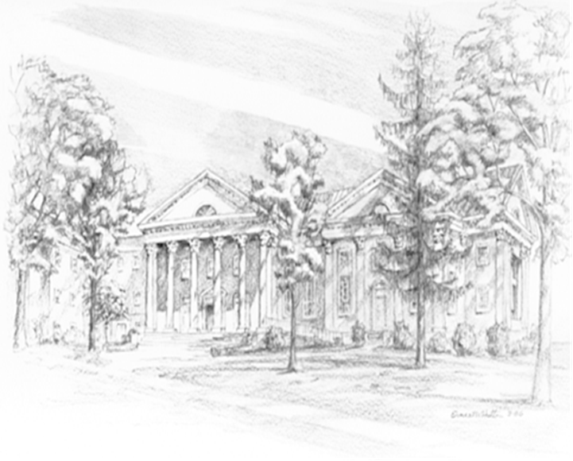

P.O. Box 877
249 South Wayne Avenue
Waynesboro, Virginia
(540) 949-8366
Church Website: www.firstpresway.org
Preschool Website: www.firstprespre.org
Email: church@firstpresway.com

