FOURTH SUNDAY IN LENT March 15, 2026
Liturgist : Terry Crickenberger
PRELUDE Suite in d: Récits Clerambault (1676-1749)

WELCOME & ANNOUNCEMENTS

INTROIT #576 Lord, Have Mercy SINGAPURA
(sung twice)

CALL TO WORSHIP (from Psalm 146)
Leader: Praise the Lord! Praise the Lord, O my soul!
People: I will praise the Lord as long as I live; I will sing praises to God all my life long.
Leader: Happy are those whose help is the God of Jacob, whose hope is in the Lord:
People: Who made heaven and earth, and all that is in them.
Leader: Who executes justice for the oppressed and gives food to the hungry.
People: The Lord sets the prisoner free; the Lord opens the eyes of the blind.
Leader: The Lord lifts up those who are bowed down; the Lord loves the righteous.
People: The Lord watches over the strangers and upholds the orphan and the widow,
Leader: But the way of the wicked he brings to ruin.
People: The Lord will reign forever. Praise the Lord!

MORNING PRAYER

*OPENING HYMN #451 Open My Eyes, That I May See OPEN MY EYES

CHILDREN’S SERMON

CALL TO CONFESSION

PRAYER OF CONFESSION
Almighty and merciful God, we continue to want more, blind to the blessings we already possess. We want everything now, blind to the value of patience and hard work. We take so much delight in our own accomplishments that we are blind to people in need. Forgive
us! Cleanse us of our entitlement, anxiousness and pride. Help us see the world with your eyes so that we can be people of gratitude, courage and compassion, because of what we see in Christ Jesus our Lord. Amen.

SILENT PRAYER
ASSURANCE OF PARDON

*GLORIA PATRI #581 Glory Be to the Father GLORIA PATRI

FIRST SCRIPTURE LESSON Psalm 23 p. 435

ANTHEM Thou Knowest, Lord Purcell (1659-1695)

Thou knowest, Lord, the secret of our hearts;
Shut not Thy merciful ears unto our prayers;
But spare us, Lord, most holy,
O God most mighty,
O holy and most merciful Father,
Thou most worthy Judge eternal,
Suffer us not at our last hour
For any pains of death, to fall from Thee. Amen.

SECOND SCRIPTURE LESSON John 9:1-41 p. 871

SERMON Vision Exam Rev. Samantha Coggins

* AFFIRMATION OF FAITH (Psalm 23:1-6)
The Lord is my shepherd; I shall not want. He makes me lie down in green pastures; he leads me beside still waters; he restores my soul. He leads me in right paths for his name’s sake. Even though I walk through the darkest valley, I fear no evil, for you are with me; your rod and your staff, they comfort me. You prepare a table before me in the presence of my enemies; you anoint my head with oil; my cup overflows. Surely goodness and mercy shall follow me all the days of my life, and I shall dwell in the house of the Lord my whole life long.

PRAYERS of the PEOPLE and LORD’S PRAYER

*CLOSING HYMN # 649 Amazing Grace AMAZING GRACE

BENEDICTION

POSTLUDE Suite in d: Grand Plein Jeu Clerambault

Link: https://www.youtube.com/watch?v=ek55xD4nCw0

Liturgy written by Tracey Davenport



Shenandoah Nursing Home: Nancy Garber

Home: Mary Ultee, Mary Ann Maupin, Warner Sandquist, Polly Bare, Olive Prettyman, Nancy Hypes, Mike and Cathy Cunningham

Friends and Family: Carolyn Hedrick-Williams (Colleen Cash), Betsy Boswell (Curry), Prettyman (Olive Prettyman), Maria Costello (Cunningham), Wes Love (Fishburne).

Military: Carson Craig, Michael Little

Last Lila Book Study
We will meet to discuss the end of Lila this Wednesday, 3/18, in the Barksdale Room at 10:00 a.m.

Holy Week Worship Services
During Holy Week, you are invited to worship together per this schedule:

Palm Sunday, 3/29 — 11:00 a.m. worship at First Pres
Maundy Thursday, 4/2 — 1p.m. with lunch of soup & bread to follow), at Second Pres
Good Friday, 4/3 — 7:00 pm worship at Smyrna Pres


An offering plate is available in the narthex.

FIRST PRESBYTERIAN CHURCH
WAYNESBORO, VIRGINIA

A community-minded congregation living out the love of Christ as we serve one
another with humility, gentleness, and patience through God’s grace.

March 15, 2026 11:00 AM

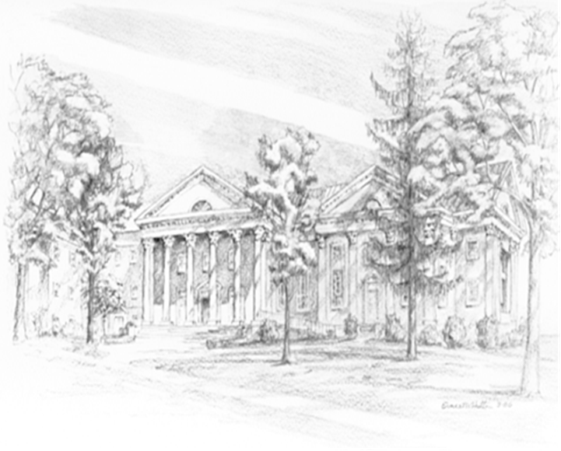

P.O. Box 877
249 South Wayne Avenue
Waynesboro, Virginia
(540) 949-8366
Church Website: www.firstpresway.org
Preschool Website: www.firstprespre.org
Email: church@firstpresway.com

