FIFTH SUNDAY IN LENT March 22, 2026
Liturgist: Patrick Fitzgibbon

PRELUDE Our Father, Who Art in Heaven, BWV 683 Bach (1685-1750)

WELCOME & ANNOUNCEMENTS

INTROIT #576 Lord, Have Mercy SINGAPURA
(sung twice)
CALL TO WORSHIP (Psalm 130)
Leader: Out of the depths we call to you, O Lord.
All: Let your ears hear our supplication.
Leader: We wait for you, O God. In your word is our hope.
All: We wait for you, O Lord, for with you there is mercy.
Leader: Come. Let us worship God.

MORNING PRAYER

THE SACRAMENT OF BAPTISM

*BAPTISM HYMN #482 Baptized in Water BUNESSAN

CALL TO CONFESSION

PRAYER OF CONFESSION
God, we are a busy people. We become preoccupied with the demands of work, our relationships, and our communities. We tend to focus on our own needs and fail to see the needs of those around us. We do that which we should not and fail to do that which we
should. We ask for your forgiveness and for your guidance in following the path you have set before us. Hear us now as we humbly come before you silently and privately to confess our sin.

SILENT PRAYER

ASSURANCE OF PARDON

*GLORIA PATRI #581 Glory Be to the Father GLORIA PATRI

FIRST SCRIPTURE LESSON Psalm 130 p.500

ANTHEM When Jesus Wept Billings (1746-1800)
(text may be found in hymn 194)
SECOND SCRIPTURE LESSON John 11:1-45 p.873

SERMON Raised in Christ Rev. Samantha Coggins

*AFFIRMATION OF FAITH The Apostles’ Creed Hymnal P. 35

PRAYERS of the PEOPLE and LORD’S PRAYER

*CLOSING HYMN #286 Breathe on Me, Breath of God TRENTHAM

BENEDICTION

POSTLUDE Wake Up! Boëly (1785-1858)

Link: https://www.youtube.com/watch?v=CbEX8waqjHE

This week’s liturgy is written by Jane Holtzclaw and the Presbyterian Outlook.

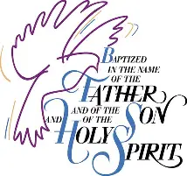



Shenandoah Nursing Home: Nancy Garber

Home: Mary Ultee, Mary Ann Maupin, Warner Sandquist, Polly Bare, Olive Prettyman, Nancy Hypes, Mike and Cathy Cunningham

Friends and Family: Carolyn Hedrick-Williams (Colleen Cash), Betsy Boswell (Curry), Damon Prettyman (Olive Prettyman), Maria Costello (Cunningham), Collin Fravill (Preschool

Military: Carson Craig, Michael Little

Holy Week Worship Services
During Holy Week, you are invited to worship together per this schedule:

Palm Sunday, 3/29 — 11:00 a.m. worship at First Pres
Maundy Thursday, 4/2 — 1p.m. table fellowship at Second Pres
Good Friday, 4/3 — 7:00 pm worship at Smyrna Pres


An offering plate is available in the narthex.

FIRST PRESBYTERIAN CHURCH
WAYNESBORO, VIRGINIA

A community-minded congregation living out the love of Christ as we serve one
another with humility, gentleness, and patience through God’s grace.

March 22, 2026 11:00 AM

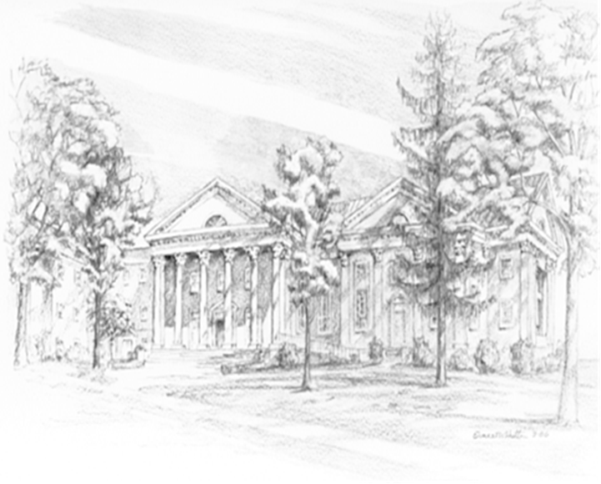

P.O. Box 877
249 South Wayne Avenue
Waynesboro, Virginia
(540) 949-8366
Church Website: www.firstpresway.org
Preschool Website: www.firstprespre.org
Email: church@firstpresway.com

