THIRD SUNDAY IN LENT March 8, 2026

PRELUDE Partita: I-III, BuxWV 179 Buxtehude (1637-1707)

WELCOME & ANNOUNCEMENTS

INTROIT #576 Lord, Have Mercy SINGAPURA
(sung twice)

CALL TO WORSHIP
Leader: O come, let us sing to the Lord; let us make a joyful noise to the rock of our salvation!
All: Let us come into God’s presence with thanksgiving; let us make a joyful noise to
God with songs of praise!
Leader: For the Lord is a great God, and a great ruler above all gods. In God’s hand are
the depths of the earth; the heights of the mountains are God’s also.
All: The sea is the Lord’s, for God made it, and the dry land, which God’s hands have formed.
Leader: O come, let us worship and bow down; let us kneel before the Lord, our Maker!
All: For the Lord is our God, and we are the people of God’s pasture, and the sheep of God’s hands.

MORNING PRAYER

*OPENING HYMN #493 Jesus, Thou Joy of Loving Hearts QUEBEC

CHILDREN’S SERMON

CALL TO CONFESSION

PRAYER OF CONFESSION
God of endless renewal, God who calls us to lives restored, God who rescues the lost and saves the afflicted, there are times when our way grows confused. We struggle to know what to do. Or worse, we know what needs to be done and find it easier to stay on the wrong path. Forgive us for failing to heed opportunities to follow a better way. Remind us that you stand more ready to forgive than we are to confess those aspects of our lives that stand in need of your
grace. And thus forgiven, help us to lean in to what you would teach us about how we are to be. We pray all these things in Jesus’ name, and for his sake…Amen.

SILENT PRAYER

ASSURANCE OF PARDON

*GLORIA PATRI #581 Glory Be to the Father GLORIA PATRI

FIRST SCRIPTURE LESSON Exodus 17:1-7 p.56

ANTHEM Stabat Mater: O My God, Bestow they Tender Mercy
Pergolesi (1710-1736)/arr. Hopson (1933-2025)
O my God, bestow Thy tender mercy
Blot out my transgressions, cleanse my sin.
Bestow Thy love.

Restore me, forgive me, uphold me from all my sins,
O hide Thy face from my sin.
Restore the joy, forgive me, hear me.

I cry to Thee, hear Thou my prayer, cast me not away.
Take not Thy Holy Spirit from me.

Open Thou my lips,
My mouth shall show forth Thy praise.

SECOND SCRIPTURE LESSON John 4:5-24 p.864

SERMON Thirsty Again Rev. Samantha Coggins

* AFFIRMATION OF FAITH (from the Confession of 1967)
God’s sovereign love is a mystery beyond the reach of the human mind. Human thought ascribes to God superlatives of power, wisdom and goodness. But God reveals divine love in Jesus Christ by showing power in the form of a servant, wisdom in the folly of the cross, and
goodness in receiving sinful men and women. The power of God’s love in Christ to transform the world discloses that the Redeemer is the Lord and Creator who made all things to serve the purpose of God’s love.

PRAYERS of the PEOPLE and LORD’S PRAYER

*CLOSING HYMN #182 I Heard the Voice of Jesus Say KINGSFOLD

BENEDICTION

POSTLUDE Partita: IV-V, BuxWV 179 Buxtehude

Link: https://www.youtube.com/watch?v=Ioj0dcFIzmY

This morning’s liturgy is written by Rev. Dr. Baron Mullis and the Presbyterian Outlook.

Shenandoah Nursing Home: Nancy Garber

Home: Mary Ultee, Mary Ann Maupin, Warner Sandquist, Polly Bare, Olive Prettyman, Nancy Hypes, Mike and Cathy Cunningham

Friends and Family: Carolyn Hedrick-Williams (Colleen Cash), Betsy Boswell (Curry), Prettyman (Olive Prettyman), Maria Costello (Cunningham).

Military: Carson Craig, Michael Little

Last Lila Book Study: 3/18
The final book study meeting on Lila by Marilynne Robinson has been rescheduled to Wednesday, 3/18 (Wednesday-after-next). Specifically, we will discuss page 180
to the end of the novel. Book study partners: look for an email from Samantha about choices to vote on, for the next book we will read together after Eastertide.




An offering plate is available in the narthex.

FIRST PRESBYTERIAN CHURCH
WAYNESBORO, VIRGINIA

A community-minded congregation living out the love of Christ as we serve one
another with humility, gentleness, and patience through God’s grace.

March 8, 2026 11:00 AM

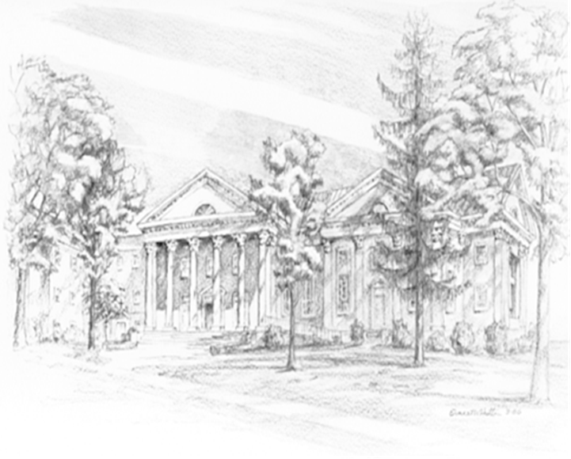

P.O. Box 877
249 South Wayne Avenue
Waynesboro, Virginia
(540) 949-8366
Church Website: www.firstpresway.org
Preschool Website: www.firstprespre.org
Email: church@firstpresway.com

