SECOND SUNDAY OF EASTER April 12, 2026
Liturgist: Terry Crickenberger

PRELUDE Toccata in E, BWV 566 Bach (1685-1750)

WELCOME & ANNOUNCEMENTS
Welcome, Rev. Erin Skinner, to the pulpit this morning!

INTROIT Alleluia Milburn (b. 1963)

CALL TO WORSHIP
Leader: Christ is risen! He greets us with a word of peace.
All: We welcome the risen Christ!
Leader: Locked doors and doubting hearts cannot keep him away.
All: We welcome the risen Christ!
Leader: He comes to bless us with the gift of the Holy Spirit.
All: We welcome the risen Christ! We worship and adore him!

MORNING PRAYER

*OPENING HYMN #236 The Strife is O’er VICTORY

CHILDREN’S SERMON Janet Shaner

CALL TO CONFESSION

PRAYER OF CONFESSION
Savior God, forgive our doubts and disbelief. You show up in our lives, yet we fail to notice you and demand more proof. We expect more when you have already given us enough.
Forgive our lack of faith. Forgive our lack of gratitude. Redeem us. Restore us. Resurrect us for life in Christ. Amen.

SILENT PRAYER

ASSURANCE OF PARDON

*GLORIA PATRI #581 Glory Be to the Father GLORIA PATRI

FIRST SCRIPTURE LESSON Psalm 16 p.430

SPECIAL MUSIC Air Muffat (1690-1770)

SECOND SCRIPTURE LESSON John 20:19-31 p.882

SERMON When Doubt is Faithful Rev. Erin Skinner

*AFFIRMATION OF FAITH Apostles’ Creed Hymnal p.35

PRAYERS of the PEOPLE and THE LORD’S PRAYER

*CLOSING HYMN #234 Come You Faithful, Raise the Strain ST. KEVIN

BENEDICTION

POSTLUDE Fugue in E, BWV 566 Bach

This week’s liturgy is written and adapted from Rev. Carol Holbrook Prickett’s online resource Deep Well Worship.

LINK: https://www.youtube.com/watch?v=z3jqytJ1Vhk

Guest Worship Leader Today: Rev. Erin Skinner
Our guest worship leader and preacher today is Rev. Erin Skinner.

Erin serves as the Ministry Relations officer for the Cumberland Region (KY, TN, VA). Erin leads congregations to resources, help pastors and church leaders identify major gift prospects and manage those prospects by utilizing services and expertise offered by the Presbyterian Foundation and New Covenant Trust Company.
Erin previously served as Director of Admissions at Union Presbyterian Seminary and as a chaplain at VCU Health and Bridgewater College, all in Virginia. Erin earned a B.A. in Psychology and Sociology and an MBA from Georgia State University. She received a Master of Divinity from Union Presbyterian Seminary and an M.S. in Patient Counseling from Virginia Commonwealth University.

She and her husband, Will, reside in Waynesboro, Va., with their two dogs, Summer and Dean.


Summit Square: Lorain Kent

Shenandoah Nursing Home: Nancy Garber

Home: Mary Ultee, Mary Ann Maupin, Warner Sandquist, Polly Bare, Olive Prettyman, Nancy Hypes, Mike and Cathy Cunningham, Collin Fravel and Family (Preschool).

Friends and Family: Carolyn Hedrick-Williams (Colleen Cash), Betsy Boswell (Curry), Damon Prettyman (Olive Prettyman), Jessica Faulk, Maria Costello (Cunningham).

Military: Carson Craig, Michael Little

ONE GREAT HOUR OF SHARING OFFERING

Around the world, millions of people lack access to sustainable food sources, clean water, sanitation, education, and opportunity. The work done in support of these causes is supported by One Great Hour of Sharing – disaster, hunger, poverty, climate change, and immigration/migration of refugees. Work provides people with safety, sustenance and hope. The Offering helps to improve the lives of people in these challenging situations.
Fifty years ago, during World War II and immediately following, Protestant churches made appeals for relief and reconstruction. In 1950 the term “One Great Hour of Sharing” was used for the first time. It has become a tradition at First Pres to support this annual appeal at Easter. Envelopes are available. Contributions may be placed in the Offering Plate in the Narthex or taken to the Church Office.

News of Lorain Kent this week, after a recent hospital visit, a decline in her health has warranted her in Hospice care. She is still in Summit Square, AL 10 room. She is sleeping a lot and comfortable. Please keep her and family in your prayers


An offering plate is available in the narthex.

FIRST PRESBYTERIAN CHURCH
WAYNESBORO, VIRGINIA

A community-minded congregation living out the love of Christ as we serve one
another with humility, gentleness, and patience through God’s grace.

April 12, 2026
11:00 AM

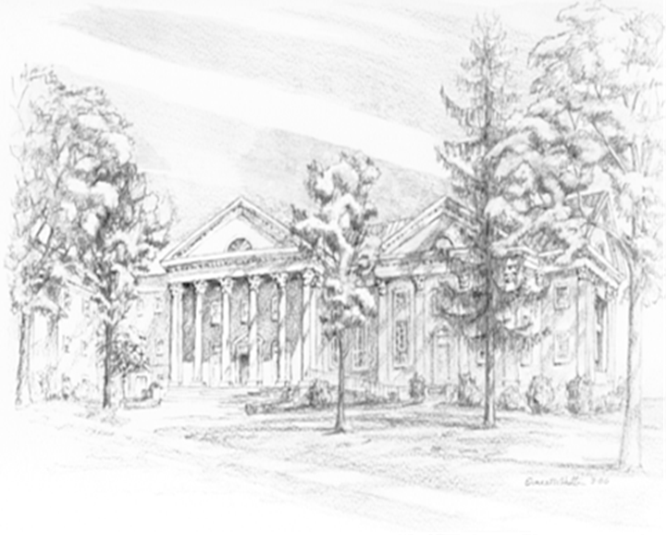

P.O. Box 877
249 South Wayne Avenue
Waynesboro, Virginia
(540) 949-8366
Church Website: www.firstpresway.org
Preschool Website: www.firstprespre.org
Email: church@firstpresway.com

