THIRD SUNDAY OF EASTER April 19, 2026
Liturgist: Patrick Fitzgibbon

PRELUDE Andante religioso Mendelssohn (1809-1847)

WELCOME & ANNOUNCEMENTS

INTROIT Deo gracias circa 1415

CALL TO WORSHIP
Leader: I will offer to you a thanksgiving sacrifice and call on the name of the Lord.
All: I will pay my vows to the Lord in the presence of all his people,
Leader: in the courts of the house of the Lord, in your midst, O Jerusalem.
All: Praise the Lord!

MORNING PRAYER

*OPENING HYMN #246 Christ is Alive! TRURO

CHILDREN’S SERMON

CALL TO CONFESSION

PRAYER OF CONFESSION
Merciful God, even as we proclaim the saving life, death and resurrection of Jesus Christ, we fail to see the living Christ in our midst.
We find ourselves preoccupied with our own well-being and success, forgetting your imperative to love our neighbor as ourselves.
We turn away from systems that challenge our way of thinking, choosing to justify our actions instead of examining our intentions.
Show us again how to live a resurrection faith, a faith that sees life and hope in the midst of death and destruction.
Transform our hearts so that where they are hardened toward you, neighbor and self,
they may once again be filled with love and moved to actions of grace and mercy.
In your holy name, we pray. Amen.

SILENT PRAYER
ASSURANCE OF PARDON

*GLORIA PATRI #581 Glory Be to the Father GLORIA PATRI

FIRST SCRIPTURE LESSON Psalm 34:1-10 p. 441

SPECIAL MUSIC We Know That Christ Is Raised Stanford (1852-1924)
(text can be found in hymn 485)

SECOND SCRIPTURE LESSON John 20:19-31 p.883

SERMON Seeing That The Lord Is Good Rev. Samantha Coggins

*AFFIRMATION OF FAITH (The Confession of Belhar)
We believe that Christ’s work of reconciliation is made manifest in the church as the community of believers who have been reconciled with God and with one another;
that unity is, therefore, both a gift and an obligation for the church of Jesus Christ;
that through the working of God’s Spirit it is a binding force, yet simultaneously a reality which must be earnestly pursued and sought: one which the people of God must continually be built up to attain.
That this unity must become visible, so that the world may believe that separation, enmity and hatred between people and groups is sin which Christ has already conquered, and accordingly that anything which threatens this unity may have no place in the church and must be resisted.

PRAYERS of the PEOPLE and THE LORD’S PRAYER

*CLOSING HYMN #238 Thine is the Glory JUDAS MACCABEUS

BENEDICTION

POSTLUDE Sonata in B-flat, op. 65 no 4: Allegro con brio Mendelssohn

This week’s liturgy is written by Rev. Ashley Drake Mertz and the Presbyterian Outlook.

LINK: https://www.youtube.com/watch?v=O6fxqGHmHro

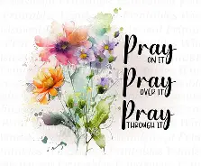
Summit Square: Lorain Kent , Phyllis Hanna, (Sandra Moultan).

Shenandoah Nursing Home: Nancy Garber.

Home: Mary Ultee, Mary Ann Maupin, Warner Sandquist, Polly Bare, Olive Prettyman, Nancy Hypes, Mike and Cathy Cunningham.

Friends and Family: Carolyn Hedrick-Williams (Colleen Cash), Betsy Boswell (Curry), Damon Prettyman (Olive Prettyman), Jessica Faulk, Maria Costello (Cunningham).

Military: Carson Craig, Michael Little

One Great Hour of Sharing will be collected thru April.


An offering plate is available in the narthex.



FIRST PRESBYTERIAN CHURCH
WAYNESBORO, VIRGINIA

A community-minded congregation living out the love of Christ as we serve one
another with humility, gentleness, and patience through God’s grace.

April 19, 2026
11:00 AM

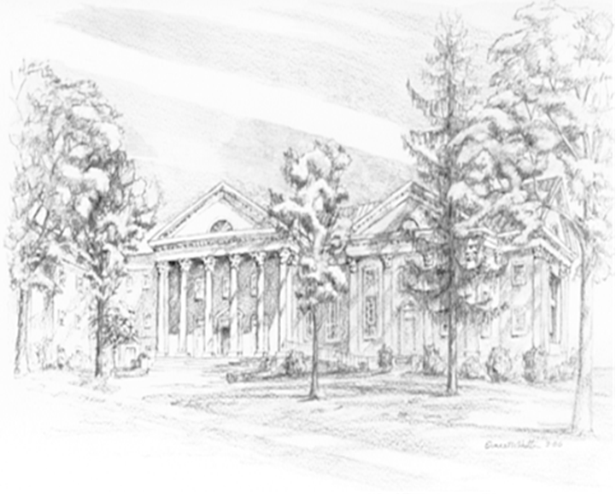

P.O. Box 877
249 South Wayne Avenue
Waynesboro, Virginia
(540) 949-8366
Church Website: www.firstpresway.org
Preschool Website: www.firstprespre.org
Email: church@firstpresway.com

