FOURTH SUNDAY OF EASTER April 27, 2026
Liturgist: Cynthia Hoover

PRELUDE My Heart Leaps With Joy Walcha (1907-1991)

WELCOME & ANNOUNCEMENTS

INTROIT Now Enter In Hebble (1934-2020)

CALL TO WORSHIP
Leader: Lift up your heads, ye mighty gates!
All: Behold! The Savior of the world is risen!
Leader: Fling wide the portals of your hearts:
All: Let us feel the presence of the God’s grace and love!
Leader: O Holy spirit, lead us on in worship;
All: Call us each by name, that we may give God glory!

MORNING PRAYER

*OPENING HYMN #35 Praise Ye the Lord, the Almighty LOBE DEN HERREN

CHILDREN’S SERMON

CALL TO CONFESSION

PRAYER OF CONFESSION
Gracious God, from before the foundation of the world, you called us by name and pledged your steadfast love. But like ornery sheep, we stray from the fold. You offer to lead us, but we prefer to lead ourselves. Christ laid down his life, yet we refuse to lay down our phones, our plans, our pride.
Forgive us, O God. Call us back to the open gate of Christ’s redeeming love, that we may enter your Beloved Community and find restoration for our souls, reconciliation with our enemies, and the glory of abiding with you, forevermore. Amen.

SILENT PRAYER

ASSURANCE OF PARDON
*GLORIA PATRI #581 Glory Be to the Father GLORIA PATRI

FIRST SCRIPTURE LESSON Psalm 100 p. 481

ANTHEM Alleluia, Alleluia! Give Thanks Fishel (b.1950)
(text can be found in hymn 240)

SECOND SCRIPTURE LESSON John 10:1-10 p.872

SERMON Come In, Go Out, Find Pasture Rev. Samantha Coggins

*AFFIRMATION OF FAITH (Second Helvetic Confession)
In all crises and trials of our life we call upon God alone and do so by the mediation of our only mediator and intercessor, Jesus Christ.
For we have been explicitly commanded: “Call upon me in the day of trouble; I will deliver you, and you shall glorify me” (Psalm 1:15).
Moreover, we have a most generous promise from the Lord who said: “If you ask anything of the Father, he will give it to you” (John 16:23), and: “Come to me, all who labor and are heavy laden and I will give you rest” (Matthew 11:28).
And since it is written: “How are men to call upon him in whom they have not believed?” (Romans 10:14), and since we do believe in God alone, we assuredly call upon God alone, and we do so through Christ alone. Amen.

PRAYERS of the PEOPLE and THE LORD’S PRAYER

*CLOSING HYMN #720 Jesus Calls Us GALILEE

BENEDICTION

POSTLUDE Toccata in F, BuxWV 157 Buxtehude (1637-1707)

This week’s liturgy is written by Rev. Dr. Aaron Pratt Shepherd and the Presbyterian Outlook. The Morning Prayer is adapted from Howard Thurman’s “Give Me the Listening Ear,” in his book Meditations of the Heart.

LINK: https://www.youtube.com/watch?v=Uj9ZcA3zhOU
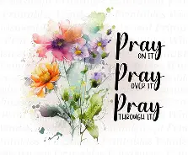
Summit Square: Lorain Kent.

Shenandoah Nursing Home: Nancy Garber (Hospice), niece Joann.

Home: Mary Ultee, Mary Ann Maupin, Warner Sandquist, Polly Bare, Olive Prettyman, Nancy Hypes, Mike and Cathy Cunningham.

Friends and Family: Carolyn Hedrick-Williams (Colleen Cash), Betsy Boswell (Curry), Damon Prettyman (Olive Prettyman), Jessica Faulk, Maria Costello (Cunningham).

Military: Carson Craig, Michael Little

One Great Hour of Sharing will be collected through April 26.
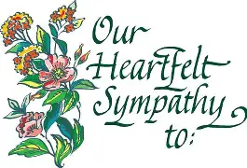
Prayers for Phyllis Hanna’s family.
Phyllis K. Hanna, 96, died peacefully on Saturday, April 18th surrounded by her loving family. Per her wishes, she will have a private graveside service.
Phyllis wished to be present for her “Celebration of Life.”
Her 95th Birthday Party was a festive gathering of all her dearest friends & family. McDow Funeral Home will handle the arrangements. Remembrances and condolences may be shared on the online obituary or mail to McDow Funeral Home, 1701 West Main Street, Waynesboro VA 22980 and will forwarded to her daughter Sandra & family.

Organ Recital Friday, May 1
You are cordially invited to the next First Friday Organ Recital and Light Luncheon on Friday, 1 May at First Presbyterian Church in Waynesboro. Director of Music/Organist Roger Daggy will play a program on the church's 1893 Woodberry and Harris organ beginning at 12:15pm, followed by a light luncheon served in the Barksdale Room.
The series will be on hiatus for the summer and will resume in October.
The concert and luncheon are free, and all are welcome!

Sincerely,
Kimberlea Daggy
Music Associate, First Presbyterian Church


An offering plate is available in the narthex.

FIRST PRESBYTERIAN CHURCH
WAYNESBORO, VIRGINIA

A community-minded congregation living out the love of Christ as we serve one
another with humility, gentleness, and patience through God’s grace.

April 26, 2026
11:00 AM

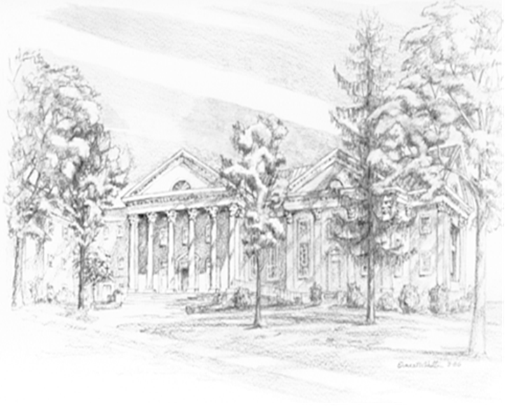

P.O. Box 877
249 South Wayne Avenue
Waynesboro, Virginia
(540) 949-8366
Church Website: www.firstpresway.org
Preschool Website: www.firstprespre.org
Email: church@firstpresway.com

