

THE COLUMNS
First Presbyterian Church, Waynesboro, VA
June 2026, Volume 64, Issue 6

First Presbyterian Church of Waynesboro is a community-minded
congregation living out the love of Christ as we serve one another with
humility, gentleness, and patience through God’s grace.

15 Toward evening the disciples approached him. “We’re out in the country and it’s getting
late. Dismiss the people so they can go to the villages and get some supper.”
16 But Jesus said, “There is no need to dismiss them. You give them supper.”
17 “All we have are five loaves of bread and two fish,” they said.
18-21 Jesus said, “Bring them here.” Then he had the people sit on the grass. He took the
five loaves and two fish, lifted his face to heaven in prayer, blessed, broke, and gave the
bread to the disciples. The disciples then gave the food to the congregation. They all ate
their fill. They gathered twelve baskets of leftovers. About five thousand were fed.
Matthew 14:15-21

When in doubt, always quote scripture. This is not one of the rules I have painstakingly collected over the years,
but perhaps it should be. Last month, we began with insights into basketball; for May, we are diving back into
the New Testament for illumination.
We are conditioned, I think, to look at the miraculous as magical, the theological equivalent of alchemy. Just as
the medieval alchemist sought to turn lead into gold, and thus enrich themselves without labor, we look at
miracles at least in part, as labor-saving plot devices: healing without the effort of treatment; gifts that eliminate
the need for impossible choices; rescue that makes of us passive recipients of grace. But, in the words of yet
another of my rules, God is not a magician; what we call miracles are signs of God at work in our midst - and
God hates to work alone.

In the feeding of the multitude, the disciples recognize a need - the crowd is getting hungry and the day is
mostly gone. This is a real problem, they know, but the best they can come up with is to send the crowds
back to town, where they might find some supper. But Jesus has something else in mind; not just pushing
the problem down the road, but actually doing something about the hunger of the people. He asks what
food is available, and is told, 5 rolls and 2 cooked fish - the lunch of a well-prepared young man. Jesus
then does the miraculous, but the miracle isn&#39;t magic- Jesus does not make everyone feel full, or have
manna fall from the heavens. The miracle happens through the work of the disciples. It is the disciples
who organize the people, getting them to sit down in an orderly fashion; they who oversee the distribution
of the loaves and fishes, making sure everyone is fed; even making sure the leftovers are collected. And
that, friends, leads us to Rule #10:

June 2026

Dear Members & Friends of First Presbyterian Church,

Later this month (June 25 - July 2), I will be in Milwaukee, Wisconsin, representing Shenandoah Presbytery as a Teaching Elder, at our denomination’s 227th General Assembly.

To assist our congregation in understanding ‘GA,’ this denomination-wide meeting, I will be circulating a guide for churches via the Presbyterian Outlook. Stay tuned for hard copies of this on Sunday mornings in June! If you are wondering what your pastor will be doing there in Wisconsin or even wondering ‘What is General Assembly (‘GA’)?’, then this guide might be for you!

Before I depart Virginia for the Midwest, I will be starting a new sermon series in worship called Hello, Old Friend: Scriptures That Have Formed My Faith. Beginning Sunday, May 31, and continuing through August, I’ll be preaching on Bible passages that have formed (and informed) me – Samantha – as a disciple of Jesus Christ, along my personal walk with God. I’m excited to see what the Holy Spirit has in store for us, as I share more with you about the difference that Jesus has made in my own life.

I hope that this month is a time of rest and rejuvenation for you, wherever you find yourself enjoying the start of summertime, including right here in Waynesboro.

Grace & peace,
Samantha

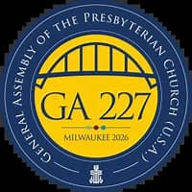


JUNE MUSIC NOTES

The month of June is upon us, and with it, the official beginning of summer! At First Presbyterian Church, June also means the end of the choir season and the beginning of guest musicians gracing our Sanctuary to play during Sunday morning services.

On 7 June, the choir will sing Draw Us in the Spirit’s Tether by Harold Friedell (1905-1958) before taking a well-deserved break. We are extremely grateful to the members of the ensemble, who faithfully volunteer week in and week out from September through early June. Our heartfelt thanks to sopranos Cathy Cunningham, Jean Hashagen and Janet Shaner, altos Susan Elder, Betsy Ruehl and Sue Wool, tenors Terry Crickenberger and Joe Earhart and basses Patrick Fitzgibbon and Max Daggy for their commitment to singing and leading worship through song. Later this summer, members of the choir will provide special music during various services.

On the second Sunday of June, the harpsichord will take front and center for the special music. FPC is fortunate to have such wonderful keyboard instruments in the Sanctuary, and Roger will highlight the delightful tones of FPC’s two manual harpsichord on 14 June.

The third Sunday of June marks Father’s Day. As in the past, father-son duo Roger and Max Daggy will provide the anthem for the day, sharing their love of the Lord, music and one another!

On the final Sunday of June, FPC welcomes students from the Heifetz International Music Institute in Staunton. Every summer, the institute brings young musicians from around the world to the valley for six weeks of intensive musical study and performance. For many years, FPC has provided an opportunity for a string quartet play during a service, and the church will welcome this year’s ensemble on 28 June.

FPC is blessed to have members committed to the mission of the church: worshipping God, educating young children, feeding the hungry and fulfilling the soul through music. We are so grateful to be part of the community and look forward to continuing the musical ministry in the church.

Blessings,

Roger and Kimberlea Daggy

NO FIRST FRIDAY ORGAN CONCERTS THIS SUMMER
Join us again on
October 4

COLLECTING PERSONAL CARE ITEMS FOR FOOD BANK



227TH GENERAL ASSEMBLY
June 28-July 2, 2026

The General Assembly is a council of the church, a discernment event and a worshipping body. It is an event that happens every two years.
As a council, the General Assembly is made up of commissioners from the Presbyterian Church (U.S.A.) presbyteries, with teaching elders (ministers of the Word and Sacrament) and ruling elders represented in equal numbers. Young adult advisory delegates, theological student advisory delegates and partner advisory delegates representing the global mission organizations, partner churches and interreligious groups also constitute the Assembly.
These individuals gather for committees and plenary sessions* to discern the direction of the church and make decisions that are implemented throughout the life of the PC(USA).
As a worshipping body, the General Assembly is a time when people from across the PC(USA) and beyond gather to celebrate God’s work in the world.
The 227th General Assembly with begin officially with committees gathering online from June 22-24. Between June 25 and 26, attendees will travel to Milwaukee. The Assembly then will participate in a Community Day on June 27 where those attending will be able to join public witness opportunities and visit the “Town Square”, where organizations will be available to equip attendees with resources and connections for further discipleship and ministry. Finally the plenary session* will take place in Milwaukee from June 28-July 2.

*A plenary session is a meeting where every member of a body is expected to attend, as opposed to a committee or a working group that includes only a fraction of its membership





Scholarship Committee Columns Report
Academic Year 2026-2027

The Memorial Fund Committee, Holly Bennett and Connie Sachlis, met on May 5, 2026 to examine scholarship applications for the 2026-27 academic year.
Ten Scholarships were awarded to:
Ezra Carter – Messiah University
Paris James Carter – Messiah University
Haven Cranford – Washington & Lee University
River Cranford – Elon University
Lexi Dull – Longwood University
Diana Forshee – Bridgewater College
Grace Golladay – South University
Kelly Griffith – JMU
Brooklyn Kerr – Bridgewater College
Lluvia Zamudio Pina – JMU

I want to personally thank Connie Sachlis and Session members for their time and effort. I am especially grateful to Colleen Cash for all of her administrative assistance throughout the academic year.
Holly Bennett



FATHER’S DAY PRAYER

Heavenly Father, I lift up every father to you today. Strengthen them in their role as leaders, providers, and nurturers. Fill them with wisdom and courage to guide their families.
Bless fathers with patience. When the world feels heavy, remind them of Your sustaining grace. Help them to lead with love, not frustration, and to reflect your heart in every word and action.
Help dads to be men of integrity. May their words and actions align with Your truth, setting a godly example for their children to follow.
Give fathers discernment in decision-making. When they face difficult choices, guide them by Your Spirit so that their families may walk in blessing.
Give fathers boldness to stand for righteousness in a world that often opposes Your ways. Help them to be lights in the darkness.
Help dads to laugh often. Bring joy into their home and remind them not to take life so seriously that they miss the beauty in each day.
Thank you for every dad who seeks to honor You. Crown their efforts with Your favor, and may their lives bring glory to your name. Amen



We are excited for our school year to end, although we are sad to see some of our friends leave us for the year and head off to kindergarten in the fall. We are ready to welcome some new friends to our fun-filled summer camp! This past month we have worked so hard yet had so much fun getting ready for our spring music program with Mrs. Lynda and all our friends.
Our summer camp is ready to kick off for so much fun June 1^{st,} and the teachers are just as excited as the children, we have so much fun planned we won’t be able to keep up with the time, from walking field trips, and water days as well as themed activities.
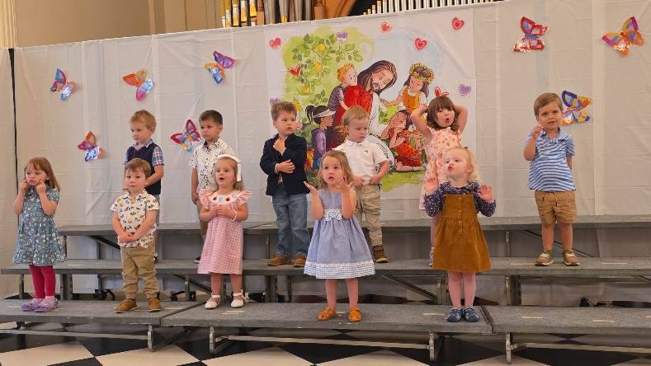
We have our tickets still on sale for our raffle baskets as well until Friday June 12th! You won’t want to miss out on the chance to win one of these fun baskets!! Tickets are 5 for $20

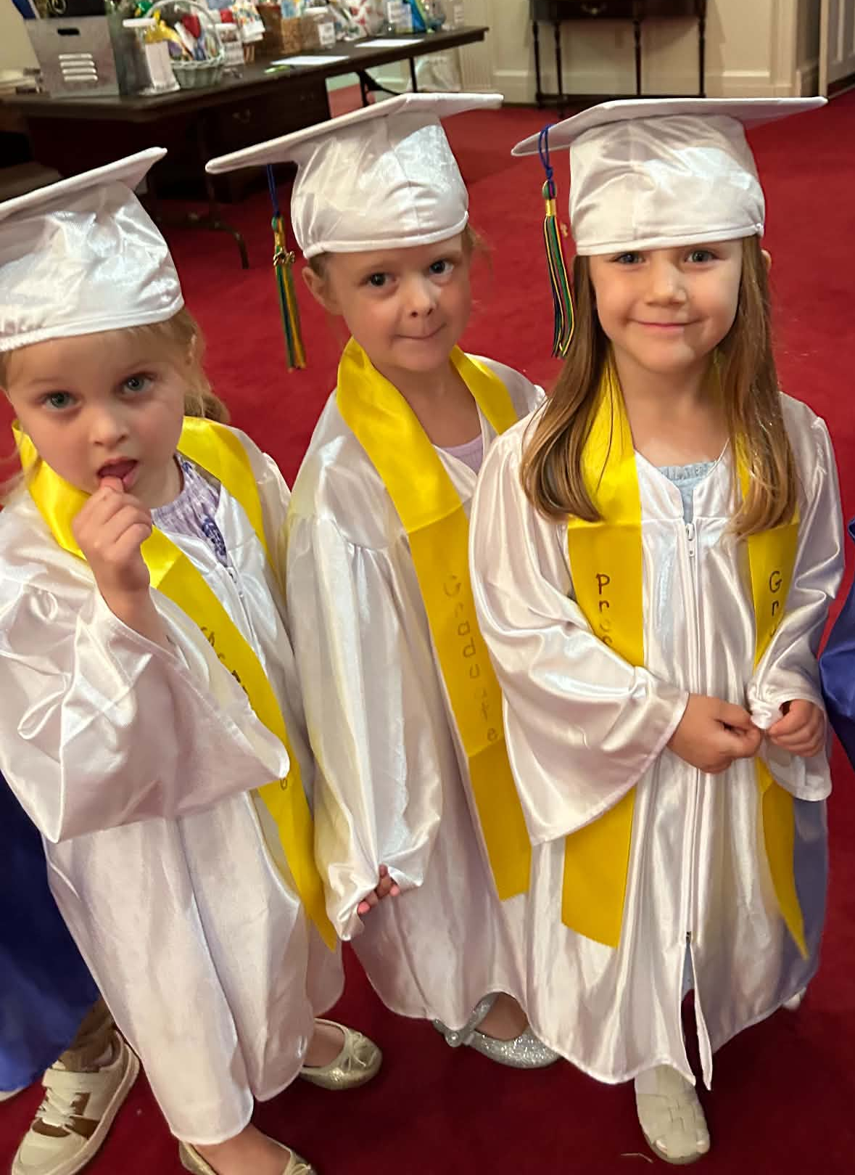

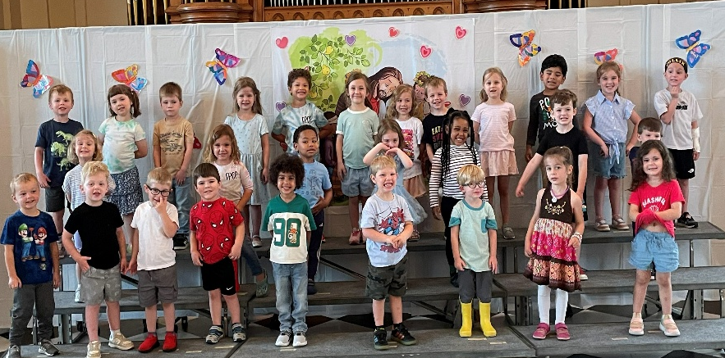


BETTER TOGETHER BIBLE STUDIES
Study resumes on September 14


SUMMER FPC BOOK STUDY

“Good Soil: The Education of an Accidental Farmhand” by Jeff Chu
(A true story of a working farm at Princeton Seminary)
Wednesdays at 10:00 in the Barksdale Room
Led by Rev. Samantha Coggins
July 8 – September 2
A limited number of books available in the Church Office

LITURGISTS BIRTHDAYS ANNIVERSARIES
June 7 – Joe Earhart 9- Pam Leech 1- Roger & Ann Bryant
June 14 – Terry Crickenberger 10- Joel Coggins 13- Bruce Bosselman & Kevin Henkel
June 21 – Patrick Fitzgibbon 14- Betsy Ruehl 14- Bob & Mary Scott Miller
June 28 – Betsy Ruehl 14- Colleen Cash 28- Mark & Sandi Henderson
16- Warner Sandquist





CHURCH OFFICERS:
Treasurer – Colleen Cash
Members of Session - Jean Hashagen, Betsy Ruehl
Cynthia Hoover, Bob Miller and Nancy Hypes.

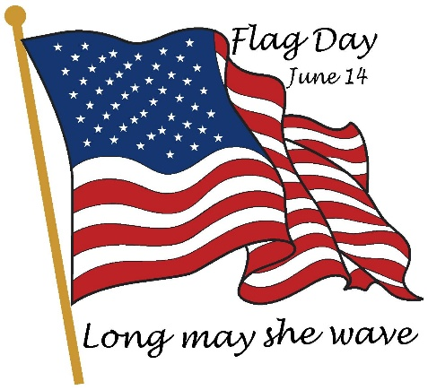

FLAG DAY – JUNE 14

Flag Day is a celebration of the American flag that occurs each year on June 14, the anniversary of the flag’s official adoption.
What we know fondly as the “Stars and Stripes” was adopted by the Continental Congress as the official American flag on June 14, 1777, during the Revolutionary War. Colonial troops fought under many different flags with various symbols – rattlesnake, pine trees, and eagles – and slogans – “Don’t Tread on Me,” “Liberty or Death,” and “Conquer or Die,” to name a few.
The Declaration of Independence made the adoption of the American flag necessary. Previously, each colony or special interest had its own flag.
On that 14th of June, Congress made the Flag Resolution of 1777, stating: “The flag of the United States shall be thirteen stripes, alternate red and white, with a union of thirteen stars of white on a blue field.
June 14 has special significance every year for FPC congregants Colleen Cash and Betsy Ruehl.

Thursday June 4
6-7:30 pm Food Bank
Sunday, June 7
11 am Worship
Tuesday, June 9
2:30 pm Session-Barksdale Room
Thursday, June 11
2-4 pm Food Bank
Sunday, June 14
11 am Worship
Thursday, June 18
6-7:30 Food Bank
Sunday, June 21
11 am Worship
Thursday, June 25
2-4 pm Food Bank
Saturday June 27
11am Bernadette Griffith Book Signing (Wife of our own Maintenance Tech Mike Griffith)
Sunday, June 28
11 am Worship - Guest Speaker John Tindall

