SIXTH SUNDAY OF EASTER May 10, 2026
Liturgist: Kimberlea Daggy

PRELUDE Variations I, II Sweelinck (1562-1621)

WELCOME & ANNOUNCEMENTS

INTROIT Let All the World in Every Corner Sing Routley (1917-1982)

CALL TO WORSHIP
Leader: We gather to celebrate the God of wonder and majesty!
All: Awesome God, help us to worship you in spirit and in truth.
Leader: We gather to celebrate Jesus Christ, who was dead and buried, and now risen indeed!
All: Jesus, renew our hope in your great power and love.
Leader: We gather to celebrate the Holy Spirit, our promised comforter and guide!
All: Come, Holy Spirit! Fill us with your presence and peace.
Leader: We gather to celebrate the ancient hope of Christians:
All: God is with us and will never let us go.

MORNING PRAYER

*OPENING HYMN #12 Immortal, Invisible, God Only Wise ST. DENIO

CHILDREN’S SERMON

CALL TO CONFESSION

PRAYER OF CONFESSION
Ever-present God, we come before you knowing we have ignored your promised Holy Spirit living within us. Therefore, we forfeit peace and bear needless worry. We become confused and deaf to your voice of truth. We struggle with obedience to your Word and fight an overwhelming sense of loneliness. Forgive us! Help us to remember that we are never alone, that you are with us and for us, by the power of your Spirit abiding in us, the Spirit of Jesus the Christ, our Savior and Lord. Amen.

SILENT PRAYER

ASSURANCE OF PARDON

*GLORIA PATRI #581 Glory Be to the Father GLORIA PATRI

FIRST SCRIPTURE LESSON 1 Peter 3:13-22 p.985

ANTHEM Teach Me, O Lord, Hurd (b. 1950)
Teach me, O Lord, the way of Thy statutes, and I shall keep it to the end.

SECOND SCRIPTURE LESSON John 14:15-21 p.877

SERMON An Advocate, Forever Rev. Samantha Coggins

*AFFIRMATION OF FAITH (from The PCUSA Study Catechism)

What do you believe when you confess your faith in the Holy Spirit?

Apart from the Holy Spirit, our Lord can neither be loved, nor known, nor served. The Holy Spirit is the personal bond by which Jesus Christ unites us to himself, the teacher who opens our hearts to Christ, and the comforter who leads us to repentance, empowering us to live in Christ’s service. As the work of the one Holy Spirit, our love, knowledge, and service of Christ are all inseparably related.

How do we receive the Holy Spirit?

By receiving the Word of God. As the midwife of the new creation, the Spirit arrives with the Word, brings us to rebirth, and assures us of eternal life. The Spirit nurtures, corrects, and strengthens us with the pure spiritual milk of the Word (1 Peter 2:2).

PRAYERS of the PEOPLE and THE LORD’S PRAYER

*CLOSING HYMN #282 Come Down, O Love Divine DOWN AMPNEY

BENEDICTION

POSTLUDE Variation IV Sweelinck

This week’s liturgy is written by Rev. Dr. Tracey Davenport and the Presbyterian Outlook.

LINK: https://www.youtube.com/watch?v=7b2dQ2kyQmg



Summit Square: Lorain Kent

UVA: Linda Quillen

Home: Mary Ultee, Mary Ann Maupin, Warner Sandquist, Polly Bare, Olive Prettyman, Nancy Hypes.

Friends and Family: Carolyn Hedrick-Williams (Colleen Cash), Betsy Boswell (Curry), Damon Prettyman (Olive Prettyman), Michel & Jim Williams (Cunningham).

Military: Carson Craig, Michael Little

FPCP Preschool Spring Program & Graduation: May 21 & 22
Our preschoolers perform their spring concert Thursday, May 21, at 6:30 pm. We will celebrate our rising Kindergarten students with a graduation the following night, Friday, May 22 at 6:00 pm. Both events are being held in the sanctuary. The congregation is invited to both events. Come on Thursday to savor the joy of these little voices, and/or Friday to celebrate our four- and five-year-olds alongside their teachers & caregivers!



An offering plate is available in the narthex.

FIRST PRESBYTERIAN CHURCH
WAYNESBORO, VIRGINIA

A community-minded congregation living out the love of Christ as we serve one
another with humility, gentleness, and patience through God’s grace.

May 10, 2026
11:00 AM

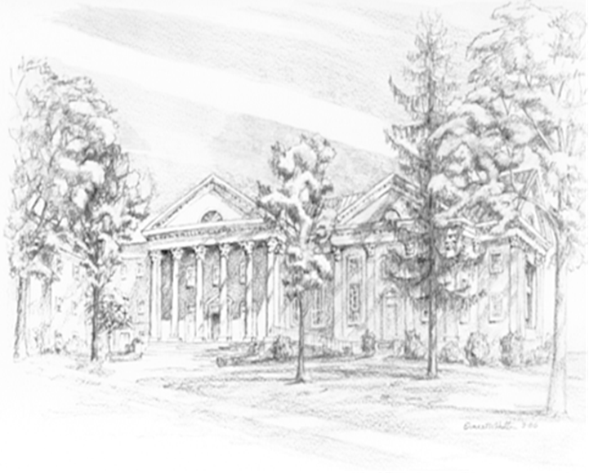

P.O. Box 877
249 South Wayne Avenue
Waynesboro, Virginia
(540) 949-8366
Church Website: www.firstpresway.org
Preschool Website: www.firstprespre.org
Email: church@firstpresway.com

