SEVENTH SUNDAY OF EASTER May 17, 2026
Liturgist: Patrick Fitzgibbon

PRELUDE How Fair and Pleasant Thou Art, Op. 18, no. 5 Dupré (1886-1971)

WELCOME & ANNOUNCEMENTS

INTROIT Now Enter In Hebble (1934-2020)

CALL TO WORSHIP (Psalm 68:7-10, 32)
Leader: O God, when you went out before your people, when you marched through the wilderness, the earth quaked,
All: the heavens poured down rain at the presence of God, the God of Sinai, at the presence of God, the God of Israel.
Leader: Rain in abundance, O God, you showered abroad; you restored your
heritage when it languished; your flock found a dwelling in it;
in your goodness, O God, you provided for the needy.
All: Sing to God, O kingdoms of the earth; sing praises to the Lord.

MORNING PRAYER

*OPENING HYMN #662 Christ, Whose Glory Fills the Skies RATISBON

CHILDREN’S SERMON

CALL TO CONFESSION

PRAYER OF CONFESSION
Eternal God, you have loved us from generation to generation. You have shown your faithfulness more often than we can recall. The Bible tells us of your steadfast mercy. You even pray for us. Yet we live holding on to past hurts; we are not open to your new creation. We prefer the safety of what we know to the excitement of discipleship. Forgive us, we pray, and make us again as you would have us be. We make all of our prayers in the name of Jesus Christ. Amen.

SILENT PRAYER

ASSURANCE OF PARDON

*GLORIA PATRI #581 Glory Be to the Father GLORIA PATRI

FIRST SCRIPTURE LESSON 1 Peter 4:12-14 p.985

ANTHEM A Hymn of Glory, Let Us Sing! Anon. circa 1415, arranged
(text can be found in hymn 258)

GOSPEL READING John 17:1-11 p.879

SERMON Looking Heavenward Rev. Samantha Coggins

*AFFIRMATION OF FAITH (from A Brief Statement of Faith)
In a broken and fearful world the Spirit gives us courage to pray without ceasing,
to witness among all peoples to Christ as Lord and Savior, to unmask idolatries in Church and culture, to hear the voices of peoples long silenced, and to work with others for justice, freedom, and peace. In gratitude to God, empowered by the Spirit, we strive to serve Christ in our daily tasks and to live holy and joyful lives, even as we watch for God’s new heaven and new earth,
praying, “Come, Lord Jesus!”
With believers in every time and place, we rejoice that nothing in life or in death
can separate us from the love of God in Christ Jesus our Lord.
Glory be to the Father, and to the Son, and to the Holy Spirit. Amen.

PRAYERS of the PEOPLE and THE LORD’S PRAYER

*CLOSING HYMN #265 Jesus Shall Reign Where’er the Sun DUKE STREET

*BENEDICTION

POSTLUDE Prelude in F, BWV 928 Bach (1685-1750)

This week’s liturgy is written by Baron Mullis and the Presbyterian Outlook.

LINK: https://www.youtube.com/watch?v=-P9syzeaetk


Shenandoah Nursing & Rehab: Linda Quillen

Home: Mary Ultee, Mary Ann Maupin, Warner Sandquist, Polly Bare, Olive Prettyman, Nancy Hypes.

Friends and Family: Carolyn Hedrick-Williams (Colleen Cash), Betsy Boswell (Curry), Damon Prettyman (Olive Prettyman.
Military: Carson Craig, Michael Little

Our sympathies to Mike & Cathy Cunningham on the passing of his sister Michel on May 13, 2026.

Lorain Kent died Monday morning at Summit Square. She was 102. A memorial service will be held this Wednesday at 2:00 pm in the sanctuary, with a reception to follow in the Barksdale Room.

FPCP Preschool Spring Program & Graduation: May 21 & 22
Our preschoolers perform their spring concert Thursday, May 21, at 6:30 pm. We will celebrate our rising Kindergarten students with a graduation the following night, Friday, May 22 at 6:00 pm. Both events are being held in the sanctuary. The congregation is invited to both events. Come on Thursday to savor the joy of these little voices, and/or Friday to celebrate our four- and five-year-olds alongside their teachers & caregivers!

Starting Monday, New Address
Joyce M. Tipton
The Legacy At North Augusta
1410 A North Augusta Street
Apt 3046
Staunton, VA 24401

Please join us for the Fellowship Luncheon after Worship, all are welcome


An offering plate is available in the narthex.

FIRST PRESBYTERIAN CHURCH
WAYNESBORO, VIRGINIA

A community-minded congregation living out the love of Christ as we serve one
another with humility, gentleness, and patience through God’s grace.

May 17, 2026
11:00 AM

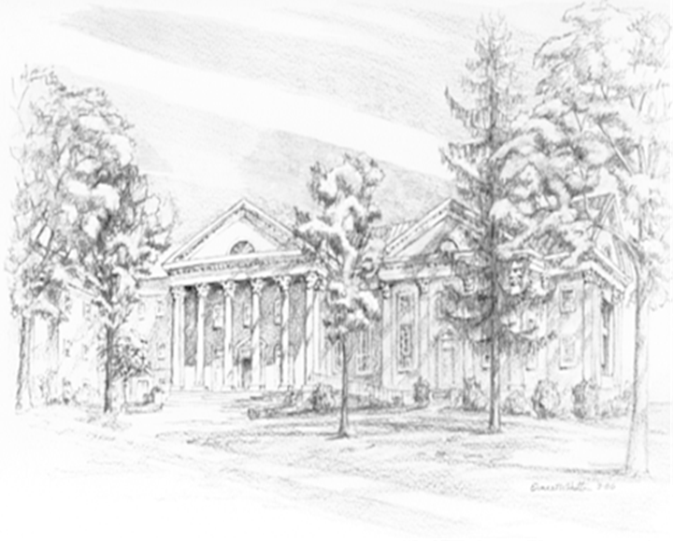

P.O. Box 877
249 South Wayne Avenue
Waynesboro, Virginia
(540) 949-8366
Church Website: www.firstpresway.org
Preschool Website: www.firstprespre.org
Email: church@firstpresway.com

