PENTECOST May 24, 2026
Liturgist: Betsy Ruehl

PRELUDE Come, Holy Spirit BuxWV 199 Buxtehude (1637-1707)

WELCOME & ANNOUNCEMENTS

INTROIT Breathe on Me, Breath of God Jackson (1840-1914)

CALL TO WORSHIP
Leader: Holy Spirit, light the fire.
All: Set our hearts blazing.
Leader: Holy Spirit, light the fire.
All: Fan the flames of adoration.
Leader: Holy Spirit, light the fire.
All: Spark in us your love!

MORNING PRAYER

*OPENING HYMN #289 On Pentecost They Gathered MUNICH

CHILDREN’S SERMON

CALL TO CONFESSION

PRAYER OF CONFESSION
God, we confess it is hard to keep up with you. You go ahead, while we hold back.
You pour out your power, while we store it up. You are reckless with your love, while we count costs. You burn bright, while we hide our light. Anoint us again with the power of your presence, and show us how to soar. We pray this with the confidence of your children.
Amen.

SILENT PRAYER

ASSURANCE OF PARDON

*GLORIA PATRI #581 Glory Be to the Father GLORIA PATRI
FIRST SCRIPTURE LESSON John 7:37-39 p.869

ANTHEM The Gift of Love Hopson (1933-2025)
(text can be found in hymn 693)

SECOND SCRIPTURE READING Acts 2:1-21 p.885

SERMON Pouring & Prophesying Rev. Samantha Coggins

*AFFIRMATION OF FAITH (Nicene Creed)
We believe in one God, the Father, the Almighty, maker of heaven and earth, of all that is, seen and unseen. We believe in one Lord, Jesus Christ, the only Son of God, eternally begotten of the Father, God from God, Light from Light, true God from true God, begotten, not made, of one Being with the Father; through him all things were made. For us and for our salvation he came down from heaven, was incarnate of the Holy Spirit and the Virgin Mary and became truly human. For our sake he was crucified under Pontius Pilate; he suffered death and was buried.
On the third day he rose again in accordance with the Scriptures; he ascended into heaven
and is seated at the right hand of the Father. He will come again in glory to judge the living and the dead, and his kingdom will have no end. We believe in the Holy Spirit, the Lord, the giver of life, who proceeds from the Father and the Son, who with the Father and the Son is worshiped and glorified, who has spoken through the prophets. We believe in one holy catholic and apostolic church. We acknowledge one baptism for the forgiveness of sins. We look for the resurrection of the dead, and the life of the world to come. Amen.

PRAYERS of the PEOPLE and THE LORD’S PRAYER

*CLOSING HYMN #279 Come, Holy Spirit, Heavenly Dove ST. AGNES

*BENEDICTION

POSTLUDE Come, Holy Spirit BWV 651 Bach (1685-1750)

This week’s liturgy is written by Rev. Carol Holbrook Prickett via her online worship resource Deep Well Worship, and by Teri McDowell Ott via the Presbyterian Outlook.

LINK: https://www.youtube.com/watch?v=HXpivWbe-MI

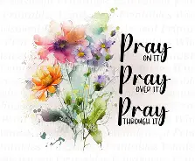

The Legacy At North Augusta: Joyce Tipton

Shenandoah Nursing & Rehab: Linda Quillen

Home: Mary Ultee, Mary Ann Maupin, Warner Sandquist, Polly Bare, Olive Prettyman, Nancy Hypes.

Friends and Family: Carolyn Hedrick-Williams (Colleen Cash), Betsy Boswell (Curry), Damon Prettyman (Olive Prettyman).

Military: Carson Craig, Michael Little

New members class next Sunday, 5/31, at 9:00am in the Barksdale Room. Please see Samantha if you plan to attend, and with whatever questions you may have.

The church office will be closed tomorrow (Monday, May 25 ) for Memorial Day.


An offering plate is available in the narthex.

Roger Daggy will Be playing an organ recital at St. John’s Episcopal Church this afternoon at 4:30pm, followed by a reception



FIRST PRESBYTERIAN CHURCH
WAYNESBORO, VIRGINIA

A community-minded congregation living out the love of Christ as we serve one
another with humility, gentleness, and patience through God’s grace.

May 24, 2026 11:00 AM

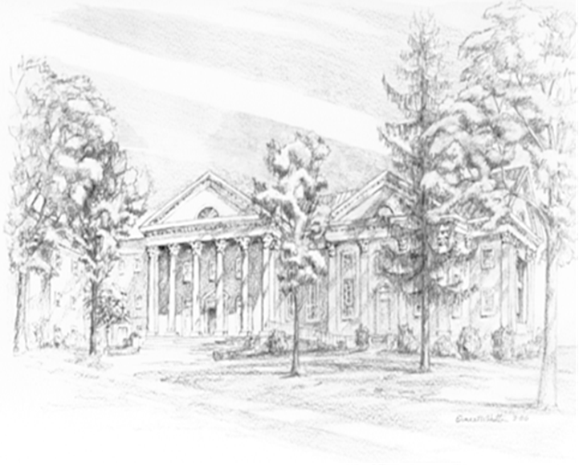

P.O. Box 877
249 South Wayne Avenue
Waynesboro, Virginia
(540) 949-8366
Church Website: www.firstpresway.org
Preschool Website: www.firstprespre.org
Email: church@firstpresway.com

