FIFTH SUNDAY OF EASTER May 3, 2026
Liturgist: Kimberlea Daggy

PRELUDE Andante in D Mendelssohn (1809-1847)

WELCOME & ANNOUNCEMENTS

INTROIT O Come, Let Us Sing Unto the Lord Lantz III (b. 1956)

CALL TO WORSHIP (based on Psalm 31:1–5, 14–15)
Leader: Our God refuses to shame us. God’s justice delivers us.
All: Praise God, in whom we seek shelter and guidance!
Leader: Our God listens to us. God rescues us from danger.
All: Praise God, in whom we seek shelter and guidance!
Leader: Our God renews our spirits. God is always faithful.
All: Praise God, in whom we seek shelter and guidance!
Leader: We trust our God. Let us worship God, whom we call ours.
All: Praise God, in whom we seek shelter and guidance!

MORNING PRAYER

*OPENING HYMN #267 Come, Christians, Join to Sing MADRID

CHILDREN’S SERMON

CALL TO CONFESSION

PRAYER OF CONFESSION
God of compassionate mercy, your grace and love extend to all people. We are called to forgive others, as you forgive us. Far too often, however, we wield forgiveness like a weapon. We see others doing wrong and feel haughty when we grant them grace. We call out the sins of the powerful but fail to notice our own power. We become narrow in our quest for truth, and ignore other people, in other rooms, crying out for your justice. Help us to search ourselves, and to seek forgiveness from those we have caused to beg us for mercy. Connect us to others, and guide us to share power and grace as we follow you.

SILENT PRAYER

ASSURANCE OF PARDON
*GLORIA PATRI #581 Glory Be to the Father GLORIA PATRI

OLD TESTAMENT READING Psalm 31 p.439

ANTHEM Thee We Adore, O Hidden Savior, Thee Gregorian Chant, arranged
(text can be found in hymn 495)

GOSPEL READING John 14:1-14 p.877

SERMON Rooms to Spare Rev. Samantha Coggins

*AFFIRMATION OF FAITH (The Belhar Confession)
Affirmation of Faith (The Belhar Confession)
We believe in the triune God, Father, Son, and Holy Spirit, who gathers, protects and cares for the church through Word and Spirit. This, God has done since the beginning of the world and will do to the end.
We believe that Christ’s work of reconciliation is made manifest in the Church, as the community of believers who have been reconciled with God and with one another;
that unity is, therefore, both a gift and an obligation for the Church of Jesus Christ.
We believe that this unity of the people of God must be manifested and be active in a variety of ways: in that we love one another, and that we experience, practice and pursue community with one another.
We believe that the variety of spiritual gifts, opportunities, backgrounds, convictions, as well as the various languages and cultures, are by virtue of the reconciliation in Christ, opportunities for mutual service and enrichment within the one visible people of God.
Jesus is Lord. Amen.

THE LORD’S SUPPER
Invitation
Great Thanksgiving
Communion of the People

*CLOSING HYMN #634 To God Be the Glory TO GOD BE THE GLORY

*BENEDICTION

POSTLUDE Fugue in C, BuxWV 174 Buxtehude (1637-1707)

Today’s liturgy is written by Dr. Jimmy Hoke and the Presbyterian Outlook.
The Affirmation of Faith is an adaptation & excerpt from the Belhar Confession, via Rev. Carol Prickett Holbrook’s Deep Well Worship liturgy.
The Belhar Confession was developed as a faithful response to racial apartheid in South Africa. Originally written in Afrikaans, it was adopted into the PC(USA) Book of Confessions in June 2016.
LINK : https://www.youtube.com/watch?v=lzQnAy6L22I

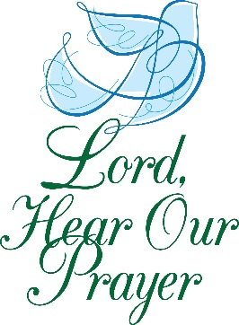

Summit Square: Lorain Kent.

Home: Mary Ultee, Mary Ann Maupin, Warner Sandquist, Polly Bare, Olive Prettyman, Nancy Hypes, Mike and Cathy Cunningham.

Friends and Family: Carolyn Hedrick-Williams (Colleen Cash), Betsy Boswell (Curry), Damon Prettyman (Olive Prettyman), Jessica Faulk, Maria Costello (Cunningham), Harold Wimer (Marcie & Tami Hemp).

Military: Carson Craig, Michael Little

Our Christian sympathies to the family of Nancy Garber 91, who died at Shenandoah Nursing home on Tuesday April 28,2026. Memorial Services were held here on Friday May 1, 2026

FIRST PRESBYTERIAN CHURCH
WAYNESBORO, VIRGINIA

A community-minded congregation living out the love of Christ as we serve one another with humility, gentleness, and patience through God’s grace.

May 3, 2026 11:00 AM

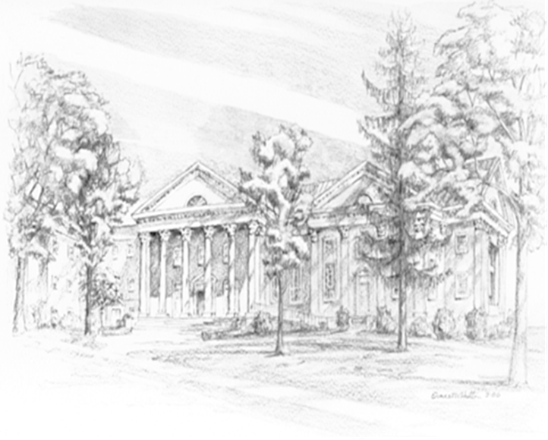

P.O. Box 877
249 South Wayne Avenue
Waynesboro, Virginia
(540) 949-8366
Church Website: www.firstpresway.org
Preschool Website: www.firstprespre.org
Email: church@firstpresway.com

