TRINITY SUNDAY MAY 31, 2026
Liturgist: Cynthia Hoover

PRELUDE Divine Spirits Boëly (1785-1858)

WELCOME & ANNOUNCEMENTS

INTROIT What Does the Lord Require Routley (1917-1982)

CALL TO WORSHIP
Leader: Our gracious God has created us and called us his own.
All: Let us worship the triune God.
Leader: Our Lord and Savior, Jesus Christ, has redeemed our lives.
All: Let us worship the triune God.
Leader: The Holy Spirit sustains and guides us all the days of our lives.
All: In gratitude and joy, let us worship the triune God!

MORNING PRAYER

*OPENING HYMN #268 Crown Him With Many Crowns DIADEMATA

CHILDREN’S SERMON

CALL TO CONFESSION

PRAYER OF CONFESSION
Look deep, loving God, and see us as we really are. We are a people who prefer our will to your will. We focus on things of the self and give little thought or care to others. We wander through our days giving little thought to our own discipleship, let alone our call to help others become disciples. Forgive us, God of grace. Forgive us and set us again on the path of your righteousness. Amen.

SILENT PRAYER

ASSURANCE OF PARDON

*GLORIA PATRI #581 Glory Be to the Father GLORIA PATRI

FIRST SCRIPTURE LESSON Psalm 8 p. 427

ANTHEM Spirit of the Living God Iverson (1890-1977)
(text can be found in hymn 288)

SECOND SCRIPTURE READING Galatians 5:16-26 p.948

SERMON My Spirit Is Willing, My Flesh Is So… Rev. Samantha Coggins

*AFFIRMATION OF FAITH (from The Study Catechism)
How do I live for the love of God?
I love because God first loved me. God loves me in Christ with a love that never ends. Amazed by grace, I no longer live for myself. I live for the Lord who died and rose again, triumphant over death, for my sake. Therefore, I take those around me to heart, especially those in particular need, knowing that Christ died for them no less than for me. Amen.

PRAYERS of the PEOPLE and THE LORD’S PRAYER

*CLOSING HYMN #300 We Are One in the Spirit

*BENEDICTION

POSTLUDE Prelude and Fugue in F attr. Krebs (1713-1780)

This week’s liturgy is written by Rev. Dr. Tara W. Bulger and the Presbyterian Outlook.

LINK: https://www.youtube.com/watch?v=hDF_FeKscUk





The Legacy At North Augusta: Joyce Tipton

Home: Mary Ultee, Mary Ann Maupin, Warner Sandquist, Polly Bare, Linda Quillen, Olive Prettyman, Nancy Hypes.

Friends and Family: Carolyn Hedrick-Williams (Colleen Cash), Betsy Boswell (Curry), Damon Prettyman (Olive Prettyman).

Military: Carson Craig, Michael Little



Prayers of comfort for the family of Darcy Wyant Coggins, whose mother, Pat Frost Wyant (Mount Vernon, OH), died on Monday. Pat was grandmother to Joel and great-grandmother to Cozy.

Food Bank Fellowship June 11
After food bank hours on Thursday, June 11, we will gather at Greenleaf Grill to celebrate another year of serving and enjoy fellowship together. We will head over once we are finished serving and cleaning, around 4:45 pm.

An offering plate is available in the narthex.

FIRST PRESBYTERIAN CHURCH
WAYNESBORO, VIRGINIA

A community-minded congregation living out the love of Christ as we serve one
another with humility, gentleness, and patience through God’s grace.

May 31, 2026 11:00 AM

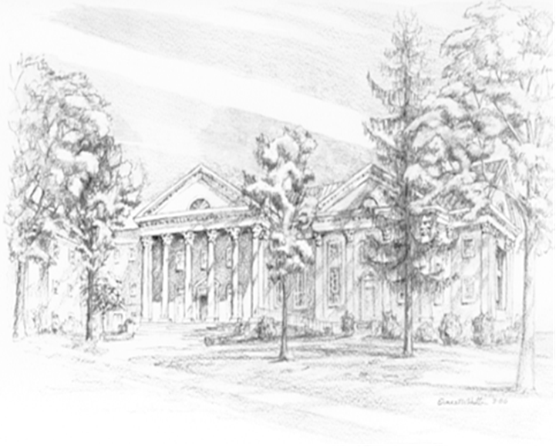

P.O. Box 877
249 South Wayne Avenue
Waynesboro, Virginia
(540) 949-8366
Church Website: www.firstpresway.org
Preschool Website: www.firstprespre.org
Email: church@firstpresway.com

