

THE COLUMNS
First Presbyterian Church, Waynesboro, VA
May 2026, Volume 64, Issue 5

First Presbyterian Church of Waynesboro is a community-minded
congregation living out the love of Christ as we serve one another with
humility, gentleness, and patience through God’s grace.

15 Toward evening the disciples approached him. “We’re out in the country and it’s getting
late. Dismiss the people so they can go to the villages and get some supper.”
16 But Jesus said, “There is no need to dismiss them. You give them supper.”
17 “All we have are five loaves of bread and two fish,” they said.
18-21 Jesus said, “Bring them here.” Then he had the people sit on the grass. He took the
five loaves and two fish, lifted his face to heaven in prayer, blessed, broke, and gave the
bread to the disciples. The disciples then gave the food to the congregation. They all ate
their fill. They gathered twelve baskets of leftovers. About five thousand were fed.
Matthew 14:15-21

When in doubt, always quote scripture. This is not one of the rules I have painstakingly collected over the years,
but perhaps it should be. Last month, we began with insights into basketball; for May, we are diving back into
the New Testament for illumination.
We are conditioned, I think, to look at the miraculous as magical, the theological equivalent of alchemy. Just as
the medieval alchemist sought to turn lead into gold, and thus enrich themselves without labor, we look at
miracles at least in part, as labor-saving plot devices: healing without the effort of treatment; gifts that eliminate
the need for impossible choices; rescue that makes of us passive recipients of grace. But, in the words of yet
another of my rules, God is not a magician; what we call miracles are signs of God at work in our midst - and
God hates to work alone.

In the feeding of the multitude, the disciples recognize a need - the crowd is getting hungry and the day is
mostly gone. This is a real problem, they know, but the best they can come up with is to send the crowds
back to town, where they might find some supper. But Jesus has something else in mind; not just pushing
the problem down the road, but actually doing something about the hunger of the people. He asks what
food is available, and is told, 5 rolls and 2 cooked fish - the lunch of a well-prepared young man. Jesus
then does the miraculous, but the miracle isn&#39;t magic- Jesus does not make everyone feel full, or have
manna fall from the heavens. The miracle happens through the work of the disciples. It is the disciples
who organize the people, getting them to sit down in an orderly fashion; they who oversee the distribution
of the loaves and fishes, making sure everyone is fed; even making sure the leftovers are collected. And
that, friends, leads us to Rule #10:

Dear members & friends of First Presbyterian Church,

As spring arrives, so does a tide of planned events: graduations, proms, sports banquets, alumni weekends...
(et cetera).

And yet, as people of faith, happenings in the life of the church can be like an undercurrent, keeping us strong and anchored amid that tide. I like to think of this undercurrent as the movement of the Holy Spirit – God’s calendar-beneath-the-calendar, perhaps.

In the month of May, there are three such happenings that I am really looking forward to:

FPC Preschool Spring Program & Graduation: Thursday, May 21 at 6:30 pm and Friday, May 22 at 6:00. There are fourteen (14) 4-year-olds graduating from the preschool this year. So in addition to the planned spring concert on Thursday evening, we will have our preschool graduation on Friday evening, as a separate celebration. With heavy bias (!) — my own 4-year-old will don her own small cap & gown on Friday – I recommend both of these chances to be blessed and encouraged by our preschoolers’ voices.

Pentecost Sunday: Sunday, May 24
On the Sunday of Memorial Day weekend, during worship, we celebrate Pentecost: the giving of the Holy Spirit to God’s people. This event was recorded in the book of Acts. But it was not a one-off event. As Christians, we understand Pentecost as an ongoing gift: God continues to pour out the Holy Spirit as sustenance for us here and now, in the month of May 2026.

Celebrating the Service of Ruling Elders throughout the month of May
This month, Jean Hashagen and Betsy Ruehl finish their 3-year terms as ruling elders on our Session. Jean and Betsy, thank you for your active service, during a busy three-year period in the life of FPC. I am grateful that, thanks to our Presbyterian polity, we can now give you the gift of a break. We thank God for your call(s) to be ordained ruling elders in our church.

As the tide of spring rolls in, may the undercurrent of the Holy Spirit sustain you.

Grace & peace,
Samantha


MAY MUSIC NOTES

“Now is the Month of Maying!” This text opens one of the most famous madrigals by Thomas Morley, which hails the beginning of May.

FPC opened the month of May with a First Friday Organ Recital and Light Luncheon. Roger Daggy began playing free programs in 2017 to highlight the extraordinary 1893 Woodberry and Harris pipe organ that graces FPC’s Sanctuary. We are also deeply grateful to Joe Earhart for planning, preparing and serving the luncheons, with assistance from Janet Shaner, Terry Crickenberger, Patrick Fitzgibbon and Max Daggy. It is a pleasure to see so many people enjoy the music and fellowship together. This series will be on hiatus for the summer and will resume in October.

We continue to celebrate Eastertide in early May. On the 3rd, the anthem will be Thee We Adore, O Hidden Savior, Thee, a plainsong chant with various harmonies, both ancient and modern.

As always, Mother’s Day falls on the second Sunday of May. The anthem that day will be paired with the first reading, I Peter 3: 13-22. Kimberlea will read the Scripture text, and the choir will respond with the refrain Teach Me, O Lord, the Way of Thy Statutes. The music is one of a hundred pieces composed by David Hurd (b. 1950), who served as Professor of Sacred Music and Director of Chapel Music at General Theological Seminary in New York City for 39 years. Hurd is also an active concert organist, currently serving as Director of Music/Organist at the Church of St. Mary the Virgin in Times Square.

On 17 May, the choir celebrates Christ’s Ascension with A Hymn of Glory, the ancient hymn DEO GRACIAS. Also known as The Agincourt Hymn, the music was originally written to accompany the tale of Henry V’s victory over the Normans on October 25, 1415.

The first day of Pentecost will be 24 May, celebrating the many gifts bestowed upon us by the Holy Spirit. The anthem be The Gift of Love, Hal Hopson’s (1933-2025) most popular piece. Hopson served Presbyterian churches in Nashville and Dallas and taught at Westminster Choir College. The Gift of Love is one of 1800 pieces published by the prolific composer, penned in 1971 and published a year later. Hopson set the text from I Corinthians to an old Scottish folk tune known as O Waly Waly or The Water is Wide.

The prelude and postlude for the first Sunday of Pentecost will be renditions of an ancient anonymous tune Komm, heiliger Geist (Come, Holy Ghost). The prelude was composed by Dieterich Buxtehude (1637-1707), the influential composer, organist and kapellmeister (music director) who worked in Lübeck, Germany. The postlude was composed by a man who spent much time soaking in all Buxtehude could offer, Johann Sebastian Bach (1685-1750). His chorale fantasia on Komm, heiliger Geist is a musical depiction of the swirling Holy Spirit under which the chorale melody thunders in the pedals.

Also, on the 24th, Roger will play an organ recital at St. John’s Episcopal Church to demonstrate the various properties of their instrument! Please feel free to saunter down Wayne Avenue to hear the program at 4:30pm, followed by a reception.

We remain grateful to First Presbyterian Church for the continued support of the music program!

Roger and Kimberlea Daggy

NO FIRST FRIDAY ORGAN CONCERTS THIS SUMMER
Join us again on October 4.

COLLECTING PERSONAL CARE ITEMS FOR FOOD BANK





Where has the time gone??? We can’t believe it is May already!! Our preschool has enjoyed watching the flowers bloom, listening to the birds’ chirping and watching the squirrels roam around. We have even seen our little squirrels snacking on top the trashcans and climbing up the walls being silly.
All our children have been practicing so hard with Mrs. Lynda and learning their music for the spring program, as well as the 4-year-olds anxiously awaiting their graduation on a separate day this year. The 4’s got to decide on a theme to decorate the after-celebration and be a huge part of - Rainbows, and “Our Future is So Bright, We had to Wear Shades” .
This last month has been a whirlwind here in the preschool. All the classrooms are getting assessments completed and planning fun things, such as planting flowers in class to take home to continue the growth with their families, while still learning about shapes, letters and colors. Our-4 year-olds are even took a trip to South America this month! “WOW” they had so much fun learning that South America’s primary languages are Spanish and Portuguese.

May 21st- Spring Program: 6:30pm
May 22nd – Preschool Graduation: 6:00pm
June 1st – Summer Camp Begins

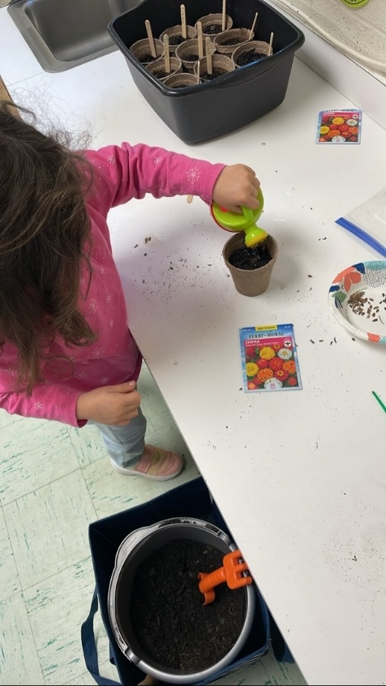
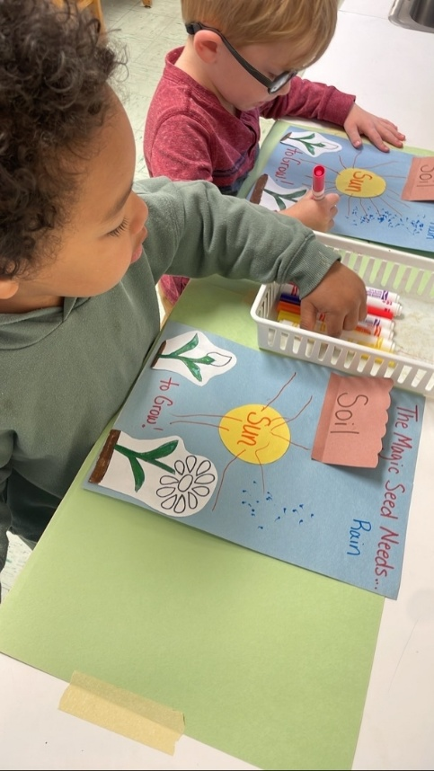
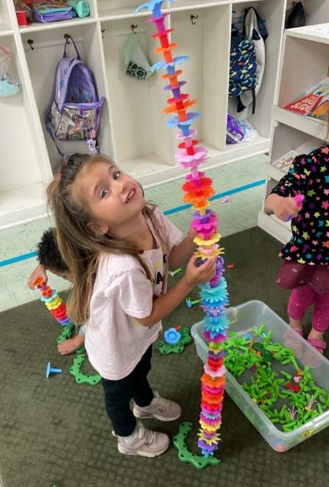

A DAY OF PENTECOST LIKE NO OTHER

In the new testament book of Acts, we read about an unusual event on the Day of Pentecost. Abou 40 days after the resurrection Jesus the 12 apostles and other early followers were gathered together in a house in Jerusalem to celebrate the traditional Jewish Pentecost. Also present were Jesus’ mother Mary and other female followers. Suddenly, a terrific wind came from heaven and filled the place. (Acts 2:1-4).

Immediately the disciples were filled with the Holy Spirit, causing them to speak in tongues. The crowds of visitors were astonished because every pilgrim heard the apostles speaking to him or her in their own language. Some people in the crowd thought the apostles were drunk.

Apostle Peter explained that the people were not drunk but empowered by the Holy Spirit, fulfilling the prophecy in the Old Testament book of Joel. It marked a turning point in the early church. With the Holy Spirit’s empowerment, Peter preached boldly to them about Jesus Christ and God’s plan of salvation.

The crowd was so moved when Peter told them of their part in the crucifixion of Jesus that they asked the apostles, “Brothers, what shall we do?” (Acts 2:37). The right response, Peter told them, was to repent and be baptized in the name of Jesus Christ for the forgiveness of their sins. He promised that they, too would receive the gift of the Holy Spirit.

Taking the gospel message to heart, Acts 2:41 records that about 3,000 people were baptized and added to the fledgling Christian church on that day of Pentecost.

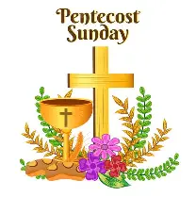


BETTER TOGETHER BIBLE STUDY
1:00 Mondays
May 4 – First PC; May 11 – Second PC;
May 18 -Hermitage; May 25 – Happy Memorial Day!
Study resumes in the fall

SUMMER FPC BOOK STUDY
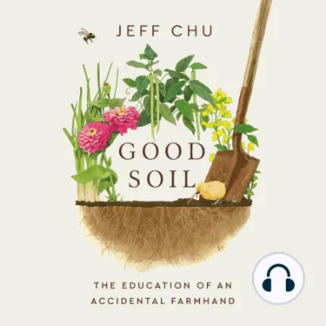
“Good Soil: The Education of an Accidental Farmhand” by Jeff Chu
(A true story of a working farm at Princeton Seminary)
Wednesdays at 10:00 in the Barksdale Room
Led by Rev. Samantha Coggins
July 8 – September 2
A limited number of books available in the Church Office

A PRAYER FOR MOTHER’S DAY

Heavenly Father, we thank You for the gift of motherhood. Today we celebrate the loving sacrifice of mothers, both biological and spiritual, who nurture us in Your ways. Bless them with joy, strength and love to continue their selfless devotion. May they feel deeply appreciated and honored, not just today but every day. Amen.






MAY BIRTHDAYS MAY ANNIVERSARIES

12 – Roger Bryant 24 – Cary & Holly Bennett
14 – Don Hashagen 25 – John &Cynthia Hoover
15 – Betty Dixon 31 – Danny & Pam Leech
16 – Carrol Smith
26 – Ron Smith



IN MEMORIAM

Phyllis Ann Hanna Nancy Ann Garber
June 29, 1929 – April 18, 2026 December 14, 1934 - April 28, 2026

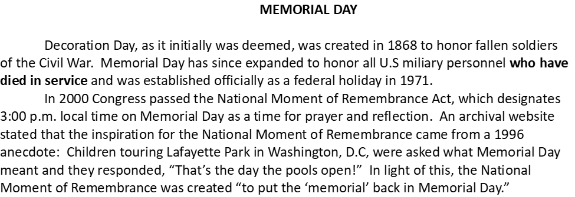



CHURCH OFFICERS:
Treasurer – Colleen Cash
Members of Session - Jean Hashagen, Betsy Ruehl
Cynthia Hoover, Bob Miller and Nancy Hypes.



MAY
Friday, May 1
12:15 pm Organ Concert/Lite lunch
3:00 pm Memorial Service-Nancy Garber
Saturday May 2
1-6 pm Sarah Braverman Rehearsal

Sunday, May 3
11 a.m. Worship
Thursday, May 7
6-7:30 p.m. Food Bank
Saturday, May 9
1-5 pm Braverman Recital
Sunday, May 10
11 a.m. Worship
Thursday, May 14
10 am Fishburne Graduation Rehearsal
2-4 p.m. Food Bank
Saturday, May 16
10 am Fishburne Graduation
Sunday, May 17
11 a.m. Worship
Congregational Meal -Barksdale Room
Thursday, May 21
6:30 pm Preschool Spring Program
6-7:30 p.m. Food Bank
Friday, May 22
6:00 pm Preschool Graduation
Sunday, May 24
11 a.m. Worship
Monday, May 25 Closed Memorial Day
Thursday, May 28
2-4 p.m. Food Bank
Sunday, May 31
9 am New Member Class (Contact Samantha, if interested)
11a.m. Worship

CONGREGATIONAL LUNCH
after Worship on Sunday, May 17
Barksdale Room

